Welcome! The Registration Guide will help you through the registration process. All students must register each year to become students of the University, this is obligatory.
If you are new to the University of Galway in order to register online you must have already activated your University of Galway Campus Account and reset your password. The instructions to do so are sent to your personal e-mail address by ISS (University's IT Department). This this the e-mail address you specified when you applied to the University of Galway. MFA e-mails will start to be sent from the 15th of August 2023.
Online Registration Guide 2023/2024 for
Adult Learning Students

Contents

Welcome from the President
Important Dates Semester I - 2023/2024
Step 1 -Login to the Student Portal
Step 2 - Start the Registration Process
Step 3 - Agree to the Terms and Conditions
Step 4 - Update your Address Details
Step 5 - Update Personal Details
Step 6 - Photo Upload
Step 7 - Fee Payment
How to complete Course Registration
Update your Profile
Registration Support
What's What Glossary!
Other Support Teams
Check List

Welcome from the President

Dear Student,
I am delighted to welcome you as student of the University of Galway. I hope your time with us will be both enjoyable and rewarding.
The guide outlines the registration process.
I urge you to take the time to read this guide carefully as it will answer many of the queries you may have at this time and contains important instructions regarding the registration process at the University of Galway.
In addition, the website
www.universityofgalway.ie/startinguniversity provides a range of material and advice to help your first year. I wish you every success in your academic endeavours here at the University of Galway.
Professor Ciarán Ó hÓgartaigh
President

Step 1 -Login to the Student Portal
To register for your course, please login to the Student Portal
To login to the Student Portal
You will need the following.
Username

This is your Student ID which is issued to you by the
Admissions Office.
Password
This is your password linked to your Galway Campus Account
Once you have entered your username and password click on Login button

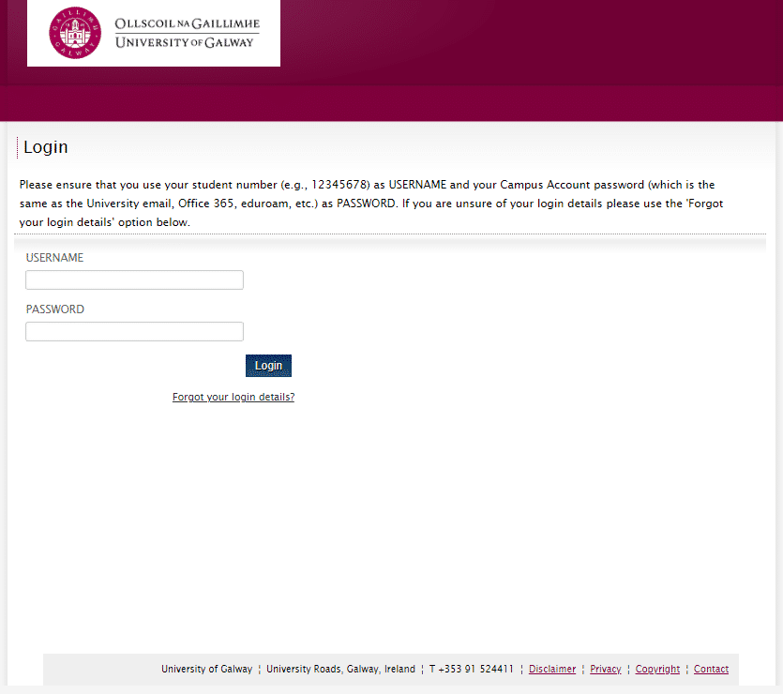
Link to Student Portal
Screenshot of Student Portal
!
Activate your MFA and reset your password if you are a new student at University of Galway, in order to be able to be able to register online, you must have already activated your University of Galway Campus Account ad reset your password. MFA e-mails will start to be sent from the 15th of August 2023.
For more information click here

!
!
!

How to find your University email Address
Your University email address was included in the mail sent to you about "Activating your new University of Galway campus account". It is located under the username section of the e-mail.

Non-EU Students
You must contact the Fees Office before registering. Pay any monies owed and then you can register ONLINE.
Click here for more information.

mus

If you attended the university previously
You must use your old/previous Student ID number.
Click here for more Information.

Prompted to sign into your account?
You may be challenged to sign into your University of Galway Campus Account before getting to the Student Portal Login Screen. If this is the case, the following steps are what is typically required to get to the Student Portal Login Screen.

If not and you are logged into the Student Portal, please to go to
Step 2 – Start the Registration Process

Step
A

Enter Your Username

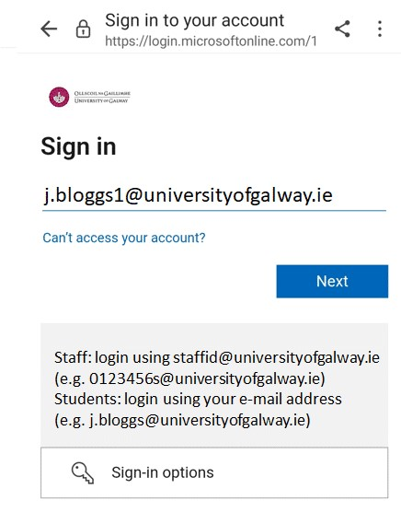
This is your @universityofgalway e-mail address. If you are new to the University of Galway, this was originally issued to you in an e-mail from ISS with Subject Line "Activating your new University of Galway campus account". MFA e-mails will start to be sent from the 15th of August 2023. This e-mail will be sent to your personal e-mail address. In this example the student's username is j.bloggs1@universityofgalway.ie.
Enter Your Password
Step
B
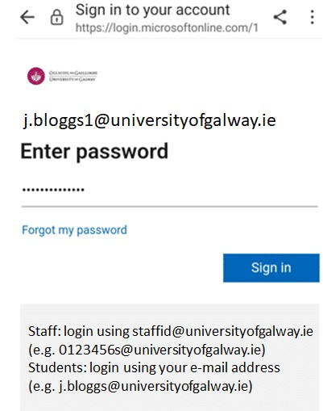

This is your latest password linked to your campus account. What is my campus account?

Verify your Identity
Step
C
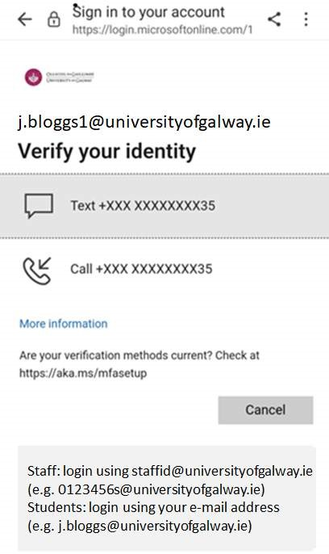
You will be prompted to verify your identity. Your response to the prompt depends on how you activated MFA. In this example, a text is sent to the phone number attached to
j.bloggs1@universityofgalway.ie MFA profile.
Enter Code
Step
D

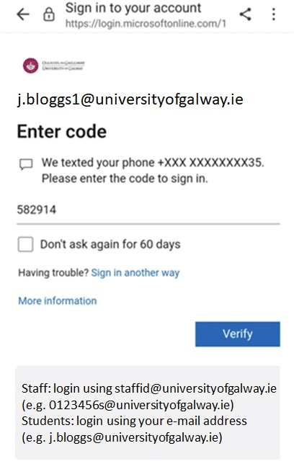

In this example you enter the code sent to your phone.

Stay Signed In?
Step
E

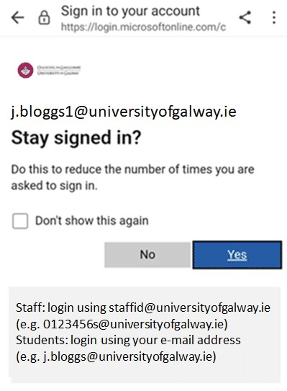
Answer either "Yes" or "No"

Student Portal Login Screen
Step
F
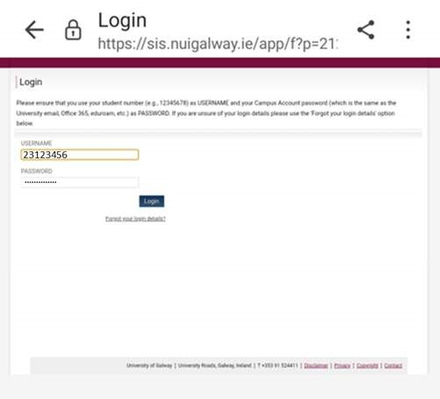
You should now be presented with the Student Portal login Screen and enter your username and password as outlined already. Remember your username is your Student ID
and your password is your campus account password. In this example J Bloggs username is Student ID 2312345

Step 2 - Start the Registration Process

Welcome to your course profile page
This page gives you an overview of your student and course details. You will see Student Name, Couse Information, Start and End Dates
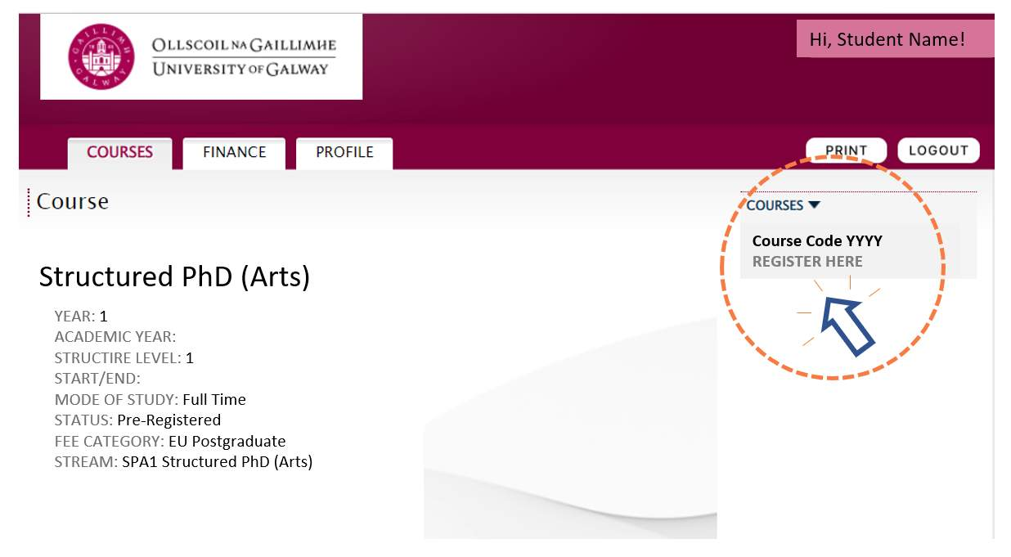
Course Code You will now use the University of Galway courses instance as detailed on your courses page e.g. 1SPA1 - Structured PhD (Arts) or 1MBY1 - Master of Science in Business Analytics

Note: STATUS of Pre-Registered means you are not a registered University of Galway student Click on “REGISTER HERE” link s shown. This will begin the registration process.
!
If 'REGISTER HERE' does not appear, see our FAQ on “Why can’t I register online’ Click Here

Spot any errors on your courses page? To contact us see the “Registration Support” section below

Step 3 - Agree to the Terms and Conditions

Once you have read the "Terms and Conditions" you should enter a tick in the tick box.
If you do not tick the "Terms and Conditions", you will not be able to proceed any further in this application.
For Terms and Conditions Click Here

Step 4 - Update your Address Details

In this section, you will need to update the fields marked with
Compulsory*
Home Address:
A home address is your family home or address where you live outside of university term time. All University of Galway postal correspondences will go to this mailing address i.e. Student ID Cards, transcript requests etc.

Term Address
A term address is where you will be living during the academic year. It is important to provide a full term-time address.

Step 5 - Update Personal Details

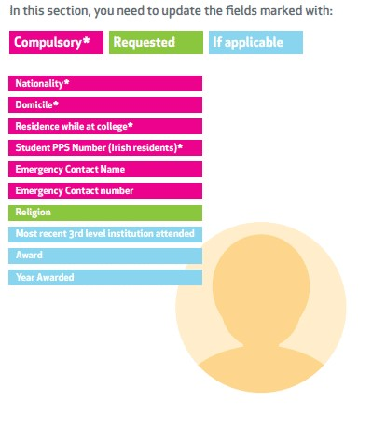
Confused by any of the Terms? Go to “What’s What Glossary” below.

CHECK THE GLOSSARY

Step 6 - Photo Upload
What is needed?
Now you must upload an image of yourself for your University of Galway Student ID Card.
This image must be:
- Of good quality

- Passport sized

- Can be taken 'selfie' style on your phone/tablet. Photo must be taken vertically. Do not turn the device to the side for a landscape shot as it cannot be adjusted after you upload.
Update this image in jpeg format where possible. For more information on acceptable image guidelines click here
How to do it?
Click browse to find your image on the PC/electronic device
Click on your photo and open
Crop your photo
Hit upload
!
Take note you must upload your photo by the 23rd of August 2023. Not uploading your photo or uploading a poor quality or unsuitable photo will lead to a delay in receiving your Student ID Card.
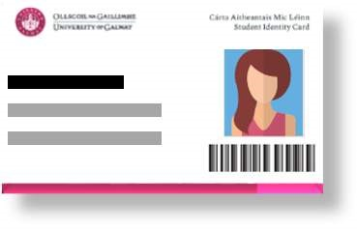
When do I get my ID card?
For University of Galway Student ID card distribution contact your Programme Administrator.

!
Having problems uploading your image e-mail regphotos@universityofgalway.ie

Step 7 - Fee Payment

In order to be a fully registered student, you must pay the appropriate fees. To find out more about your fees, please click here
The 5 questions asked at this step will determine your fee amount.
If you are unable to proceed past this point, you will be prompted to contact the Fees Office

Please refer to the online user guide if you wish to view a video clip on this in “Step 7 – Fee Payment”.
Once you have completed all questions, a fee will be calculated based on your answers. This is the fee you must pay online or by a bank giro. If you answered 'Yes' to the Question on the SUSI funding, you must choose SUSI from the drop-down box and enter your SUSI number in the format WXXXXXXXXXXXX.

To pay your fees select 'Pay Now'. A secure payment page will open where you can enter your debit/credit card details. For more information click here

How to complete Course Registration

Click on the 'Finish' button
This will return you to the 'Courses' page
Your status should now be changed from 'Pre-registered' to 'Registered'
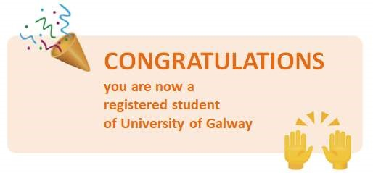
Forgot to complete your Personal Details?
To add your PPS number (Irish Residents) or your emergency contact details, log into your Student Portal and click on the 'Profile' tab.
Need a statement to say you are registered?
Student Portal
Once registered, you can print a registration statement by clicking on the 'Proof of Registration' button on the 'Courses' and/or 'Profile' page on your Student Portal.
Student Registry Helpdesk
For customised registration statements, name and address changes, validation of forms please see please see here.

Update your Profile

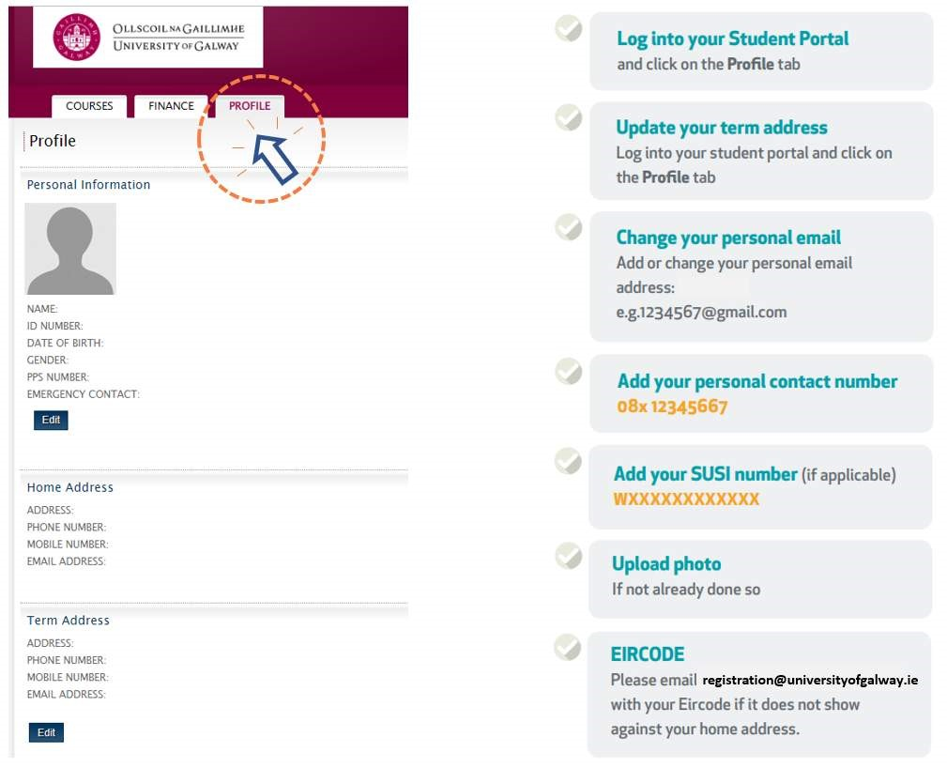

Still need help? Refer to “Registration Support” section below.

How to Register for your Modules

Before selecting your modules
- Attend your orientation module briefing
- Read any course outlines provided

Selecting your modules
Click on SELECT SUBJECT/MODULES on your course page on the Student Portal. If you wish to find out more about adding and deleting modules please refer to the online user guide to view a video clip in the section “How to Register for your module”.

Confirming your modules
Once you have selected your modules, it is very important to hit Confirm and continue to Finish.

Canvas Access:
Once you have selected your modules you will have access to them 24 hours later on Canvas. For further information on Canvas Click Here (to be added await ISS)

Still need help? Refer to “Registration Support” section below

Registration Support

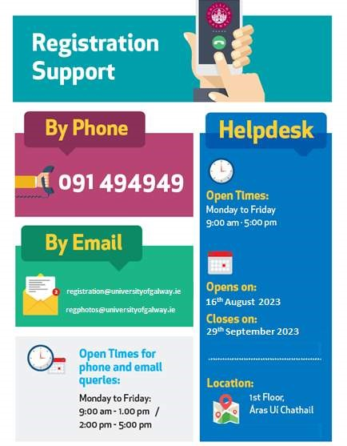
Click here for exact location of Áras Uí Chathail

What's What Glossary!

What is Registration?
Registration is the collection and maintenance of student data. All students at NUI Galway must register each year to become students of the University, this is obligatory.

Online Registration
Online registration allows students the freedom to register for their course and also pay fees online.

Username
Your username is your student number, which was issued to you by the Postgraduate Admissions Office, which is now your Student ID number.

Password
The University’s IT section (ISS) will email you to advise you on how to activate your MultiFactor Authentication (MFA). While activating your MFA, you are also requested to change your password to one unique to you. This is the password you will use to log into your Student Portal to register as a student of the university. Click here for more information.

Register Here
Once logged into the 'Courses' page on your Student Portal, click on Register Here; this starts the process of registration.

Terms and Conditions
All those who register as a student of University of Galway do so understanding that they agree to abide by all the rules and regulations of the University as they apply to students. Click here for the University’s Terms and Conditions.

Nationality
This is the country of your birth.

Domicile
Domicile refers to your country of permanent address prior to entry to the programme of study e.g. a Polish person comes to Ireland 2 weeks prior to commencing a higher education course. While their nationality is Polish and their correspondence address is in Ireland, their country of permanent residence is still Poland.

Only in the case where a student has been residing in Ireland for 3 years or more out of the last 5 prior to commencing their course would their Domiciliary of Origin be Ireland. Their Domiciliary of Origin must not change throughout the duration of their study.

PSS Number
Please supply your PPS number this is a HEA requirement.

Emergency Contact Details
Please add a name and phone number of someone we can contact in case of any emergency.

Fees
All Fee queries must be directed to the Fees Office, find details: http://www.universityofgalway.ie/fees

Term Address
A term-time address is where you will be living during the academic year. It is important to provide a full term-time address. You can update your term address if different from your Home Address and is under the Profile tab.

Personal Email & Mobile Number
Please make sure you supply your personal email address and add your mobile number to your Profile details.

SUSI Number (if Applicable)
SUSI is the single Awarding Authority for all new student grant applications. The SUSI reference begins with a W followed by 12 numbers.

Course Code and Course Title
Your course instance code is for example; 1SPA1
Your course instance title is for example; Structured PhD (Arts)

Your course instance code is for example; 1MV1
Your course instance title is for example; Masters of Biomedical Science

GST Course
All research students will be registered for the Canvas module GS5110 under 1GST1 Graduate Studies Training. Click here for more information.

Forgot your Password
If you cannot remember your password, please click here for further information. Contact the Library & IT Service Desk on servicedesk@universityofgalway.ie should you encounter any difficulties.

Other Support Teams

Need further advice?
Help is available from other support Teams, click on the links below
ISS SERVICE DESK
FEES
STUDENT REGISTRY HELPDESK
LIBRARY
GRADUATE STUDIES
COLLEGES/SCHOOLS
ADMISSIONS
STUDENT SERVICES
DISABILITY SUPPORT SERVICE

Check List

Have You?
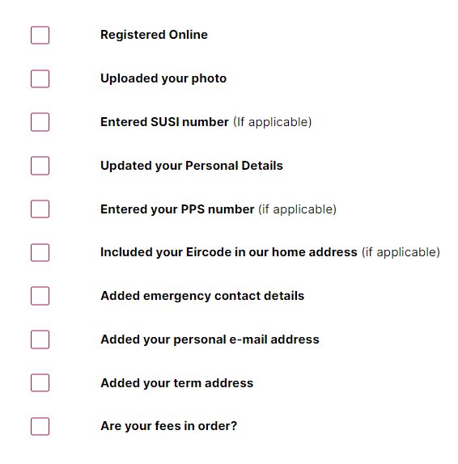

*The contents of this booklet are for information purposes only and shall not be deemed to constitute a contract between the University of Galway and an applicant or any other third party. Whilst every effort has been made to ensure the accuracy of the information in this publication, the University reserves the right to amend, change or delete any courses, syllabi, examinations, dates, fees, regulations, rules or orders at any time without notice.

