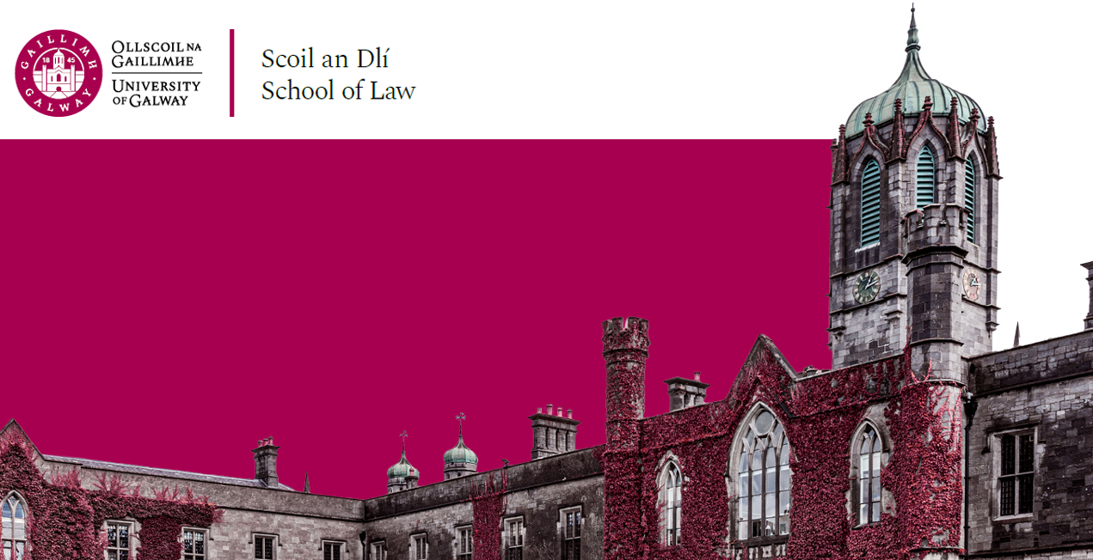

BA LAW
Everything you need to know for the year ahead

Scoil an Dlí
Leabhrán Acadúil
2023 –2024
School of Law
Academic Booklet
2023 – 2024
Please note that the information contained in this document is subject to change.

Programme Director  Ms Nicola Murphy  nicola.murphy@universityofgalway.ie | Class Adviser 1st BA Law  Ms Ursula Connolly  ursula.connolly@universityofgalway.ie
Class Adviser 2nd BA Law  Dr Maureen O’Sullivan  maureen.osullivan@universityofgalway.ie | Class Adviser Final BA Law  Prof Donncha O’Connell  donncha.oconnell@universityofgalway.ie
BA LAW PROGRAMME CONTACTS

MODULE SELECTION

First Year – BA Law
Code | Module | Semester | ECTS
LW103.I | Irish Legal System (Obligatory) | 1 | 5
LW126 | Legal Skills (Obligatory) | 2 | 5
LW3109 | Tort (Obligatory) | 1 & 2 | 10
Note:
1. As the number of places in Second BA Law is limited to a maximum of 100, students who wish to progress to study Law as one of their degree subjects are required to pass the above First BA Law modules and First Year overall in order to be eligible to progress to Second Law.
2. BA (Connect) Students do not take Legal Skills

Second Year – BA Law
Code | Module | Semester | ECTS
LW227 | Constitutional Law I (Obligatory) | 1 | 5
LW202 | Contract I (Obligatory) | 1 | 5
LW107.i | Legal Methods & Research (Obligatory) | 1 | 5
LW228 | Constitutional Law II (Obligatory) | 2 | 5
LW205 | Contract II (Obligatory) | 2 | 5
LW370 | Comparative Disability Law* (Optional) | 2 | 5
LW232 | Housing Law and Policy* (Optional) | 2 | 5
LW358 | Environmental Law II* (Optional) | 2 | 5
Note:
- Students must take and pass in Second Arts the 5 obligatory modules plus 1 optional module from the above list.
- Students should note that the module Legal Methods and Research is examined by means of assignments. Students must complete and submit the assignments as directed by the lecturer in the course of the first semester lectures in this module.
- BA (Connect) students do not take the optional modules in Semester II.

LW370 Comparative Disability Law: This module will deal with the law and policy affecting individuals with disabilities. It will take as its starting point an examination of the general concept of equality and its application in the field of disability. Specialist topics shall include consideration of the relevant portions of transportation law, education law, housing law, employment law and planning law. The scope of the module shall be comparative in nature and shall cover in particular the relevant UN, US, Canadian, Australian, Irish and European laws.

LW358 Environmental Law II: This module will examine the legal aspects of a number of different sources of pollution including water pollution (inland and coastal), air pollution, waste, noise etc. The Common Law nuisance principles and the Rule in Ryland v Fletcher will be examined, as well as recent case law in this area. Recent domestic legislation (in particular the Water Pollution Act and the Air Pollution Act) as well as EC developments will be considered, particularly from the point of view of monitoring and penalties for breach. The role of environment impact assessments will also be considered.

LW232 Housing Law & Policy: This new course will explore traditional housing law areas such as mortgages, property law, landlord and tenant law, succession, family law, conveyancing, planning and standards. It will also explore new perspectives in this distinct and expanding area of Irish housing law and policy including EU law, international and European human rights law and developments in consumer rights. Of particular concern will be the relationship between law reform options and the social and other policies of the EU. The course will take into account evolving European capital markets as well as the move towards Social Inclusion and rights-based approaches emanating from the United Nations and Council of Europe.
Study Abroad
It is possible for students to spend their third year studying abroad as part of an Erasmus (within the EU) or international (outside the EU) exchange. There are three categories of students who can study abroad and the procedure is different for each category.
1. For students taking French, German, Italian or Spanish, their exchange will be arranged by their language department co-ordinator.
2. BA (Global Experience) students not taking a language will be contacted by the College mobility co-ordinator in October, and invited to an information session to explain the application process. Places will be allocated in early December.
3. BA Government students and BA Law students who do not take a language will be contacted by the College mobility co-ordinator in January, and invited to an information session to explain the application process. This is highly competitive, as there is a limited number of places available. Second year Semester I results will be the deciding factor.

Final Year – BA LAW
Code | Module | Semester | ECTS
LW503 | European Union Law I (Obligatory) | 1 | 5
LW4103 | Administrative Law I (Obligatory) | 1 | 5
LW409 | Criminal Law I (Obligatory) | 1 | 5
LW504 | European Union Law II (Obligatory) | 2 | 5
LW4104 | Administrative Law II (Obligatory) | 2 | 5
LW413 | Criminal Law II (Obligatory) | 2 | 5

Entry to the LLB
The LLB is a three year postgraduate degree in law. BA Law graduates with at least 70 ECTs in law are eligible to skip the first two years of the LLB and enter the final year. Students who have taken the full BA Law will have 80 ECTS in law. Most students who have taken law as part of a Connect degree will have 70 ECTS in law.
The entry requirement for BA Law graduates is a third class honours degree. Offers will be sent out by the Law School in early summer. There is no need to apply via the online postgraduate application system.

