*Title of the Satellite Meeting: New Horizons in Artificial Intelligence in Libraries*

*Date: July 21-22, 2022*

*Location: National University of Ireland, Galway, Ireland.*

Steps Towards Building Library AI Infrastructures: Research Data Repositories, Scholarly Research Ecosystems and AI Scaffolding

Raymond Uzwyshyn

Division of Library Collections and Digital Services,  
Texas State University, San Marcos, USA.

E-mail address: ruzwyshyn@gmail.com

Creative Commons LicenseCopyright © 2022 by Raymond Uzwyshyn. This work is made available under the terms of the Creative Commons Attribution 4.0 International License: <http://creativecommons.org/licenses/by/4.0>

ABSTRACT:

*Artificial Intelligence possibilities for Deep Learning, machine learning, neural nets and natural language processing present fascinating new AI library service areas. Most of these areas will be integrated into traditional academic library ‘information’ and ‘digital’ literacy programs and university research environments to enable research faculty, students and library staff. Most university faculty, graduate students and library staff working outside of Computer Science disciplines will require help to enable their data and research towards new AI possibilities. This research overviews methodologies and infrastructures for building new AI services within the ‘third interdisciplinary space’ of the academic library. A library is a very suitable space to enable these new ‘algorithmic literacy’ services. This work utilizes the pragmatic steps taken by Texas State University Libraries to set up good foundations. Data-centred steps for setting up digital scholarly research ecosystems are reviewed. Setting needed data-centred groundwork for library AI services enables research, data and media towards wider global online AI possibilities. Library AI external scholarly communications services are discussed as well as educational methodologies involving incremental steps for foundational AI scaffolding. Bootstrapping tools build on present systems and allow for the later enablement of future AI insights. Pathways are clarified from data collection to data cleaning, analytics and data visualization to AI applications. Focused steps needed are forwarded to move library staff, research faculty and graduate students towards these new AI possibilities. Data-centred ecosystems, retooling and building on present library staff expertise are reviewed. Data research repositories, algorithmic and programmatic literacy are recommended for later AI possibilities. Preliminary AI library working groups and R&D prototype methodologies for scaling up future library services and human resource infrastructures are considered. Recommended emergent pathways are prescribed to create library AI infrastructures to better prepare for a currently occurring global AI paradigm shift.*

**Keywords:** Artificial Intelligence, Deep Learning, Data Research Repositories, Academic Libraries, Research Libraries

# INTRODUCTION

# Deep learning, machine learning, neural nets and natural language processing are fascinating new areas of AI. Most university research faculty, graduate students and library staff work outside Computer Science AI disciplines. A majority of the university community don’t know where to begin with enabling their research data with new AI paradigms. This research overviews pragmatic steps taken by Texas State University libraries to set up good foundations for AI possibilities. These steps include data research repository foundations, digital scholarly research ecosystem infrastructure,s and relevant tools and services to set important groundwork for research, data and media towards new arising AI possibilities .

# Texas State University is a US Carnegie Higher Research Activity University. The Libraries are designated an Association of Research Libraries member. With approximately 40,000 students, the university is a comprehensive research and teaching university across undergraduate, graduate and doctoral levels. This research may be most productively utilized and adapted by any similar-sized medium or larger academic library or research institution thinking about beginning AI programs.

Texas State University Libraries, <https://www.library.txstate.edu/>

Developing AI-related library scholarly services for research faculty, graduate students and library staff begins with education and incremental steps to enable insights and knowledge. Research data gathering and experimental data is plentiful at academic research institutions and in libraries. This research may now be corralled towards many new, productive and innovative AI pathways. This article outlines steps needed to enable library staff, research faculty and graduate students towards these new possibilities. Technological ecosystems, new hires and retooling possibilities for AI infrastructures for academic libraries will be discussed. How research centers may strategically move into these areas will be reviewed. Methodologies, challenges, scholarly communications models and preliminary infrastructures begin with data repositories, scholarly research ecosystems and algorithmic literacy programs. These allow bootstrapping towards AI possibilities and setting strong foundations for larger successful new millennia AI library programs.

# EDUCATIONAL STEPS AND SCAFFOLDING

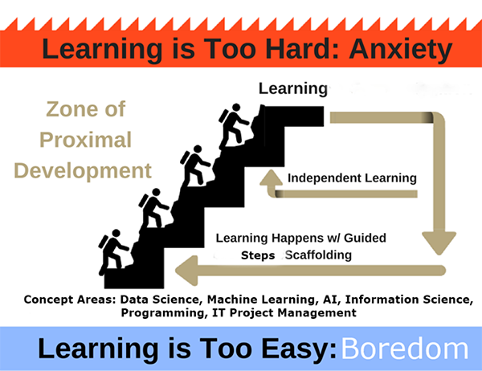

Educational Scaffolding and Steps Towards Learning, Warren, 2021.[1]

To build any successful library AI program, educational steps and scaffolding are needed. Because the learning curve for AI is steep, staff education should be thought about in detail by library managers and administration. Artificial Intelligence combines areas of data collection, data science, programming, information science and IT project management. The larger goals of staff professional development and algorithmic literacy programs are also explicitly not to turn disciplinary research faculty, graduate students and library staff into AI experts. Education develops a more sophisticated vocabulary towards AI programmatic literacy and larger conversations. The university’s larger learning community becomes familiar with the language of AI paradigms. Later they will be able to converse knowledgably on project possibilities and work with AI engineers and Ph.D.’s.

# AI Paradigms and Origins

AI has many origins - each with unique algorithmic paradigms. Some paradigms are better suited than others to solve particular problem areas. It is best for any algorithmic literacy program to begin generally. Introduce university faculty, graduate students and library staff to the wider field before delving deeply into particular areas. There are many good introductory texts, documentaries, online courses and YouTube videos to inspire before beginning Deep Learning’s back propagation and linear algebra and calculus cribs needs to understand processes (see Reference bibliographies).

For example, Carnegie Mellon’s Tom Mitchell or Karoly Zsolnai’s ‘Two Minute Papers’ YouTube Videos both provide excellent inspiring overviews of recent AI development and progress[2] and Pedro Domingos*, The Master Algorithm* provides an excellent categorization of the different AI schools, origins, algorithms and best solutions for various problem areas or tasks (Domingos, 2015).

|  |  |  |  |  |
| --- | --- | --- | --- | --- |
| **AI Paradigm** | **Origin** | **Algorithm** | **Problem** | **Solution** |
| **Deep Learning Machine Learning** | **Neuroscience (Neural Nets)** | **Back Propagation Neural Nets** | Complex Tasks, Hidden Patterns | Back propagation |
| **Symbolic AI** | Logic, Philosophy | Inverse Deduction | Knowledge Composition | Inverse Deduction |
| **Bayesian Inference** | Statistics, Probability Theory | Probabilistic Inference | Uncertainty | Probabilistic Inference |
| **Evolutionary Computation** | Evolutionary Biology (Complexity Theory | Genetic Algorithms | Structure Discovery | Genetic Programming |
| **Reasoning by Analogy** | Psychology | Kernel Machines (Support Vector Machines) | Similarity | Kernel Machines |

AI Paradigms, Origins and Algorithms. Dr. Pedro Domingos, The Master Algorithm, 2015.

The larger idea is to build awareness in both a larger university community and library staff so that there is desire and inspiration for further knowledge to build skillsets. Present AI attention is largely focused on Deep Learning, Machine Learning and neural nets (See Carnes, 2019; Coldfusion, 2020; Lecun, 2022, Mitchell, 2022; Fridman, 2022 et al.). While there are other important areas, this is an excellent place to focus on beginnings a wider program. There is a lot of current attention here and many significant, inspiring gains.

The last ten years of Deep Learning or Neural Net Algorithms have shown incredible progress with regards to results from natural language processing and conversational chatbots to cybersecurity to strategic reasoning (AlphaGo) to computer vision and object recognition (Mitchell, 2022). Here, it is best to both briefly overview the field but also, pragmatically set scalable limits so that progress may be made with both algorithmic paradigms and pragmatic application for both library staff and research faculty and graduate students so that projects may be achieved, and core research and data enabled.

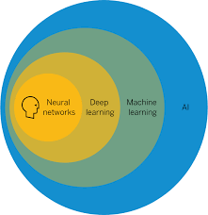

Fields and Subfields of AI: Machine Learning, Deep Learning and Neural Networks

By focusing on a particular area after a group is inspired, there is some feeling of control and gaining of skills that may be achieved, enabling both library projects and faculty and graduate student research to new levels.   
  
Levels of Learning

# Online Data Research Repositories

With any Library AI program, it is also best to begin pragmatically. There is a clear trajectory in academic libraries from data and data collection to data science, analytics, visualization and AI. This all begins with the data. Its organization and center is a good online data research repository. An academic online research data repository will allow both a university library to consolidate and share online faculty and graduate student research, manage university research data and provide important online data archiving and publishing strategies for research data. It will also provide library staff, surrounding research faculty and graduate students important entry level skills needed towards AI. These foundational skills surround important tasks of data organization, data cleaning, creating structured data, data citation and creating metadata schemas, among other skills. These skills will all be important building blocks needed towards AI’s ‘larger pathways.

Texas Data Repository, <http://data.tdl.org>[3]

The Texas Data Repository is a good example of a preliminary needed step to begin any AI program. The Texas Data Repository reconfigures Harvard’s open source Dataverse as a consortial environmental aggregating research data from various Texas universities collaborating together. Setting up this type of open-source software on an individual institutional or consortial configuration will build many infrastructure skills. This will enable library staff in setting up this data-centered service for the larger university community, but also for the university researchers in beginning to build their ‘data science’ skills towards the later ‘data’ and algorithmic literacy needed for AI paradigms.

Open Refine <https://openrefine.org/>

Enabling a data repository for the institution will encourage scholars and library staff to learn basic ‘data cleaning’ tools such as Open Refine. Open Refine is a powerful tool for working with messy data and transforming it so it will be in a suitable state to be taken and utilized by a later AI algorithm for later training and processing.

The Online Research Data Repository Lifecycle, Uzwyshyn, 2016.

Gaining fundamental data literacy with the larger online research data repository lifecycle will serve both the university community and library staff well for excellent foundations on building the next levels of AI projects.

To generalize, a university online data repository and larger research community competence with both the data research lifecycle and how the data repository enables this larger ecosystem will provide a great foundation for later AI pathways.

# Digital Scholarship Ecosystems (DSE)

A digital scholarship ecosystem (DSE) should also be pursued following development of an online research data repository. While a Data Repository will always be central, an online institutional collections repository should also not be overlooked, especially for the ability to store and house both the metadata and core data for large textual files. These ‘token’-based datasets are needed for natural language processing and text-based AI. A larger DSE generally consists of two primary online components for content and four tertiary online components for communication. A research data repository and digital collections repository will make up together the primary content repositories (data, media and text).

As mentioned, Texas State University utilizes the consortial Texas Data Repository based on Harvard’s Dataverse for the Data Research Repository. The well-known open-source software, DSpace is used for the university’s digital collections repository. For universities and research institutions, the four tertiary components will enable better online global communication and networks. These are an online electronic theses and dissertation management system (ETD System, VIREO), identity management system (ORCID), open academic journal system software (OJS3) and user interface content management software (OMEKA). Together, these function as a unified digital scholarship ecosystem (DSE). This ecosystem allows great facility in later enabling larger AI pathways continuing to build on strong foundations.

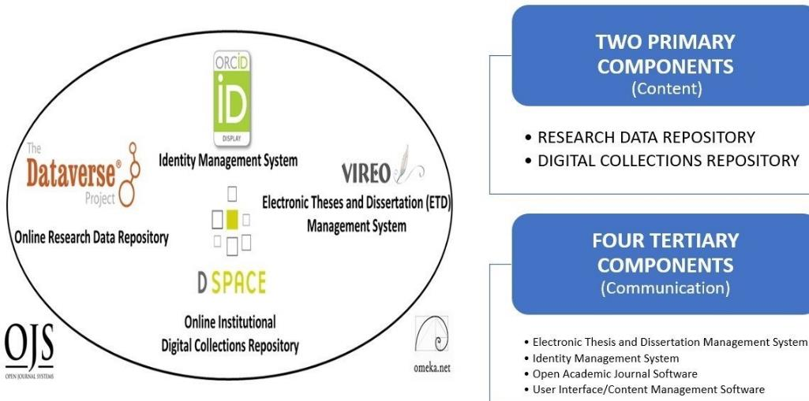

# A Digital Scholarship Research Ecosystem, Six Components, Online Content and Communication[4]

# Open Science, Data, AI and Digital Scholarship Ecosystems

# Innovative Open Science and AI possibilities are now enabled through affordances and combination of a digital scholarship ecosystem and data research repository. The HAM10000 image dataset is a large collection of multi-source dermatoscopic images of Cancerous skin lesions uploaded to Dataverse by Viennesse Dermatologist, Dr. Philip Tschandl, in 2018. Because Harvard’s Dataverse allows for the uploading of datasets from other universities appropriate research datasets may be uploaded for later sharing or use by anyone globally

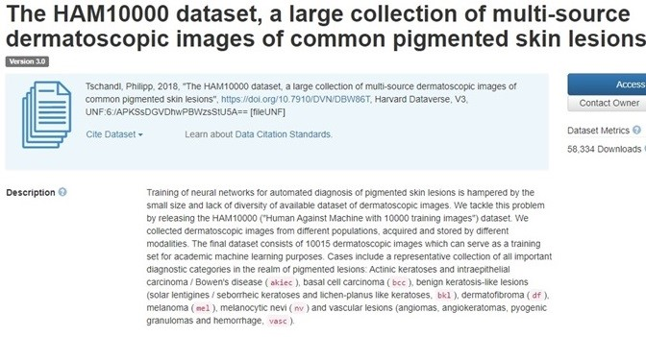

# 

# HAM10000 Dataset, https://dataverse.harvard.edu/dataset.xhtml?persistentId=doi:10.7910/DVN/DBW86T

BRAC University from Dhaka Bangladesh that uses DSpace as an institutional repository to house theses and dissertations from the School of Data and Sciences, Dept. of Computer Science and Engineering. Here the students have downloaded and utilized the image data as training material to train a deep learning neural net algorithm to recognize cancer growths with efficiency greater than, or equal to, board certified dermatologists.

This is a very good example of open science and AI possibilities operating on global levels through the enabling power of digital scholarship ecosystems and data repositories. Content and data that otherwise would be unavailable is brought together with new machine learning algorithmic techniques. New research and a very good thesis is produced. Geographically dispersed content and knowledge from three different continents has been aggregated to 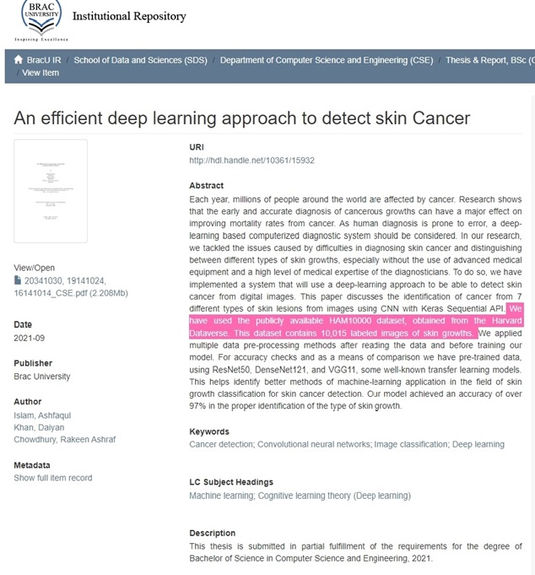advance the pursuit of knowledge and science. [5]

BRAC University Dspace Repository 2021 Deep Learning/AI Thesis <http://dspace.bracu.ac.bd/xmlui/handle/10361/15932>

# AI Human Resources

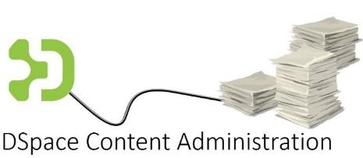  
Transferrable Skills from other Institutional Repository Staff

In creating an AI infrastructure, hiring a whole new staff department will not be feasible for most libraries. Many research and academic libraries, though, will have an online digital collections repository such as DSpace in place and operational. This will also serve the library well. Many of the institutional repository content administrative skills gained with the Institutional Repository are transferrable to the Data Research Repository. This makes AI and data learning curves easier to begin.

A staff member already in place for this repository position can initially take up a data- centered function with an upcoming data research repository. The will begin by helping faculty and graduate student with their research data and repository functions until a full time ‘data scientist’ is hired. Other staff skills are similarly transferable.

A cataloger focusing on digital metadata, can easily be also transferred part time to begin as the data repository metadata specialist. This will serve upcoming AI functions well, especially with regards to machine learning. Much of the neural net training here is about what is called in machine learning terminology ‘labeled’ and ‘unlabeled’ data. Essentially, this is a simpler schema for metadata. Various other data cleaning and metadata skills will also come in useful here.

As a tiered gateway towards AI, hiring a Data Visualization specialist will also be useful to gain support towards more complex AI initiatives. This specialist will initially provide library support for data visualization and analytics projects through dashboards and information visualizations for data-driven decision making and finding insights from library data, but also from faculty and graduate student research data.

The Insights Possible from Data Driven Dashboards

Subject liaisons and research and information outreach librarians will also come in useful in communicating with various departmental and school research faculty and conveying the library’s new data-driven scholarly communication possibilities with information visualization. Enabling research faculty occurs with their possible data sets through both the repository and possible further information visualization help and resources. These possibilities will also introduce the new ‘data repository’, data/information/research visualization and create bridges toward upcoming ‘AI’ pathways.

Library Data Driven Dashboards as Operational Gateways Towards AI

A Data Research and Information Visualization Specialist will also allow university administration, research faculty and graduate students to see the usefulness of the programmatic possibilities with data towards greater insight. Education on research faculty levels should now also develop higher level strategies to clean and normalize data for future AI R&D projects and begin more complex programmatic analytics pathways with Python. The later Data Visualization Specialist or Librarian can then be the bridge for transferrable skills towards AI and full time Data repository role as needs formaliz.

# AI Learning Paths From Data to Carpentries

Data Carpentries <https://carpentries.org/>

As the algorithmic literacy needs of both library staff and the surrounding university research community firm up there will be needs arising from both researchers and library staff for more pragmatically-oriented foundational coding and data science skills. With the libraries’ activities, research academics will obtain an understanding for enabling their research data towards higher level insights. Various areas of the library will also begin to realize the potential of these more algorithmic pathways.

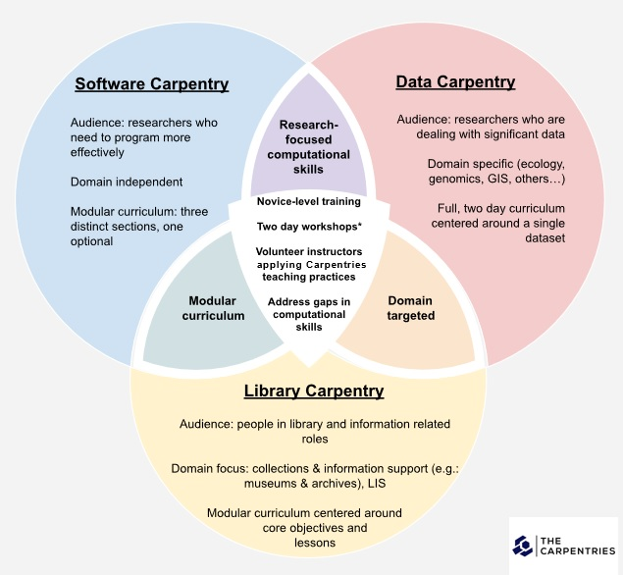  
Data, Software and Library Carpentries <https://carpentries.org/>

Carpentries workshops combine pragmatic programmatic knowledge needed for university researchers and graduate students with algorithmic literacy needs of library staff. They are also great scholarly communications bridges for dialogue and collaborative work between research faculty working on learning how to enable their research through data and programming and library staff who are also taking up these new methodologies towards larger library algorithmic literacy AI infrastructures and programs

# Library AI Conferences

As the learning curves and paths towards AI are steep, it will be important to keep staff both motivated and inspired - motivated with inspiring examples of benchmarks and milestones being achieved in our surrounding society (medicine, natural language processing, strategic games). New library AI conferences arising will serve these purposes well.   
  
Stanford University Libraries Fantastic Futures Conference for Libraries Archives and Museums, 2019-2022. <https://library.stanford.edu/projects/fantastic-futures>   
  
Two such conferences have become more well-known: Carnegie Mellon’s *Artificial Intelligence for Data Discovery and Reuse* and Stanford’s 2nd *International Conference on AI for Libraries, Archives and Museums*. Stanford’s Conference has travelled from the US to the Bibliothèque Nationale de France in Paris and then Norway. In subsequent years, Carnegie Mellon has productively combined with the CMU’s Open Science Symposium.

Carnegie Mellon University Libraries AI for Data Discovery and Reuse, <https://events.library.cmu.edu/aidr2020/>

Both together serve to inspire and motivate staff.

Artificial Intelligence presentations are also beginning to occur at more general library technology conference such as Computers in Libraries, Coalition of Networked Information Meetings, Texas Conference of Digital Libraries and IFLA’s now historic AI Satellite Conference New Horizons for Artificial Intelligence in Libraries, 2022.

# FIrST Library AI R&D and BETA Prototypes

Texas State Convolutional Neural Nets Football Jersey Number Feature Extraction Classification Prototype

It will be important at this time for motivated library staff to also be encouraged with pursuing AI beta projects. More than larger successes, these projects will be important for staff to gain initial understandings of models and the various pieces needed here for working on convolutional neural nets and deep learning model projects. Learning new areas of knowledge are wide and will range from AI processing power parameters (compute) and new video cards (NVIDIA GPU’s) to the Python programming language and vocabulary of pretrained and untrained models, classification, feature extraction, image and natural language libraries, to name a few.

Texas State San Marcos Newspaper Neural Nets Object Recognition Metadata Classification Project, Peters 2022.

What is important in these experiments is getting the staff thinking about these new models and what can or cannot yet be achieved. Understanding processes and possibilities is more important than large results at this stage. This will begin to get library staff working on levels of R&D and iterating on results as classification improves with model training.

# Library AI Workshops, Institutes and Fellows PRograms

Library specific AI Fellows institutes and workshops are also beginning to appear. It is important to write recommendation letters and send motivated employees who apply for these workshops to attend. These institutes will be important both for motivating staff, but also for sharing curriculum and creating larger networks with other motivated parties.

|  |  |
| --- | --- |
|  |  |
| * Weeklong Fellows Program at University of Texas Austin   (20 Fellows) | ■ AI challenges and opportunities  ■ Ethical considerations and guidelines  ■ UX-Human/AI Interaction Lifecycle  ■ Existing library, archive, and museum projects  ■ AI project planning  o Project Design  o Data collection, classification, and transformation  o Roles and implementation  ■ Python Basics, Python for Machine Learning  ■ APIs and bibliometrics  ■ AI in search and discovery  ■ Machine learning and coding  ■ Harvesting, evaluating, and training data sets for use in AI  ■ Conversational AI – Theoretical foundations  ■ Conversational AI – applications  ■ Linked open data Machine learning for text with topic modeling and clustering |
| * Onboarding, * AI Institute * Library Centered AI * Programming Workshops * Final Project * AI Specialist Support |
| * Networking with National Library AI Experts * Other Fellows |

IMLS IDEA Institute on Artificial Intelligence. <https://idea.infosci.utk.edu/>

Following these types of institutes, it is important to open the door towards projects that have begun through these opportunities. This will also offer leadership opportunities for staff teaching, presenting to fellow staff, sharing curricula and beginning to think about further infrastructures that may be constructed locally to develop out of organic needs.

# UNIVERSITY Library Collaborations

It is important to embrace change and it is paramount to understand that as the larger library begins to retool for the paradigm shift of AI so, too, will the larger parent research institution and associated IT infrastructures. As this occurs, unexpected opportunities for collaboration, participation and partnership will begin to occur. For example, there is a current trend of dissolving and downsizing the traditional libraries research and information outreach services. The traditional reference and subject librarian services are transforming to online and other modalities but also as a cost saving measure. Simultaneously, many universities are now adopting new AI Chatbot infrastructure for the students and faculty campuswide. This new chatbot infrastructure presents opportunities for the libraries to utilize skills in different ways. Subject librarians may now retrain, train the chatbot, retool and transform previous research skills and expertise towards new paradigm possibilities.

|  |  |
| --- | --- |
|  |  |
|  |  |

Changing Roles: Chatbots, AI and Chatbot Administrators

These unexpected AI changes should also be embraced. They open doorways for exploration and research. Previous research skills can be now retooled towards the investigation and tuning of future AI natural language processing models ranging from Open AI’s GPT3 and GPT4 to Google’s DeepMind Gopher and other upcoming models. Help is not disappearing in the 21st century but the chatbot may now need some help in understanding its human audiences. This help can now be accompanied by a knowledgeable guide at the side, the previous research and instruction librarian, now newly minted as Chatbot Administrator.

# Libraries as Complex Dynamic Adaptive Systems

Libraries as Complex Adaptive Systems, Bryant, Dortmund, Lavoie, 2020.[6]

Libraries are complex, adaptive, dynamic systems. As library staff, university faculty and graduate students interact from the bottom, system-wide patterns emerge from the top. As this emergence occurs, it is important to begin to formalize some of this activity through an AI Working Group (AIWG). Ideally, the membership of this group should begin through partnerships, friendships and collaborations of interested library staff. As this activity ramps up, it should be formalized to continue conversations. This will provide direction, responsibility and accountability for artificial intelligence projects arising and important ethics related discussion, decisions, policy and later oversite.

This group can also later be opened further so both university research faculty and graduate students are invited. This will also help guide and offer suggestion and direction to strategic paths. This group will later add to the innovation, vision and potential.

# Next Steps, GRaduate Students, Post-Docs and Permanent AI Hires

At a certain point, library staff will realize they have come to the end of their AI learning journey. This will signal the time to hire a graduate student and eventually, a Ph.D. or Post Doc in Machine Learning or AI. Good graduate students can be found more easily in university engineering schools or computer science departments. Course listings will have names like *Machine Learning for Engineering Applications* or *Neural Nets and Deep Learning for Computer Science*. Associated research faculty will be only too glad to assign suitable students and work with library staff to have their students paid for part time AI research assistant projects or theses work. Relationships are key here and these will be win/wins for both the library, student, professor, and university in many ways.

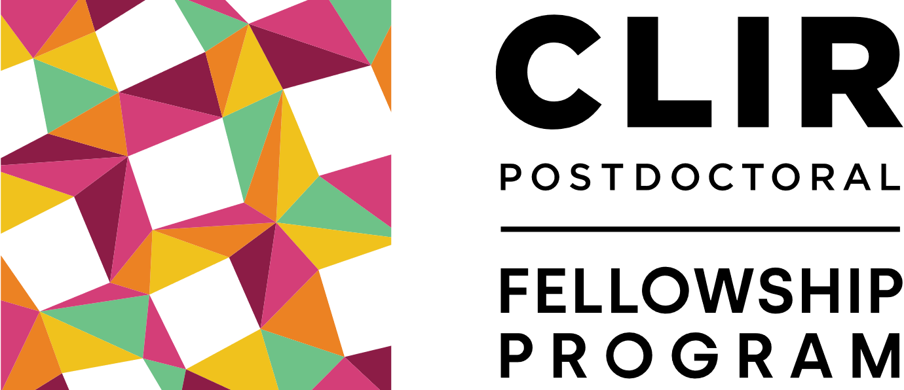

CLIR Postdoctoral Fellowship Program <https://postdoc.clir.org/> CLIR AI Research in Archives <https://haira.clir.org/blog/>

Following these successes, graduate students can be hired permanently. Ph.Ds. and Post-Docs can also be sought. There are even library specific Post-Doc programs through the Center for Library and Information Services on both US and global levels. These may be pursued to make use of a recent Ph.D.’s specialized skills and bring new AI skillsets into libraries.

# Conclusion – Library AI SUCCESS

The new road to library AI success is still largely open. There are trailblazing opportunities for most internal sections of the library. This ranges from Special Collections and Archives to possibilities for better understanding the black box of acquisitions’ budgets to metadata with AI and natural language processing. Search and retrieval, library usage data, statistics and deriving insight from vast arrays of data now make up the 21st century academic research library landscape.

Beyond this, there is incredible potential in connecting research faculty and graduate students and their research data collections with AI. Most of these researchers come from traditional academic disciplines. These are still widely outside of artificial intelligence, machine learning and computer science. The prospects for these new infrastructures are incredible. These are both towards the advancement of the next levels of human knowledge and exploration for discovery and insight previously thought impossible. On many levels, it is important for libraries to begin thinking along these paths to enable these new library AI possibilities.

**REFERENCES**(Select AI, Data Science and Learning Resources Bibliography)  
  
 **Articles, Reports and Books**

Bryant, R. Dortmund, A. and Lavoie, B. Social Interoperability in Research Support: Cross Campus Partnerships and the University Research Enterprise. *OCLC Research Reports.* 2020. <https://www.oclc.org/content/dam/research/publications/2020/oclcresearch-social-interoperability-research-support-a4.pdf>

Carnes, Beau.*Grokking Deep Learning in Motion*. Manning Publications (O’Reilly), 2019.   
  
Cordell, R. *Machine Learning and Libraries: A Report on the State of the Field*. LC Labs: Library of Congress, Washington D.C. 2020.  
  
Domingos, Pedro. *The Master Algorithm: How the Quest for the Ultimate Learning Machine Will Remake Our World*. New York: Basic Books, 2015.   
  
Esteva, A, Thrun, S. et al. Dermatologist-level Classification of Skin Cancer with Deep Neural Networks*. Nature*, Volume 542 (February 2, 2017). pp. 115-119. doi:10.1038/nature21056  
  
Hervieux, S. and Wheatley, A. *The Rise of AI: Implications and Applications of Artificial Intelligence in Academic Libraries*. ACRL 2022.  
  
Johnson, Steven. *Emergence: The Connected Lives of Ants, Brains, Cities and Software*. New York: Scribner, 2001.

Kleinveldt, Lynn. Smarter high education learning environments through AI: What this means for academic libraries. *Trends and Issues in Library Technology: Special Issue on AI*: June 2022. pp. 12-15. <https://repository.ifla.org/handle/123456789/1940>   
  
Recht, Benjamin and Hart, Moritz. 2022. *Patterns, Predictions and Action: Foundations of Machine Learning* (Early History). Princeton University Press. 2022.  
  
Sanchez, Nogales, Patrana Garcia, Alicia and Cerdan Medina, Jose Carlos. Digital Transformation, Data Reuse and Heritage Collections at the National Library of Spain. *Trends and Issues in Library Technology: Special Issue on AI*, June 2022. pp. 16-21. <https://repository.ifla.org/handle/123456789/1940>   
  
Sartorius. *Understanding the Relationship Between Data Science, Artificial Intelligence and Machine Learning*. 2020 <https://www.sartorius.com/en/knowledge/science-snippets/data-science-vs-artificial-intelligence-vs-machine-learning-602514>

Uzwyshyn, R. 2020 Developing an Open-Source Digital Scholarship Ecosystem. *International Conference on Education and Information Technology*. St. Anne’s Oxford, United Kingdom. February 2020. Available from: <https://www.researchgate.net/publication/357286044_Research_Data_Repositories_and_Global_Scholarly_Ecosystem_Possibilities>.

Uzwyshyn, R. 2016. Online Research Data Repositories: The What, When Why and How. *Computers in Libraries*. 36:3, April 2016. pp. 18-21. <http://rayuzwyshyn.net/TXU2016/OnlineDataResearchRepositoriesUzwyshyn.pdf>

Warren, Erica. Maximize Learning: Keeping Students in the Zone of Proximal Development. *Good Sensory Learning* 2021. <https://goodsensorylearning.com/blogs/news/scaffolding-development>

**General AI Video Overviews/Introductions**  
*In the Age of AI*. Frontline PBS. 2021. <https://www.youtube.com/watch?v=5dZ_lvDgevk>  
  
*Artificial Intelligence and Algorithms: Pros and Cons*. Tilman Wolff und Ranga Yogeshwar. DW 2021. Available: <https://www.youtube.com/watch?v=s0dMTAQM4cw> Part II, <https://www.youtube.com/watch?v=-ePZ7OdY-Dw>   
  
*Artificial Intelligence. Machine Learning. Neural Networks. Future Technology*. Bloomberg Businessweek Canada. 2022. <https://www.youtube.com/watch?v=ypVHymY715M>  
  
ColdFusion (2018). *Why Deep Learning Now?* (Documentary Overview). <https://www.youtube.com/watch?v=b3IyDNB_ciI>   
  
Domingos, P. *The Master Algorithm: Talks at Google*. Nov 27, 2015, Retrieved from: <https://www.youtube.com/watch?v=B8J4uefCQMc>   
  
Domingo, P. *The Ultimate Software*. PSW Science Talk. September 13, 2021. <https://www.youtube.com/watch?v=7K9X2WiBvu>   
  
Domingos, P. *Managing in the Age of AI*. Miami: Transform, 2022. <https://vimeo.com/694708852/9bbb077e93>

Hofstadter, Douglas*. Analogy as the Core of Cognition*. Stanford Presidential Talk. September 10, 2009. https://www.youtube.com/watch?v=n8m7lFQ3njk  
  
Jordan, Michael I. *Machine Learning, Recommender Systems and the Future of AI*. February 20, 2020. https://www.youtube.com/watch?v=EYIKy_FM9x0  
  
Larochelle, Hugo. *The Deep End of Deep Learning*. TedxBox, 2017. <https://www.youtube.com/watch?v=dz_jeuWx3j0>

Lecun, Y. *Heroes of Deep Learning: Chief AI Scientist at Facebook*, 2022. <https://www.deeplearning.ai/hodl-yann-lecun/>

Mitchell, Tom. 2022 *Where on Earth is AI Headed?* Carnegie Mellon. <https://www.youtube.com/watch?v=ij9vqTb8Rjc>   
  
LeCun, Yann. *Is AI Just Statistics*. January 22nd, 2022. <https://www.youtube.com/watch?v=iug8FAl0B1U>

Peters, Todd and Long, Jason. 2022. *An Attempt at Metadata Enhancement through Machine Learning*. Texas Conference on Digital Libraries ([Zoom Video and PPT](https://tcdl2022.sched.com/event/1149u/3a-an-attempt-at-metadata-enhancement-through-machine-learning-if-you-want-something-done-right-do-it-yourself-do-graduate-assistants-gas-help-or-hinder-in-institutional-repository-ir-projects-when-you-say-nothing-at-all-ux-and-digital-coll)).

Perl, Judea. (2020*). Causal Reasoning, Counterfactuals and the Path to Artificial General Intelligence*. (Interviewed by Lex Fridman)  
 <https://www.youtube.com/watch?v=pEBI0vF45ic>

Zsolnai, Karoly. 2022. *Two Minute Papers*. Recent AI R&D Papers. <https://www.youtube.com/c/K%C3%A1rolyZsolnai/videos>

**Machine Learning, Data Science and Python Online Courses**Dabrowski, Anna. Digital Carpentry Materials. [*GitHub - ajdabrowski/carpentries-instruction-materials: Materials for teaching Carpentries workshops*](https://github.com/ajdabrowski/carpentries-instruction-materials)

Carin, Lawrence. *Introduction to Machine Learning*. Coursera (Duke University). Free. <https://www.coursera.org/learn/machine-learning-duke>   
  
Fridman, Lev. *MIT Deep Learning and Artificial Intelligence Lectures*. <https://deeplearning.mit.edu/> 2022.

Gugger, Sylvain and Jeremy Howard. *Practical Deep Learning for Coders with Fastai and Pytorch: AI Applications without a PhD*. <https://course.fast.ai/>

Hinton, Geoff. 2016. *Neural Networks for Machine Learning*. (Coursera Course). <https://www.youtube.com/watch?v=cbeTc-Urqak&list=PLoRl3Ht4JOcdU872GhiYWf6jwrk_SNhz9>

Lateef, Zulaikha. *A Comprehensive Guide to Artificial Intelligence with Python*. March 29, 2022. Retrieved from: <https://www.edureka.co/blog/artificial-intelligence-with-python>

*Machine Learning Crash Course with TensorFlow API.* Google. (Free). <https://developers.google.com/machine-learning/crash-course>  
  
  
Ng, Andrew. *Deep Learning*. Coursera. <https://www.coursera.org/specializations/deep-learning>

Severance Charles (Professor at U Michigan School of Information). *Introduction to Python for Everybody*. Codecamp (Free). <https://www.freecodecamp.org/learn/scientific-computing-with-python/python-for-everybody/>

Zhang, A, Lipton, Z., Li Mu, Smola Al. *Dive into Deep Learning*. <https://d2l.ai/index.html>

**AI Library Related Conferences and Organizations.***Artificial Intelligence for Data Discovery and Reuse* (2019-2022). Carnegie Mellon. https://events.library.cmu.edu/aidr2019/  
  
The Carpentries. Foundational Coding and Data Science Skills for Researchers and Libraries Worldwide <https://carpentries.org/> 2022.  
  
CLIR Global. *Council on Library and Information Resources*. <https://www.clir.org/global/> Postdoctoral Library AI Program: <https://postdoc.clir.org/>   
  
*Fantastic Futures* (Stanford Based). Norway (2022). <https://www.nb.no/artikler/fantastic-futures/>. FY21 (France). USA Stanford <https://library.stanford.edu/projects/fantastic-futures>   
  
Leonard, Peter. *Neural Networks: Machine Vision for the Visual Archive*. Coalition for Networked Information (CNI). 2018. <https://www.cni.org/wp-content/uploads/2018/04/cni_neurel_leonard.pdf>

1. See: https://goodsensorylearning.com/blogs/news/scaffolding-development
2. See Tom Mitchell: <https://www.youtube.com/watch?v=ij9vqTb8Rjc> and Karoly Zsolnai: <https://www.youtube.com/c/K%C3%A1rolyZsolnai/videos>
3. See Uzwyshyn, Online Data Repositories (2016). <https://www.researchgate.net/publication/304780954_Online_Research_Data_Repositories_the_What_When_Why_and_How>
4. See Uzwyshyn, 2020. Open Source Digital Scholarly Ecosystems. Available at: <https://www.researchgate.net/publication/336923249_Developing_an_Open_Source_Digital_Scholarship_Ecosystem>
5. See also, the original inspirational discovery article for this thesis. Esteva, A, Thrun, S. et al. Dermatologist-level Classification of Skin Cancer with Deep Neural Networks. Nature, Volume 542 (February 2, 2017). pp. 115-119. doi:10.1038/nature21056
6. See: <https://www.oclc.org/content/dam/research/publications/2020/oclcresearch-social-interoperability-research-support-a4.pdf>