Computerised working-memory focused Cognitive Remediation Therapy for psychosis – A pilot study
Hargreaves A¹*, Dillon R¹*, Anderson-Schmidt H^{1,4}, Corvin A¹, Fitzmaurice B¹, Castorina M³, Robertson I³, Donohoe G^{1,2}
*These authors contributed equally to this work
¹Department of Psychiatry, Trinity College Dublin, Dublin, Ireland
²School of Psychology, National University of Ireland Galway, Galway, Ireland.
³Trinity College Institute of Neuroscience, Trinity College Dublin, Ireland ; School of Psychology, Trinity College Dublin, Ireland
⁴Department of Psychiatry and Psychotherapy, University Medical Center, Georg-August University, Göttingen, Germany

Background Cognitive deficits are a core feature of schizophrenia and related psychotic disorders and are associated with decreased levels of functioning. Behavioural interventions have shown success in remediating these deficits; determining how best to maximise this benefit while minimizing the cost is an important next step in optimising this intervention for clinical use.

Aims To examine the effects of a novel working-memory focused cognitive remediation therapy (CRT) on cognitive difficulties based on internet delivery of training and weekly telephone support.

Method Participants with a diagnosis of psychosis (n=56) underwent either 8 weeks of CRT (approximately 20 hours) or 8 weeks of treatment as usual (TAU). IQ, working memory and episodic memory were measured both pre and post intervention for all participants.

Results In addition to improvements on trained working memory tasks, CRT training was associated with significant improvements in two tests of episodic memory. No association between CRT and changes in general cognitive ability (e.g. IQ) was observed. Effect sizes for statistically significant changes in memory were comparable to those reported in the literature based on 1:1 training.

Conclusions The cognitive benefits observed in this pilot study indicates that internet based working memory training can be an effective cognitive remediation therapy. Ahead of a randomised trial of working memory training, the successes and challenges of an internet based treatment are discussed.
- Introduction
A core feature of many psychosis disorders is poor cognitive performance. Deficits in cognition often predate the emergence of clinical symptoms, and then persist throughout the illness, strongly predicting functional outcome (Green et al, 2000; Wykes & Reeder, 2005). Because current antipsychotic medications do not adequately treat these deficits (Green, 1996; Fett, 2011), behaviour based therapies designed to remediate cognitive deficits, an approach known as ‘cognitive remediation therapy’ (CRT) have become a significant focus of research.
The term CRT has been used to refer to a number of interventions which seek to ameliorate difficulties with cognitive skills such as attention, memory, problem solving, information-processing speed, organization, and planning. CRT interventions differ widely in terms of method of administration (pen and paper versus computer), frequency of sessions, mode of administration (use of therapist versus patient working alone) and method of training. Despite these differences, a meta-analysis by Til Wykes et al (2011) based on n= >2000 participants found consistent evidence of cognitive gains associated with CRT, yielding an average effect size ~0.5 across the range of interventions considered. Importantly, these benefits are not confined to cognition; CRT has also been shown to be associated with benefits to social and occupational functioning (Wykes et al, 2011).
Several questions about CRT remain, however, including the cost-effectiveness of the various approaches taken (Wykes, 2010). Even if the cost of CRT compares favourably to currently used pharmacotherapy, the number of therapist hours involved are typically substantial, making delivery potentially problematic in standard clinical settings. Efforts to address this issue have included delivery of CRT in a group setting (Medalia et al, 2001) and, recently, to make use of computer and/or internet based approaches. While computerised approaches previously only permitted a ‘one size fits all’ approach, contemporary adaptive software enables task difficulty to be dynamically and automatically varied according to the patient’s own response, and to changes in that response over time. This permits patients the freedom to engage in training beyond the clinical setting and without the need of 1:1 support for each session. An important question for such ‘e-health’ initiatives is to determine patients’ capacity to carry out such ‘remote’ training and how much training support is required to adequately facilitate participation.

A further question for maximising the cost effectiveness of training compares the benefits of a more general versus a more specific (and potentially shorter-term) approach to the cognitive functions being trained in CRT. For example, working memory (WM) deficits have been targeted both in patients with schizophrenia (Takeuchi et al, 2010) and in patients with other disorders (Klingberg et al, 2010). This approach is partly based on the hypothesis that WM improvements may benefit cognitive function more generally. In support of this hypothesis, WM training in non-schizophrenia samples has been associated with a transfer of benefits to attention, problem-solving, and fluid intelligence (Lilienthal et al, 2013; Salminen et al, 2012; Kundu et al, 2013; Rudebeck et al, 2012; Jaeggi et al, 2010; Jaeggi, 2008). To date, only a few studies have looked at WM training (particularly auditory WM) in psychosis. Results have been promising, with WM training being associated with improvements in both verbal WM and general cognitive ability (Fisher et al, 2009; Hubacher et al, 2013; Subramaniam et al, 2014; Wexler et al, 2000; Haut et al, 2010). Whether a targeted approach such as this is more beneficial, either in terms of size or cost effectiveness of effect, however, remains uncertain (Wykes et al; 2011).

The aim of this study was to investigate the effectiveness of a novel 8 week WM training program, designed to be both ecologically valid and web based, in patients with schizophrenia and related psychosis. To test this hypothesis we examined 56 patients with psychosis who underwent either 8 weeks of CRT or 8 weeks of treatment as usual (TAU) in a single blind controlled trial. Because WM is correlated with fluid intelligence, and WM training previously associated with gains in general cognitive ability (Jaeggi et al, 2010) we hypothesized that benefits to working memory would also be associated with benefits to other aspects of cognition, including general cognitive ability (IQ).

- Methods

2.1 Subjects: In the pilot stage of this study being reported here, fifty six participants were recruited from community health teams from various sites across Ireland (Dublin, Wicklow, Sligo). Patients were referred by their local treatment teams following a series of presentations made about CRT by the study team. All participants provided written informed consent and were interviewed using the Structured Clinical Interview for DSM-IV Axis 1 Diagnosis (SCID) (First et al, 2002). DSM-IV diagnosis was established following SCID interview and review of all available information – interview, family or staff report, and chart review. Criteria for inclusion in the study were that participants were aged between 18 and 65 years, had a history of psychosis, were community based and clinically stable (in the opinion of the treating team), and were engaged in some activity (e.g. part time work or were attending a rehabilitation clinic for at least two days each week). Exclusion criteria included a history of organic impairment, head injury resulting in loss of consciousness, or drug abuse in the preceding 6 months.

2.2 CRT programme
An online CRT training programme specifically targeting WM, developed by our group, was employed (McAvinue, 2013). This programme, which was web based targeted both auditory and visual WM modalities following Baddeley’s (2000) model. Each of the 10 training tasks was designed to be, to at least some extent, ecologically valid by relating training to every-day tasks (e.g. remember the faces of people introduced to you to at a party). Prior to commencing training, computer access and training needs of participants were evaluated. If the participants did not have internet access, a laptop and internet dongle was provided as was any training required with accessing the training website and logging on.

The program consisted of a mixture of psycho-education on the nature of working memory, strategy based learning, and practice of nine working memory focused training exercises that were gradually introduced over a 5 week period starting with the easier exercises first. The exercises ranged from n-back tasks to classic digit span tasks while maintaining real-life similarities by using real faces and scenarios. For example, on one task (the Faces task), participants are given the scenario that they are at a party and asked to pay attention to the people they ‘meet’ at the party and are then later required to recollect the faces of the people they have been introduced to. During training, the exercises are adjusted in level of difficulty by changing the amount of information to be retained and the speed at which the information was presented, based on the participant’s responses. Strategy training involved participants being coached in how to apply the exercise training to everyday life. This includes techniques in how to exercise working memory day to day (e.g attempting to remember phone numbers) and tips on how to organise information more effectively (e.g learning how to use a mental blackboard). Details of the training exercises can be found in McAvinue et al (2013).

Each participant was expected to practice the exercises for 30 to 40mins a day for 5 days a week (2 rest days – of the patient’s choice). In total each participant was required to complete 40 days of training within a 12 week window. As part of the program, at the end of each session participants were given visual feedback via a graph of time in training and scores obtained so that they could track their individual progress.

Assistance in completing the CRT programme involved 1) an initial start-up session to demonstrate how the programme worked and 2) weekly phone calls to monitor and encourage progress. Participants were also provided with a detailed instruction manual and logbook to mark and keep track of their progress. Participants’ activity was monitored regularly online, with the researcher having access to individual exercise performance, quantity of exercises complete and time and date of exercise completion.

2.3 Assessment of outcome
All patients completed the following outcome measures before and immediately after completion of CRT:
Episodic memory was assessed using the logical memory subtest from the Wechsler Memory Scale, 3rd edition (WMS-III; Wechsler, 1998). Working memory was assessed using letter number sequencing (LNS) from WMS-III.
General cognitive functioning (IQ) was measured using selected subtests (Similarities and Matrix Reasoning) from the Wechsler Adult Intelligence Scale, 4th edition (WAIS-IV; Wechsler, 2008).

Our primary outcome measures consisted of total scores on both the episodic memory and working memory tasks administered. Our secondary outcome measures consisted of the total scores on the similarities and matrix reasoning subtests.

2.4 Statistical analysis
We approached our analysis of the effects of CRT on our main outcome variables as follows: First, demographic and clinical characteristics between the CRT and TAU groups were compared using independent t-tests (for continuous data) and chi-squared (for categorical data) in SPSS 22.0 (2014). Continuous variables included age and chlorpromazine equivalent, while categorical variables included gender and education. For each test run, group (two levels: CRT and TAU) was entered as the grouping variable and the demographic characteristic in question was entered as the test variable. Next, association between intervention and cognitive function, episodic memory and working memory was tested using a general linear model in SPSS version 22 (SPSS, 2014). A mixed analysis of covariance (ANCOVA, repeated measures) was undertaken for each cognitive outcome variable. Treatment group (CRT v. TAU) was used as the independent variable, stage (baseline assessment v. follow-up assessment) was used as the within subjects variable, and baseline assessment was used as a covariate. Effect sizes of statistically significant associations were determined using Cohen’s d, calculated using the means and standard deviations of the difference between baseline and follow-up assessment.

- Results

3.1 Sample Characteristics
A total of 56 participants were recruited, with an average age of 43.5 years, of whom 35 (76%) were male (see Table 1). There was a 27% (n = 8) withdrawal rate from the CRT group; various reasons for withdrawal were reported, including unfamiliarity with computers and demands of the training program. No significant differences between the groups (CRT group n = 22, TAU group n = 26) were observed in gender${(x}^{2}$ = 0.503, p = 0.478), medication dosage (chlorpromazine equivalent; t = 1.1, p = 0.278) or education level${ (x}^{2}$ = 5.74, p = 0.57). For age, although not statistically significant, the TAU group trended towards being slightly older than the CRT group (t = -1.8, p = 0.077 (see Table 1). Given the difference in age is 0.5SD between the treatment groups, we ran the analysis with and without age as a covariate; no statistical difference in findings were observed between the two analyses. The results presented in table 1 present the analyses run without co-varying for age.

3.2 Response to treatment intervention
A baseline comparison of the CRT versus TAU groups revealed no significant differences between groups in cognitive performance, although a trend level difference in letter number sequencing performance was observed. At follow-up, by comparison, a number of significant differences emerged (See Table 2).

We next sought to establish whether any statistical differences in the rate of change from pre-assessment to post assessment. After co-varying for baseline differences in working memory, a trend level difference in improved performance was observed between the CRT group and the TAU group on the working memory outcome measure used (letter number sequencing task; F=3.14; p=.084). For episodic memory, patients in the CRT group show significantly greater improvements in episodic memory in both immediate and delayed memory (Logical memory I: F=9.78; p=.003; Logical memory II: F=6.69; p=.014; see Figure 1). These differences represent medium sized effects according to Cohen’s criteria (Logical memory I: Cohen’s d=0.46; Logical memory II: Cohen’s d=0.36). Finally, no difference was observed between treatment groups in general cognitive ability (WAIS similarities: F=.062; p=.805, WAIS Matrics: F=.071; p=.791, full scale IQ (FSIQ): F=.338; p=.566).

Because the amount of time participants spent engaged with the CRT programme varied widely (mean minutes: 2592.3, SD minutes: 556.9; minimum 366.6 minutes, max 2592.3 minutes), we used Spearman’s Rho to explore whether greater amounts of time engaged with the programme would result in greater cognitive improvements overall. No significant correlations were observed between total minutes and rate of change in performance following CRT on any cognitive variable (all p>.05).

Only 5 subjects in total belonged to the BD and PDNOS groups (see table 1). As SZ and BD have differing cognitive profiles, we re-ran our analysis based on the SZ only cohort so as to be able to compare results. Removing the BD and PDNOS patients from both the TAU and CRT groups did not change the significance of the findings: the CRT group continued to show significantly greater improvement over the TAU group in both immediate and delayed episodic memory (immediate: F=10.32; p=0.003; delayed: F=6.07; p=0.019) and trend level differences in rate of improvement in working memory (F=3.0; p=0.092).

Discussion:
This study sought to ascertain the effectiveness of a novel 8 week WM training program on neuropsychological performance in patients with schizophrenia and related psychosis. Based on a comparison of patients receiving CRT versus TAU, we observed 1) a trend-level association between CRT training and improved performance on our primary outcome measure of working memory; 2) significant improvements in episodic memory as measured by the immediate and delayed conditions of the logical memory task. The effect sizes observed for these changes were moderate, consistent with estimates previously reported for CRT (Wykes, 2011); and 3) the improvements in memory related tasks did not generalise to IQ. These findings were unchanged when patients with psychotic disorders other than schizophrenia were removed from the analysis.

An important rationale for our study was determining the feasibility of a ‘home-based’ CRT program in which staff support was limited to telephone support. The findings of this pilot data suggest that this approach is possible: in stable community based patients, 74% were able to complete the program using the telephone support available. These findings provide support for this approach, and suggest that a randomised controlled trial of this intervention is warranted to establish the benefits of this approach.

According to Wykes (2005), one of the fundamental concepts of CRT is that any cognitive benefits apparent be generalizable across cognitive domains. A key finding of the current study is the transferability of cognitive benefit from WM training to episodic memory. This finding is in concordance with the literature where a positive association between WM and episodic memory performance in patients with psychosis has been reported (Kundu et al, 2013; Rudebeck et al, 2012). Two further cognitive domains have also been reported to be positively impacted by WM training; attentional ability (Kundu et al, 2013; Lilienthal et al, 2013) and fluid reasoning (Rudebeck et al, 2012; Jaeggi et al, 2008). Further investigation of these domains in relation to WM CRT training would be desirable.

Unexpectedly, although WM specific CRT proved significantly beneficial to episodic memory performance, training only resulted in trend level improvements in WM performance as measured by the letter number sequencing task when compared to TAU. This was despite the significant improvements on the nine working memory training tasks employed, and the significant change in letter number sequencing performance from pre to post training within the CRT group. In retrospect, one explanation for this is likely to have been our reliance on only one measure of working memory to measure outcome. This measure, which provided an index of verbal working memory, may not have been sufficiently sensitive to training related changes, given that our intervention focused on both visuospatial and auditory WM. A meta-analysis of WM training by Melvy-Lervag (2013) of 23 studies suggested that WM training produces reliable short and long term improvements in WM skills for visuospatial WM, but only weaker short-term improvements for verbal WM. Not including a visuo-spatial measure of working memory was a weakness in this pilot study and will need to be addressed before the true effects of this training on working memory can be established.

Other limitations of this pilot study included the small sample size, the lack of an active control group and the lack of any occupational or real-life functional outcome measures. As a pilot study, a passive control group (TAU) was employed. Limitations of this comparison include the difference in study mediated social contact between the intervention and control groups. While the CRT group was exposed to therapist contact during neuropsychological assessments, weekly phone calls and an initial in-person meeting to set up the programme, the control group met the therapist only for neuropsychological assessments. According to Ybarra et al (2011) social interaction in and of itself may benefit cognition. A randomized controlled trial of our programme, employing an active placebo condition now underway, will we hope, enable us to address these limitations.

In conclusion, the present study of a low-support computerized WM focused training program, was observed to be cognitively beneficial to patients with psychosis, with effects sizes comparable to those previously reported for other interventions. Although promising, the results are preliminary; an appropriately powered, randomized controlled trial is now required to determine whether these effects are replicable and generalizable to other cognitive domains and to everyday functioning.

References
Baddeley A. (2000). The episodic buffer: a new component of working memory? Trends Cogn. Sci. (Regul. Ed.) 4, 417–423
Ball K, Edwards JD, Ross LA (2007) The impact of speed of processing training on cognitive and everyday functions. J. Gerontol. Ser. B: Psychol. Sci. Soc. Sci. 62, 19–31.
Baron-Cohen S, Wheelwright S, Hill J, Raste Y, Plumb I (2001) The “Reading the Mind in the Eyes” Test Revised Version: A study with normal adults and adults with Asperger Syndrome or high functioning Autism. J. Child Psychol. Psychiat. Vol. 42, No. 2, 241-251
Fett AK, Viechtbauer W, Dominguez MD, Penn DL, van Os J, Krabbendam L. (2011)The relationship between neurocognition and social cognition with functional outcomes in schizophrenia: A meta-analysis. Neuroscience and Biobehavioral Reviews, 35: p. 573–588.

Fisher M, Holland C, Merzenich M, Vinogradov S. (2009) Using neuroplasticity-based auditory training to improve verbal memory in schizophrenia. Am. J. Psychiatry 166, 805–811.
Garrido G, Barrios M, Penadés R, Enríquez M, Garolera M, Aragay N, Pajares M, Vallès V, Delgado L, Alberni J, Faixa C, Vendrell JM. (2013) Computer-assisted cognitive remediation therapy: cognition, self-esteem and quality of life in schizophrenia. Schizophr Res. Nov;150(2-3):563-9.
Green MF. (1996) What are the functional consequences of neurocognitive deficits in schizophrenia? Am J Psychiatry 153:321-30

Haut KM, Lim KO, MacDonald A. (2010)Prefrontal cortical changes following cognitive training in patients with chronic schizophrenia: Effects of practice, generalization, and specificity. Neuropsychopharmacology 35, 1850–1859,

Hogarty GE, Flesher S, Ulrich R, Carter M, Greenwald D, Pogue-Geile M, Kechavan M, Cooley S, DiBarry AL, Garrett A, Parepally H, Zoretich R. (2004) Cognitive enhancement therapy for schizophrenia: effects of a 2-year randomized trial on cognition and behaviour. Archives of General Psychiatry, vol. 61, no. 9, pp. 866–876

Hubacher M, Weiland M, Calabrese P, Stoppe G, Stöcklin M, Fischer-Barnicol D, Opwis K, Penner I. (2013) Working Memory Training in Patients with Chronic Schizophrenia: A Pilot Study. Psychiatry J. 2013:154867
Jaeggi SM, Buschkuehl M, Jonides J, Perrig WJ. (2008) Improving fluid intelligence with training on working memory. Proc. Natl. Acad. Sci. USA 105, 6829–6833.

Jaeggi SM, Studer-Luethi B, Buschkuehl M, Su Y, Jonides J, Perrig WJ. (2010) The relationship between n-back performance and matrix reasoning-implications for training and transfer. Intelligence 38, 625–635.

Kundu B, Sutterer DW, Emrich SM, Postle BR. (2013) Strengthened effective connectivity underlies transfer of working memory training to tests of short-term memory and attention. J. Neurosci. 33, 8705–8715.

Lawlor-Savage L & Goghari VM (2014) Review: Working Memory Training in Schizophrenia and Healthy Populations. Behav. Sci. 4, 301–319
Lilienthal L, Tamez E, Shelton JT, Myerson J, Hale S. (2013) Dual n-back training increases the capacity of the focus of attention. Psychon. Bull. Rev. 20, 135–141.

McAvinue LP, Golemme M, Castorina M, Tatti E, Pigni FM, Salomone S, Brennan S, Robertson IH. (2013) An evaluation of a working memory training scheme in older adults. Front Aging Neurosci. May 23;5:20.

McGurk SR and Meltzer HY (2000) The role of cognition in vocational functioning in schizophrenia. Schizophrenia Research, vol. 45, no. 3, pp. 175–184
Medalia A, Revheim N, Casey M (2001) The remediation of problem-solving skills in schizophrenia. Schizophr Bull ; 27:259—267
Melby-Lervåg M, Hulme C. (2013) Is working memory training effective? A meta-analytic review. Dev Psychol. Feb;49(2):270-91.

Pillet B, Morvan Y, Todd A, Franck N, Duboc C, Grosz A, Launay C, Demily C, Gaillard R, Krebs MO, Amado I. (2014) Cognitive remediation therapy (CRT) benefits more to patients with schizophrenia with low initial memory performances. Disabil Rehabil. Aug 11:1-8.

Richmond LL, Morrison AB, Chein JM, Olson IR. (2011) Working memory training and transfer in older adults. Psychol. Aging. 26, 813–822
Rudebeck SR, Bor D, Ormond A, O’Reilly J.X, Lee AC. (2012) A Potential Spatial Working Memory Training Task to Improve Both Episodic Memory and Fluid Intelligence. PLoS One 7, e50431.

Salminen T, Strobach T, Schubert T. (2012) On the impacts of working memory training on executive functioning. Front. Hum. Neurosci. 6, 166.

Shipstead Z, Redick TS, Engle RW (2012). Is working memory training effective? Psychol. Bull. 138, 628–65410
SPSS (2014) SPSS 22.0 Command Syntax Reference , SPSS Inc, Chicago
Subramaniam K, Luks T, Garrett C, Chung C, Fisher M, Nagarajan S, Vinogradov S. (2014) Intensive cognitive training in schizophrenia enhances working memory and associated prefrontal cortical efficiency in a manner that drives long-term functional gains. Neuroimage 99, pp. 281–292.

Takeuchi H, Taki Y, Kawashima R. (2010) Effects of working memory training on cognitive functions and neural systems. Rev Neurosci. 21(6):427-49.

Wechsler Adult Intelligence Scale, Fourth edition (WAIS-IV). Wechsler D. The Psychological Corporation: New York; 2008.

Wechsler Memory Scale, Third edition (WMS-III). Wechsler D. The Psychological Corporation: New York; 1998

Wexler BE, Anderson M, Fulbright RK, Gore JC. (2000) Preliminary evidence of improved verbal working memory performance and normalization of task-related frontal lobe activation in schizophrenia following cognitive exercises. Am. J. Psychiatry 157, 1694–1697

Wykes T. (2010) Cognitive remediation therapy needs funding. Nature. 2010 Nov 11;468(7321):165-6.

Wykes T & Reeder C (2005) Cognitive remediation therapy for schizophrenia, theory and practice. Routledge, East Sussex
Wykes T, Huddy V, Cellard C, McGurk SR, Czobor P. (2011) A meta-analysis of cognitive remediation for schizophrenia: methodology and effect sizes. Am J Psychiatry. May;168(5):472-85.

Ybarra O, Winkielman P, Yeh I, Burnstein E, Kavanagh L. (2011) Friends (and Sometimes Enemies) With Cognitive Benefits. What Types of Social Interactions Boost Executive Functioning? Social Psychological and Personality Science May vol. 2 no. 3 253-261

Tables and figures

Table 1 Number, age, chlorpromazine equivalent, gender and education of CRT and TAU groups.
 |  | CRT group | TAU group | t/x² | p
 |  | N=22 | N=26
Psychosis subtype  SZ  SZA  BP  PDNOS |  | N=14  N=5  N=1  N=2 | N=19  N=5  N=1  N=1
Age | M (SD) | 40.2 (8.8) | 45.88(12.05) | -1.8 | 0.077
Chlorpromazine equivalent (mg/day) | M (SD) | 495.7(515.7) | 321.1(297.6) | 1.1 | 0.278
Gender | m, f | 17, 5 | 18, 8 | 0.503 | 0.478
Education: 1,2,3 * | N in each respective category | 6,6,10 | 8,6,12 | 5.74 | 0.57
*Education: 1, Primary School; 2, Leaving Certificate; 3, Post leaving cert studies

Table 2: Comparing CRT intervention group to TAU group on neuoropsychological performance post intervention using a mixed analysis of covariance (ANCOVA, repeated measures).
 | Pre-Training |  |  |  | Post-Training
 | CRT | TAU | F | p | CRT | TAU | F | p
Logical Memory I | 659 (3.34) | 7.72 (3.7) | 1.19 | 0.281 | 9.7 (3.37) | 8.09 (3.63) | 9.78 | 0.003
Logical Memory II | 7.4 (2.77) | 7.8 (3.69) | 0.164 | 0.687 | 9.38 (3.59) | 8.09 (3.63) | 6.69 | 0.014
Letter-Number Sq | 6.9 (3.29) | 8.96 (3.94) | 3.84 | 0.056 | 8.47 (2.52) | 9.25 (3.89) | 3.14 | 0.084
Full Scale IQ | 96.05 (15.89) | 90.73 (13.54) | 1.1 | 0.301 | 99.05 (16.38) | 91.18 (14.93) | 0.338 | 0.566
Performance IQ | 96.19 (19.59) | 89.00 (13.19) | 1.52 | 0.226 | 95.25 (22.01) | 89.27 (17.12) | 0.071 | 0.791
Verbal IQ | 97 (16.42) | 93.53 (15.40) | 0.41 | 0.526 | 96.8 (17.16) | 93.18 (14.06) | 0.062 | 0.805

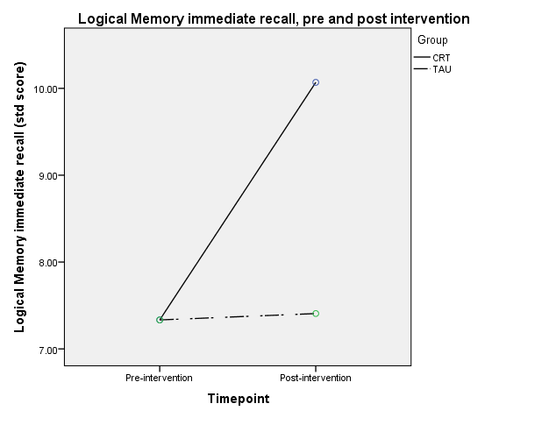
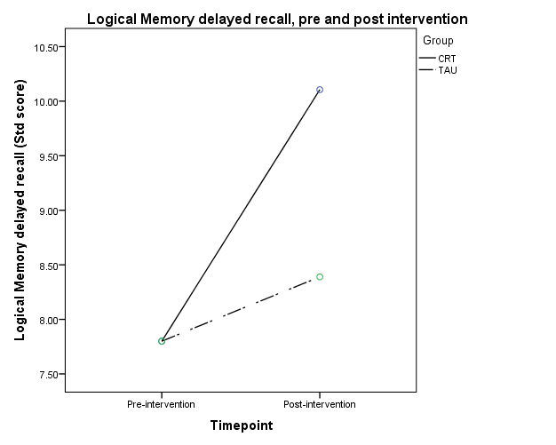
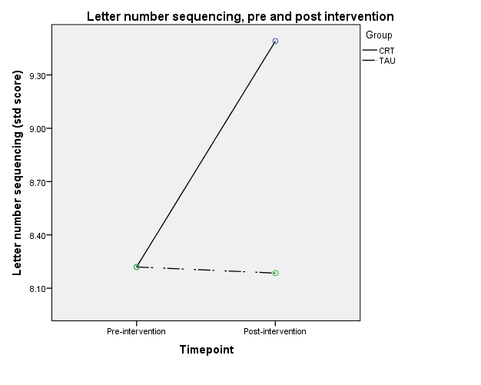
Figure 1: Performance on the Logical Memory immediate and delayed task, and Letter number sequencing task for CRT and TAU groups.

