UNIVERSITY OF GALWAY PERMIT APPLICATIONS 2022-2023

Introduction.
The new Permit Parking system has been in operation since 1 Sept 2020. This replaced the old system which was shut down officially on 31 August 2020.

All customers who already registered in previous years (2020 and 2021) may log into their accounts and purchase their permits for 2022-2023.

UNIVERSITY STAFF AND STUDENTS
Please note that ALL NEW Staff and Students must register an account using the “LOGIN WITH EDUGATE” option on first use of the system. Current Staff and Student users must continue to use the “LOGIN WITH EDUGATE” option. This access route uses Staff or Student number and the password allocated with your university account. You may not change or reset this password on the permit system.

NON University Staff, Visitors and Contractors
ALL NEW Non University Staff, Visitors and Contractors should use the “Create Account” option when first registering. Subsequent account access is via the blue “Log In” option shown below.
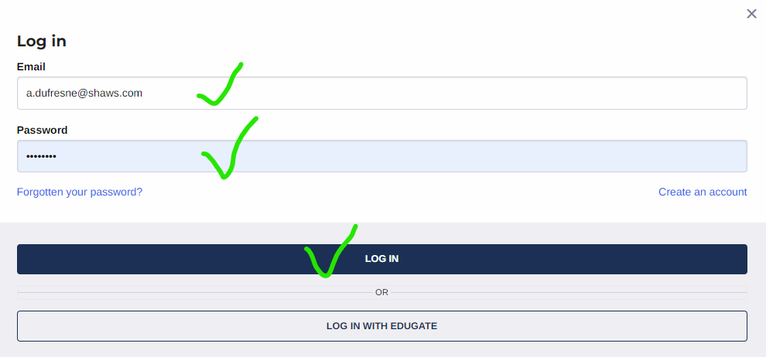

Using Google Chrome or Firefox go to:
https://nuig.apcoa.ie/applicant

If you are a registered University Staff member or Student:
Staff and Students MUST use their Edugate (college id) username and password to set up an account for permits (and for all subsequent logins to the account).
Do NOT use “Create My Account” as this option is for Non University Staff, Visitors, Contactors.
The same applies to the “Reset My Password” facility. This will NOT work for Staff and Students.
Use “Login –Login with Edugate” to set up your account. Use your 8 Digit University Id and password for logging in via this method. This secure link ensures that your university status is verified, allowing you to purchase pre-approved permits. The Parking Permit system does not retain or have access to your University ID or login information. This is processed through a secure gateway.
Select “Log In” from top right of screen.
Choose “Log In with Edugate”.
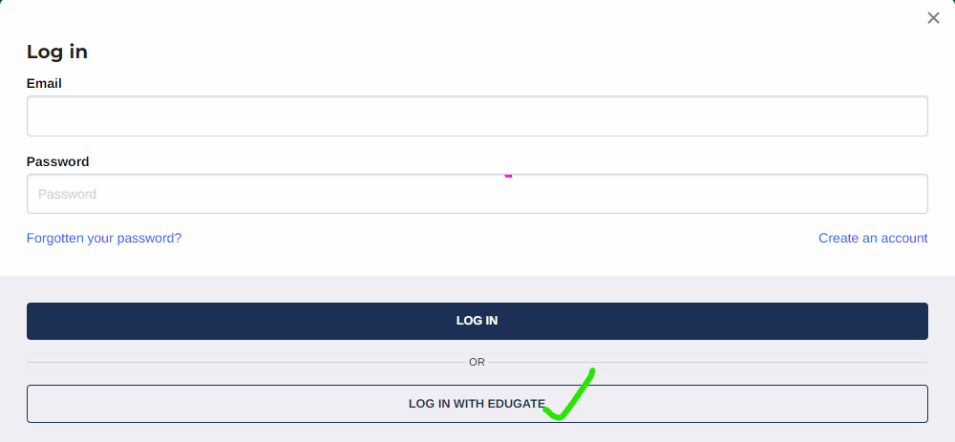

This will allow you to apply for a pre-approved Staff or Student Permit by verifying your University credentials.

Once you have successfully verified your status, continue to the Account Details screen to complete your account details.
If you are a Visitor, a Contractor or Non University Staff Member

Visitors, Contractors and non UNIVERSITY Staff should register using the “Create New Account” option.
On first use, select “Create Account” from top right of screen. Use “Login” option if already registered.
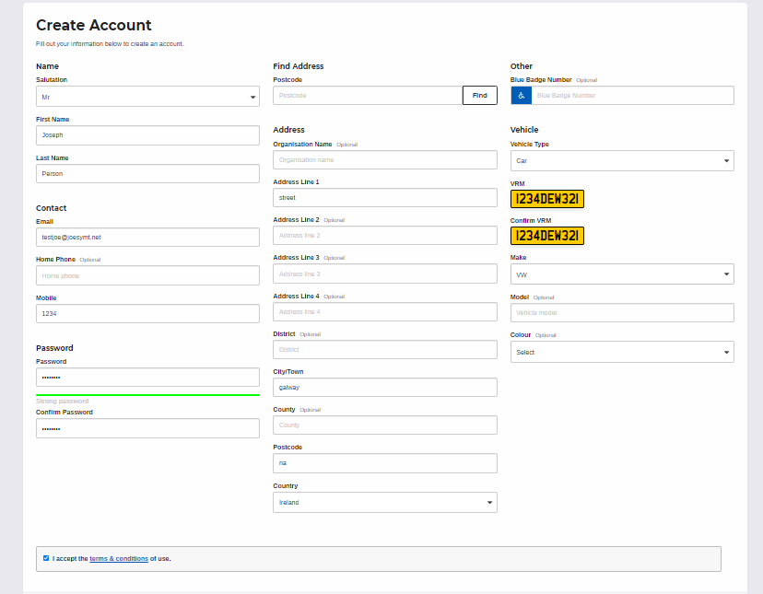

ALL Applicants: Enter your details including car registration.

It is important for the purpose of registering your permit that correct information is entered for email address and vehicle registrations.

All other fields are optional and may be completed with “na” or “123” if preferred.
For Non University Staff, Contractors and Visitors sufficient information must be entered to assist in establishing validity of permit application. You will be prompted to provide this additional information when you apply for these permits. Failure to provide detailed information supporting your permit application may result in the application being rejected.

All Applicants: Complete registration.
On successful registration you will be directed to the Home page.
Please note that you MUST have entered Vehicle details in order to purchase a permit.

All Applicants: Buy permit.

There are a number of permit options available. Select “Apply For Permits”.

PLEASE NOTE: The Salary Deduction option is available until 30 September 2022 only and to avail of this option you must select permit type:

Staff Permit Salary Deduction 2022-2023
OR
Ceadunas Foirne Asbhaint Pha 2022-2023

Choose the “Select” button for the permit you wish to apply for.

- Staff and Student permits may only be purchased by verified account holders (via Edugate).
- The Staff Permit Salary Deduction option is available on this system until 30 September each year. To avail of it you must select the appropriately named permit and also be sure to enter your staff number correctly when prompted. No payment is required for this permit on the system, the monies will be deducted from your Salary due course.
- Visitor and Contractor permits may be applied for by non verified account holders. Start Date (From Date) must be specified. These will need to be authorised by the Parking Office before payment is made. The Permit is not valid for use until it has been approved and paid for.
- For all permit applications Vehicle Registration must be selected.
- Additional Vehicles can be added to the account using the menu on top right of screen “Vehicle”.
- Protected Vehicles can be changed by accessing the “Bookings” option on the same menu.
- Once payment has been made for a permit the permit is live and the vehicle registration chosen is protected on the system.

To Add Additional Vehicle Regs to Your Account
- Login to Account
- Select “Vehicles” from menu on top right.
- Add or delete regs to your account.
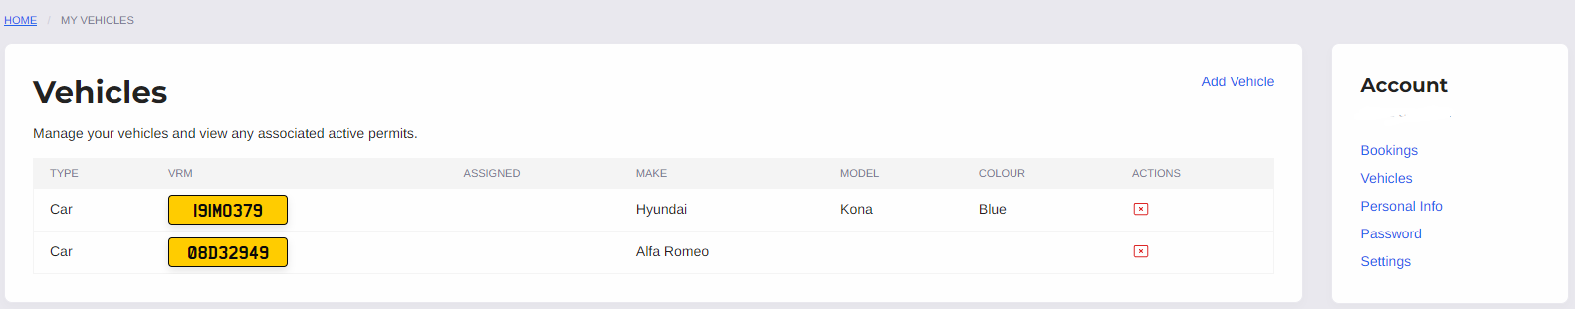

To Change Protected Reg on your account
- Login to account.
- Ensure that the vehicle reg you wish to protect is registered to your account. If not, use the “Vehicles” tab to add it.
- Select “Bookings” from menu on top right to view your permit.
- Use Actions bar to change protected vehicle on the permit.

