Inclusive Learning in Higher Education

Photo by Nicolas COMTE on Unsplash

Virtual Symposium Programme

April 7th and 8th 2021

Contents
(Click on any item to navigate directly to it)

Welcome! 1
Key information 2
Meet the Symposium organisers 3
Programme schedule – Day One - Wednesday 7th of April 4
Programme schedule – Day Two - Thursday 8th of April 5

Contributors and abstracts - Wednesday 7th of April

Dr Shivaun Quinlivan and Dr Lucy-Ann Buckley:
Inclusive Learning at NUI Galway - Key findings on student experiences of inclusion and exclusion (11:10 – 11:30) 6
Henriette Stoeber:
Diversity and inclusion in the European Higher Education Area (11:30 – 12:00) 8
Hamsavani Rajeswaren (with student panel):
Centring the student voice (12:15 – 13:30) 9
Dr Ebun Joseph and Anne Marie Stokes:
Racism and anti-racism in Irish higher education (14:30 – 15:45) 10
Dr Jesse Stommel:
Designing for care - inclusive pedagogies for online learning (16:00 – 17:30) 12

Contributors and abstracts – Thursday 8th of April

Dean’s Award-winners:
Inclusive Practice at NUI Galway - Dean’s Awards for Inclusive Teaching (11:15 – 11:45) 13
Professor Julie Rattray:
Inclusive pedagogies and practices: professional and personal reflections (12:00 – 12:45) 16
Tracy Galvin:
How the accessibility regulations complement Universal Design for Learning (UDL): Lessons learned from Northern Ireland (13:30 – 14:30) 17
Enhancing Digital Teaching and Learning project team:
The future of inclusive digital teaching and learning (14:30 – 15:45) 18
Dr Jesse Stommel:
Ungrading and radical assessment (16:00 – 17:00) 21

Welcome!

NUI Galway’s Inclusive Learning at NUI Galway project team, in partnership with the Centre for Excellence in Learning and Teaching (CELT), are delighted to welcome you to our virtual Symposium on Inclusive Learning in Higher Education on April 7th and 8th 2021.

We’re excited to host a fantastic line-up of speakers and panellists to explore issues of diversity and inclusion in higher education – locally, nationally and internationally. While we have two full days of online presentations and panel discussions, we hope the event will also provide some opportunities for connecting with each other and sharing practices and perspectives. Breakout rooms will be open for those who would like to connect with other delegates over lunch or coffee breaks.

We hope you will find plenty to inspire you over the next two days, and that this event will spark more conversations about inclusion in our higher education institutions.

The organisers would like to thank the following for their support and participation:

- The National Forum for the Enhancement of Teaching and Learning in Higher Education, who funded this event as part of the 2019/20 Inclusive Learning at NUI Galway project.

- The wider Inclusive Learning at NUI Galway project team, including Dr Miriam Byrne (School of Physics), Dr Niall Madden (School of Mathematics, Statistics and Applied Mathematics) and Dr Daniel Savery (Access Centre). The team would also like to acknowledge the contribution of Dr Sharon Flynn who was involved in this team from its establishment in 2018.

- NUI Galway’s President, Professor Ciarán Ó hÓgartaigh; Deputy President and Registrar, Professor Pól Ó Dochartaigh; Vice-President for Equality and Diversity, Professor Anne Scott; Dean of the College of Business, Public Policy and Law, Professor Geraint Howells; and the former Dean of that College, Professor John McHale, whose support of the Inclusive Learning projects at NUI Galway has been invaluable.

- Dr Chaosheng Zhang (School of Geography, Archaeology and Irish Studies), who has kindly given permission for his beautiful photographs of Galway City and county to be shared throughout this event.

- Our team of captioners from AI Media

Key information

The event will take place on Zoom, which allows for live interaction between presenters and participants. The link to sign in (sent to you via Eventbrite) will enable you to dip in and out of the various sessions on each day. You will be asked to sign in with your full name and email address. Do ensure that you join any sessions of interest in good time. Please do not share the sign-in or join links with others.

The programme schedule is set out on pages 4 and 5 below. More information about our contributors, and abstracts for each session, are provided on pages 6 – 21 below.

All sessions will be recorded and shared, and your participation will be taken as consent to your spoken and written contributions being recorded and shared.

Participants are welcome to use the virtual coffee/lunchroom to connect during breaks between sessions.

Feel free to tweet about the symposium using the hashtag #InclusiveNUIGalway, tagging our organisers and contributors – all Twitter handles are given below.

Respect is a core value at NUI Galway and everyone participating in this event is expected to communicate in a respectful manner. The organisers reserve the right to mute and/or to exclude participants who exhibit or support exclusionary or disrespectful behaviours such as:

- Discriminatory, hateful or insulting speech or text regarding the race, ethnicity, gender, gender identity, sexual orientation, family or civil status, disability, age, religion, nationality, physical appearance or socioeconomic background of contributors, participants, or others
- Threats, intimidation or harassment of any kind, including sexual harassment
- Sharing of hateful or offensive text, images, or links
- Use of offensive language or terms
- Encouraging, supporting or promoting such behaviours

Meet the Symposium organisers

NUI Galway’s Centre for Excellence in Teaching and Learning (CELT) and the Inclusive Learning at NUI Galway project have joined forces to bring you this event – this is the team.
Dr Iain Mac Labhrainn (He/Him) Dr Lucy-Ann Buckley (She/Her) Dr Shivaun Quinlivan (She/Her)
Director of CELT Vice-Dean for Teaching and Vice-Dean for Equality, Diversity
Learning, College of Business, & Inclusion, College of Business,
Public Policy & Law Public Policy & Law
@iainmacl @LucyAnnBuckley @She_Persisted4
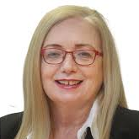
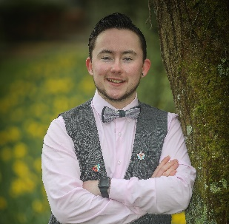

Kate Molloy (She/Her) Imelda Byrne (She/Her) Cameron Keighron (They/Them)
Learning Technologist, CELT Head of Access Centre PhD candidate, Medicine
@hey_km @ImeldaByrne2019 @CameronKeighron
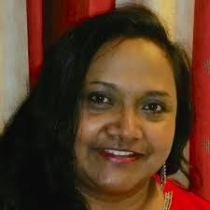
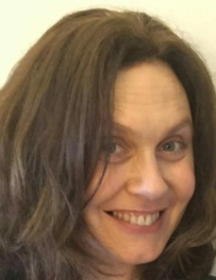

Dr Dinali Wijeratne (She/Her) Jane Ennis (She/Her) Anna Ní Fhlatharta (She/her)
Postdoctoral researcher, Inclusive Learning project Marketing & Engagement Inclusive Learning projects manager, Access Centre Officer, Access Centre
@DinaliWijeratne @ennisimo @AnnaNiF

Programme – Day One Wednesday 7th of April

Chair: Imelda Byrne, Head of NUI Galway Access Centre
Time (GMT+1) | Session and speaker(s)
10.45 am | Zoom sign in opens  Kate Molloy, Centre for Excellence in Learning and Teaching (CELT), NUI Galway
11.00 am | Symposium launch  Imelda Byrne, Access Centre, NUI Galway
11.05 am | Welcome and introduction  Professor Ciarán Ó hÓgartaigh, President, NUI Galway
11.10 am  Presentation | Inclusive Learning at NUI Galway – key findings on student  experiences of inclusion and exclusion  Dr Shivaun Quinlivan and Dr Lucy-Ann Buckley, co-leads, Inclusive Learning at NUI Galway projects
11.30 am  Presentation, formal response | Diversity and inclusion in the European Higher Education Area  Henriette Stoeber, Policy Analyst, European Universities Association  Response by Professor Pól Ó Dochartaigh, Deputy President and  Registrar, NUI Galway, current chair of the Irish Universities  Association Registrars’ Group  Session chair: Dr Lucy-Ann Buckley, Vice-Dean for Teaching and Learning, College of Business, Public Policy and Law, NUI Galway
12.00 pm | Break (virtual coffee room available)
12.15 pm  Panel session | Centering the student voice  Hamsavani Rajeswaren, student activist, with student panel
1.30 pm | Lunch break (virtual lunchroom available)
2.30 pm  Presentations | Racism and anti-racism in Irish higher education  Dr Ebun Joseph, University College Dublin  Anne Marie Stokes, Galway Traveller Movement  Session chair: Dr Shivaun Quinlivan, Vice-Dean for Equality and Diversity, College of Business, Public Policy and Law, NUI Galway
3.45 pm | Break (virtual coffee room available)
4.00 pm  Workshop | Designing for care: inclusive pedagogies for online learning  Dr Jesse Stommel, University of Mary Washington
5.30 pm | Closing remarks  Dr Shivaun Quinlivan, College of Business, Public Policy, and Law, with Imelda Byrne, Access Centre, NUI Galway

Programme – Day Two Thursday 8th of April

Chair: Cameron Keighron, NUI Galway PhD candidate, student activist and advocate
Time (GMT+1) | Session and speaker(s)
10.45 am | Zoom sign in opens  Kate Molloy, Centre for Excellence in Learning and Teaching (CELT), NUI Galway
11.00 am | Welcome and introduction: Equality and Diversity at NUI Galway  Professor Anne Scott, Vice-President for Equality and Diversity, NUI Galway
11.15 am  Inclusive practice  showcase | Inclusive practice at NUI Galway – Dean’s Award for Inclusive Teaching  Dean’s Award winners 2019 and 2020  Session chair: Professor Geraint Howells, Executive Dean of the College of Business, Public Policy and Law, NUI Galway
11.45 am | Break (virtual coffee room available)
12.00 pm  Keynote presentation | Inclusive pedagogies and practices: professional and personal reflections  Professor Julie Rattray, Durham University  Session chair: Dr Lucy-Ann Buckley, Vice-Dean for Teaching and Learning, College of Business, Public Policy and Law, NUI Galway
12.45 pm | Lunch break (virtual lunchroom available)
1.30 pm  Workshop | How the accessibility regulations complement Universal Design for Learning (UDL): Lessons learned from Northern Ireland  Tracy Galvin, Queen’s University Belfast
2.30 pm  Panel session with Enhancing Digital Teaching and Learning Project | The Future of inclusive digital teaching and learning  Dr Sharon Flynn, IUA Enhancing Digital Teaching and Learning Project Leader and project team members  Kate Molloy, NUI Galway  Dr Morag Munro, Nicole Carr, Eddie Corr, Katharina Kurz, Robyn Meyler, Julian Nagi and Michaela Waters, Maynooth University  Suzanne Stone, Dublin City University  Clíodhna O’Callaghan, University College Cork
3.45 pm | Break (virtual coffee room available)
4.00 pm  Keynote presentation | Ungrading and radical assessment  Dr Jesse Stommel, University of Mary Washington  Session chair: Dr Iain MacLabhrainn, CELT, NUI Galway
5.00 pm | Closing remarks  Dr Lucy-Ann Buckley, College of Business, Public Policy and Law, NUI Galway, with Cameron Keighron

Contributors and abstracts - Wednesday 7th of April

Dr Shivaun Quinlivan and Dr Lucy-Ann Buckley

Inclusive Learning at NUI Galway – Key findings on student experiences of inclusion and exclusion (11:10 – 11:30)
@LucyAnnBuckley
Dr Lucy-Ann Buckley (She/Her) is the Vice-Dean for Teaching and Learning in the College of Business, Public Policy and Law at NUI Galway, and a Senior Lecturer in Commercial Law. She specialises in equality law, particularly gender equality, disability and intersectional issues, and is a member of the Berkeley Center on Comparative Equality and Anti-Discrimination Law. From 2018-2020, Dr Buckley acted as an expert advisor to the States of Guernsey in relation to the development of new multi-ground equality legislation. Dr Buckley has published widely regarding equality issues in family and labour law, including: reasonable accommodation for persons with disabilities; the sexual harassment of women with disabilities; gender equality in Irish employment law; prenuptial agreements and family property. With Dr Shivaun Quinlivan, Dr Buckley co-leads two inclusive learning projects at NUI Galway: an undergraduate project funded by the NUI Galway Student Project Fund, and a postgraduate project funded by the National Forum for the Enhancement of Teaching and Learning in Higher Education.
@She_Persisted4
Dr Shivaun Quinlivan (She/Her) is the Vice-Dean for Equality, Diversity and Inclusion in the College of Business, Public Policy and Law at NUI Galway, and a Senior Lecturer in Law. Her research focuses primarily on the right to equality with a particular focus on the right to education for people with disabilities: see De Beco, G., Quinlivan, S., & Lord, J. (Eds.). (2019). The Right to Inclusive Education in International Human Rights Law (Cambridge Disability Law and Policy Series). Cambridge: Cambridge University Press. She is a member of the Berkeley Center on Comparative Equality and Anti-Discrimination Law and the Irish Women’s Lawyers Association. Dr Quinlivan acted as an expert advisor to the States of Guernsey in relation to the development of new multi-ground equality legislation from 2018-2020. In 2016-17 she was an O’Brien Residential fellow in the Centre for Human Rights and Legal Pluralism in McGill University in Canada. With Dr Lucy-Ann Buckley she co-leads two inclusive learning projects at NUI Galway.

Abstract

Research on teaching and learning has demonstrated the prevalence and impact of exclusionary practices, often (though not always) linked with unconscious bias, e.g. in relation to race, ethnicity, gender, LGBT+ status and disability. These exclusionary practices impact not only on the student experience, but on retention and completion rates. However, although extensive research into inclusion and exclusion in higher education exists at international level, there is a dearth of Irish data. To address this gap, this presentation draws on two Inclusive Learning projects, at undergraduate and postgraduate levels, to highlight student experiences of inclusion and exclusion at NUI Galway. The presentation explores particular themes arising from a range of student surveys, individual interviews and focus groups, conducted across five Schools in two different Colleges of the University. These schools provide an excellent snapshot of the student experience in NUI Galway because they represent students in Arts, Humanities, Social Sciences and Law (AHSSL), STEM and professional courses as well as students on a satellite campus. The research finds much evidence of good practice, but also strong themes of isolation, alienation and exclusion among particular groups, particularly international and intercultural students, students with disabilities, students with caring responsibilities and LGBT+ students.

Henriette Stoeber

Diversity and inclusion in the European Higher Education Area (11:30 – 12:00)

@euatweets

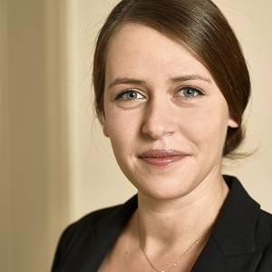
Henriette Stoeber (She/Her) is a Policy Analyst in the Higher Education Policy Unit of the European University Association (EUA). Prior to joining the EUA, she worked as a research assistant at the Hungarian Rectors’ Conference and spent several years at the German Academic Exchange Service’s (DAAD) National Agency for Higher Education Cooperation, initially as intern/research assistant and later as programme manager in the department supporting the Bologna Process implementation in Germany. Henriette has also worked in the private sector in the United Kingdom.

Henriette holds a Joint Master degree in European Public Policy with distinction from the University of York (United Kingdom) and Central European University (Hungary), where she specialised in the field of higher education policy.

Abstract

This session will provide an overview of European higher education institutions’ approaches to diversity, equity and inclusion, and outline key aspects of recent European policy developments on the theme.

Based on data collected through EUA’s INVITED project, it will discuss how higher education institutions in Europe aim to enhance diversity as part of their overarching mission, what challenges they face and how these might be overcome. The session will proceed to outline steps taken in the European Higher Education Area, with particular focus on the recently developed “Principles and Guidelines to strengthen the Social Dimension” and their potential impact on the higher education sector. In addition, the session will highlight how Erasmus+ aims to enhance inclusion in the new generation of the programme (2021-27).

This session will be chaired by Dr Lucy-Ann Buckley (She/Her), Vice-Dean for Teaching and Learning in the College of Business, Public Policy, and Law. Following Henriette’s presentation, NUI Galway’s Deputy President and Registrar, Professor Pól Ó Dochartaigh (He/Him), will offer a formal response. Professor Ó Dochartaigh is the current chair of the Irish Universities Association (IUA) Registrars’ Group.

Hamsavani Rajeswaren

Centring the student voice (12:15 – 13:30)

@Hamsavani_
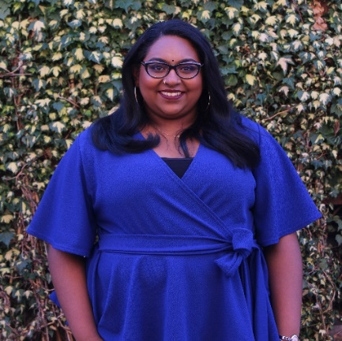
Hamsavani Rajeswaren (She/Her) is a passionate social justice activist and has spent her time as an international student in the student movement focusing on liberation campaigns. Previously, she served two terms as Vice-President for Equality and Diversity at Queen's Students’ Union. In her time at Queen's, she ran the first Black History Month campaign across Ireland and pioneered conversations on decolonisation and the BAME Attainment Gap at an institutional level.

An award-winning activist, Hamsavani's work focuses on platforming minority groups on a local and national level, leading on conversations of anti-racism, decolonisation, intersectionality, reproductive justice, and feminism. She is currently living and working in her home country, Singapore, but still is keenly connected to the Irish feminist movement and is currently a board member of Alliance for Choice.

Abstract

In working to create a more inclusive learning environment, often we wonder how learners are involved in their education. As we move towards more active forms of engaging learners and embedding equality and diversity in the classroom, what often slips the mind is actually centring student voice at the core of curriculums in itself. Inclusivity in learning cannot be achieved without focussing on calls for a free, liberated and accessible education - which should be reflected in curriculums. The student movement across the UK and Ireland has long stood together in calls for this - and in recent years we have found aspects of this in the forms of Student Partnership Frameworks on the part of institutions and students and staff driving decolonial work on curriculums and institutional structures.

In this session, Hamsavani will reflect on pedagogy, institutional structures, student and staff movements, and ultimately their effects on centring the student voice in creating an inclusive learning environment.

A student panel, in conversation with Hamsavani, will give an insight into their experience of inclusive learning in higher education. They will discuss barriers that they and others have faced, as well as insights into how to make our higher education environment more accessible, diverse and inclusive.

Dr Ebun Joseph and Anne Marie Stokes

Racism and anti-racism in Irish higher education (14:30 – 15:45)
@EbunJoseph1
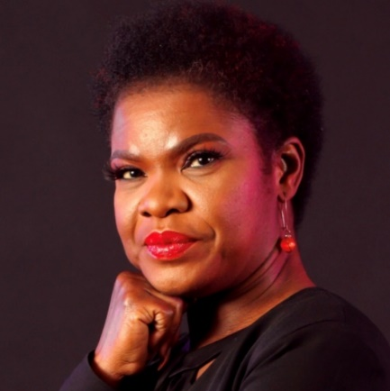
Dr Ebun Joseph (She/Her) is a Race relations consultant, Director of the Institute of Antiracism and Black Studies and Chairperson of the African Scholars Association Ireland (AFSAI). She is the Coordinator and Lecturer in UCD of the first Black Studies module in Ireland. She has worked as a Teaching Fellow at TCD, a Career Development Consultant at the Royal College of Surgeons in Ireland, and as a Training and Employment Officer with Business in the Community Ireland. She is an author, TV panellist, columnist, equality activist and convenor of various webinars on Anti-Racism.
With a research focus on Labour markets and race relations, Ebun is published and contributes regular responses on contemporary issues of racism in Ireland. Her recent book is titled Racial stratification in Ireland: A Critical race theory of labour market inequality with Manchester University press. She also co-authored the book, Challenging Perceptions of Africa in Schools: Critical Approaches to Global Justice Education.

Abstract

Higher Education Institutions (HEI) in modern states are both racialised and hierarchical in their organisation (Ahmed, 2012). This paper outlines lessons from a recent racial stratification study that compared the disparity in labour market outcomes for different groups of migrants in the Irish labour market. It offers insights for higher education on how racial discrimination works institutionally. The paper draws on a considerable body of studies which highlight the tensions experienced by those categorised as ‘other’ within HEI in terms of staffing, promotion, and student experience and participation. It cautions against the colour-blind approach to racial difference in HEI which silences people who present as visibly different while they are impacted by the racial order within the system. The pervasiveness of implicit bias, group favouritism, inferiorisation of difference, the harshness of the learning environment for those at the bottom of the racial ladder and the Eurocentric curricula are also discussed.

This paper argues that silence about racial injustice in the HEI makes them complicit in the proliferation of inequality by enabling the [re]production of the racial order which disempowers not only those othered but also the dominant population. Despite the increasing diversity of students in lecture rooms, this paper concludes that the HEI is still a white place of white privilege that invisibilises difference. It calls for deliberate actions that can move the HEI from pursuing a non-racist stance to an antiracist one.
Anne Marie Stokes (She/Her) is a project worker with Galway Traveller Movement (GTM), an organisation working to achieve equality and self-determination for the Traveller community in Galway city. Since its inception, GTM has mobilised Travellers and settled people to work collectively to challenge discrimination in all its forms. The organisation is committed to the principles of community work, such as active participation, collective action, lobbying and campaigning to bring about positive social change for Travellers.
Anne Marie left school at fifteen years old without any qualifications. She attended NUI Galway as a mature student, entering through an Access Course. Her experiences on the Access Course gave her the skills and confidence to progress to a degree course.
Higher education was challenging at times for Anne Marie: it was an environment in which she often felt out of place. With a lot of encouragement from her work colleagues and her lecturers and tutors, she graduated from NUI Galway with a Bachelor of Arts (Philosophy and Sociological and Political Studies) and a Master of Arts (Gender, Globalisation and Human Rights).

Abstract
Irish Travellers (also known as Pavees or Mincéirs) are an indigenous ethnic minority with a rich and distinct culture, and a centuries-old history of nomadism. Historically, Travellers have been subjected to marginalisation, discrimination and racism, with an official policy of assimilation in place until the 1990s. Travellers were finally officially recognised as a distinct ethnic group in Ireland in 2017. However, Irish Travellers continue to experience poor health, mortality and education outcomes, relative to the general population.
Less than 1% of Travellers hold a third-level qualification in Ireland, compared to about 30% of the general population. This session will explore some of the root causes of low rates of Traveller participation in Irish higher education, and will consider ways to ensure that Traveller students in higher education feel a sense of belonging, and confidence that their cultural identity is valued and celebrated.
Education is a wonderful gift; it can change an individual’s perspective of the world. I would like to pass that gift on to my community. My vision is to encourage Traveller students to progress to third-level education, and to encourage school leavers that there are pathways to return to education. The great Nelson Mandela once said that “Education is the most powerful weapon which you can use to change the world”. I believe that education is a vital tool in my community’s fight against racism and discrimination.
This session will be chaired by Dr Shivaun Quinlivan (She/Her), Vice-Dean for Equality, Diversity and Inclusion, College of Business, Public Policy and Law.

Dr Jesse Stommel

Designing for care - inclusive pedagogies for online learning (16:00 – 17:30)

@jessifer

Jesse Stommel (He/Him) is co-founder of Digital Pedagogy Lab and Hybrid Pedagogy: the journal of critical digital pedagogy. He has a PhD from University of Colorado Boulder. He is co-author of An Urgency of Teachers: the Work of Critical Digital Pedagogy.
Jesse is a documentary filmmaker and teaches courses about pedagogy, film, and new media. Jesse experiments relentlessly with learning interfaces, both digital and analogue, and his research focuses on higher education pedagogy, critical digital pedagogy, and assessment. He’s got a rascal pup, Emily, a clever cat, Loki, and a badass daughter, Hazel. He’s online at jessestommel.com.

Abstract

Educational institutions are spaces for learning, but more specifically, they are spaces for social learning. There is no one-size-fits-all set of best practices for building a learning community, whether on-ground or online. Right now, we should begin our efforts toward building community by designing for the students who need that community most, the ones most likely to have been feeling isolated even before the pandemic: disabled students, chronically ill students, students of colour, queer students, and students facing housing and food-insecurity. This session will present some practical tips but focus primarily on engaging participants in conversation — about the challenges and opportunities online spaces present, especially in our present moment.

Contributors and abstracts – Thursday 8th of April

Inclusive Practice at NUI Galway - Dean’s Awards for Inclusive Teaching (11:15 – 11:45)

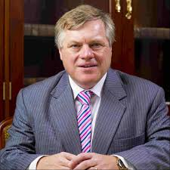
The chair for this session is Professor Geraint Howells (He/Him), Executive Dean of the College of Business, Public Policy and Law, NUI Galway. Professor Howells is former Professor of Commercial Law and Associate Dean in Humanities for Internationalisation at Manchester University. He has served as Dean of Law at the City University of Hong Kong and Head of the Law School in Manchester, and, previously, in Lancaster.

Abstract

This session will showcase the work of NUI Galway staff who were awarded the College of Business, Public Policy and Law’s Dean’s Awards for Inclusive Teaching in 2019 and 2020. Chaired by the Dean of the College, Professor Geraint Howells, individual and team Award-winners will discuss how they implement inclusive practice in their teaching, how this impacts on student learning and the student experience, and what winning the award meant to them on a personal or team level. The session will highlight the importance of identifying, recognising and rewarding inclusive teaching practice in higher education and will offer some practical ideas for implementing similar award schemes in other Colleges or Higher Education Institutions.

2019 Award-winners

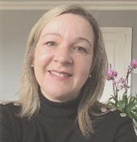
Danielle Martin (She/Her) is a Lecturer in German and IT for Business/Hospitality at Shannon College of Hotel Management, NUI Galway. Danielle won the Dean’s Award for Inclusive Teaching (individual award) in 2019.

@daniellemartin

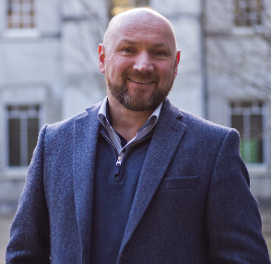
Dr Denis Dennehy (He/Him) is a Lecturer in Business Information Systems and Programme Director, M. Sc. Business Analytics, NUI Galway. Denis was part of the team that won the Dean’s Award for Inclusive Teaching (team award) in 2019.

@DennehyD

2020 Award-winners

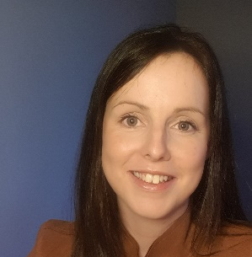
Dr Patricia McHugh (She/Her) is a Lecturer in Marketing at NUI Galway. Patricia won the Dean’s Award for Inclusive Teaching (individual award) in 2020.

@PatriciaMcHugh

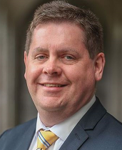
Dr Sean T. Ruane (He/Him) is Head of Food and Beverage and a Lecturer in Management, Strategy and Tourism at Shannon College of Hotel Management, a College of NUI Galway. Sean was part of the team that won the Dean’s Award for Inclusive Teaching (team award) in 2020.
@s_ruane
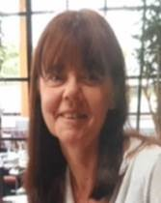
Eithne Costelloe (She/Her) is a Culinary Lecturer at Shannon College of Hotel Management, and part of the team that won the Dean’s Award for Inclusive Teaching (team award) in 2020.

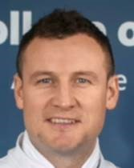
Keith Carden (He/Him) is a Culinary Lecturer at Shannon College of Hotel Management, and part of the team that won the Dean’s Award for Inclusive Teaching (team award) in 2020.
@keithcarden

Professor Julie Rattray

Inclusive pedagogies and practices: professional and personal reflections (12:00 – 12:45)

@joolsled

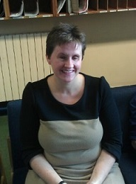
Julie Rattray (She/Her) is Professor of Higher Education and Director of Education in the School of Education at Durham University. Her research interests include the affective dimensions of learning with a particular focus on liminality and threshold concepts. Julie teaches on a range of undergraduate and postgraduate modules that take a psychological approach to teaching and learning or which focus on aspects of Higher Education. In addition, she contributes to the postgraduate Certificate in Academic Practice where she contributes sessions on Inclusive Practice and conceptual frameworks of teaching and learning. Julie is a Senior fellow of the Higher Education Academy and supports colleagues with fellowship and senior fellowship applications.

Abstract
Discussions of the concept of ‘inclusive ‘pedagogy’ have become increasingly pervasive and salient in recent years with the massification and diversification of higher education. There is increased acceptance that our pedagogies and practices need to change to become more inclusive and to support a wider variety of learners than ever before. Despite this realisation, discussions of inclusive pedagogy can provoke a range of emotions and responses in academic tutors, teachers and institutions. Such responses can range from a wholehearted embracing of what ‘inclusive pedagogy’ is to a reluctance to engage with something that is perceived of as adding yet more work to the already overburdened academic. This latter position, in my experience, frequently comes from a place of uncertainty about what is required and confusion about the kinds of difference such an approach can make to the learning experience. It is also greatly influenced by the institutional ethos and culture that operates as either an enabler or a barrier to the adoption of inclusive practices.
I hope to explore some of these issues and to reflect on how individuals can be empowered to utilise inclusive pedagogies that will enrich the learning experience for all. By asking a series of critical questions I will draw on my personal experiences as a university teacher, a Director of education and a disabled person to consider how at both an institutional and individual level we can start to implement change. I will draw on concrete examples of practice and evidence from the research literature to frame the discussion which I hope will have both practical and conceptual relevance.
This session will be chaired by Dr Lucy-Ann Buckley (She/Her), Vice-Dean for Teaching and Learning, College of Business, Public Policy and Law.

Tracy Galvin

How the accessibility regulations complement Universal Design for Learning (UDL): Lessons learned from Northern Ireland (13:30 – 14:30)

@tracygalvin77
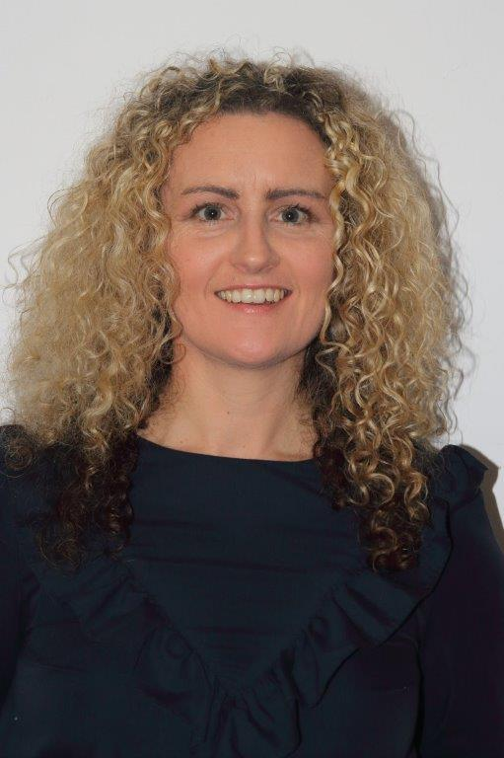
Tracy Galvin (She/Her) is an Education Developer at the Centre for Educational Development at Queen's University, Belfast (QUB). She is a Senior Fellow with Advance HE and currently completing her PhD and SEDA Senior fellowship. Her key area of expertise is initial teacher education, academic practice and professional development of teaching, learning and assessment among academics through equality, diversity, inclusive and accessible practices.
Tracy leads an institutional project on Equality, Diversity, and Inclusion in the Curriculum across faculties and works closely with academic EDI leads and the Student Union working on several inclusive projects. Internal to QUB she is Chair of two working groups: Universal Design for Learning and Internationalising the Curriculum that feeds directly into Supporting Student Attainment Action Group (SSAAG) and is a member of the Disability Forum. External to QUB she is part of two international UDL groups International Collaboratory for Universally Designed Education (INCLUDE) and Birds of a Feather UDL SIG. She is also a member of the UK JISC Community Leadership team on accessibility.

Abstract

The UK Digital Accessibility regulations came into force in September 2020 where Higher Education Institutions (HEIs) became subject to scrutiny around digital inclusion for websites, virtual learning environments (VLEs), mobile apps, and digital learning materials. At the same time, Ireland transposed the EU Web Accessibility directive into Irish law. From the outset of the pandemic, there was a lot of support, guidance, and resources developed for educators on compliance of digitally accessible learning materials, that closely align with multiple means of representation in the UDL framework. This interactive workshop outlines the fundamentals of digital accessibility and how it maps onto the UDL framework in terms of learner variability, expert learners, learning barriers, flexibility and choice in teaching, learning, and assessment. Several resources and guidance are provided, along with reflective questions, and an accessibility action plan that can be adapted to various roles as a key takeaway.

Enhancing Digital Teaching and Learning project team

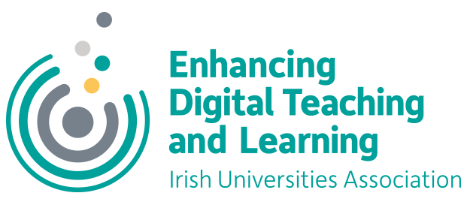
The future of inclusive digital teaching and learning (14:30 – 15:45)
@sharonlflynn

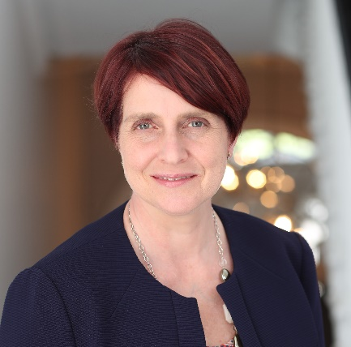
Dr Sharon Flynn (She/Her) is Project Manager for Enhancing Digital Capacity in Teaching and Learning in Irish Universities, an initiative of the Irish Universities Association (IUA). Sharon works closely with senior academic leaders across the university sector to develop, pilot, review and roll out an ambitious staff development programme to enhance the digital confidence, skills and competences of those who teach in Irish universities.

Abstract

The Enhancing Digital Teaching and Learning in Irish Universities Project is a three-year project, funded through the Higher Education Authority’s Innovation and Transformation Programme. It is aimed at enhancing the digital attributes and educational experiences of Irish university students through enabling the mainstreamed and integrated use of digital technologies across the teaching and learning process.

In the context of Covid-19, the project has re-focused to support a move to a more blended approach to teaching and learning in the academic year 2020/21, while adhering to the four project pillars. The EDTL Approach describes a pathway with considerations for those who are adapting a module or programme for effective remote teaching.

In this panel session, members of the wider project team will showcase inclusive practices from across the institutions and examine the future of inclusive digital teaching and learning based on what’s been learned throughout this time. The discussion will be underpinned by core project values such as our pedagogy-first approach, and student partnership.

@hey_km
Kate Molloy (She/Her) is a Learning Technologist with the Centre for Excellence in Learning and Teaching at the National University of Ireland, Galway. She is currently working as NUI Galway Project Lead on the IUA Enhancing Digital Teaching and Learning (EDTL) project. As a teacher, she became interested in critical pedagogy, inclusivity, and the use of technology. In 2015, she moved into higher education where she supports staff teaching with technology. Her work focuses on the informed and ethical use of technology in higher education, learning design, and open practice. Kate is Secretary, National Executive of the Computers in Education Society of Ireland, and an active participant in the Virtually Connecting community.
@MunroMo

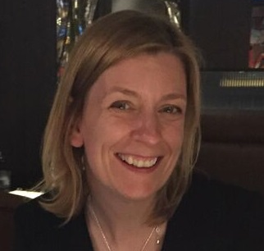
Dr Morag Munro (She/Her) is the Maynooth University Institutional Lead for the IUA Enhancing Digital Teaching and Learning (EDTL) project and lecturer on Maynooth’s postgraduate diploma programme in HE Teaching, Learning and Assessment. Previous to her current role, Morag was Educational Technology Officer in the Centre for Teaching and Learning at Maynooth, where she provided support and guidance to staff in relation to digital technologies, learning, teaching and assessment, and co-ordinated and contributed to various learning and teaching development projects.

Prior to joining Maynooth, Morag worked at Dublin City University in roles as Head of the Learning Innovation Unit and Learning Technologist, and at the University of Strathclyde as a Learning Technologist. She also spent time working in instructional design and project management in the commercial e‐learning sector. Morag holds a BEng in Chemical Engineering and an MSc in Energy Systems and Environment from the University of Strathclyde. Her Doctoral studies were completed at the University of Glasgow, and focused around a critical discourse analysis of neoliberal constructions of learning technologies in Higher Education.

Morag’s research interests include developing critical perspectives on educational technologies; design of inclusive curriculum and learning environments; critical discourse analysis of education policy; and promoting education for inclusivity, global citizenship and sustainability. Morag will be joined by Maynooth University students Nicole Carr, Eddie Corr, Katharina Kurz, Robyn Meyler, Julian Nagi and Michaela Waters.
@suzielearning

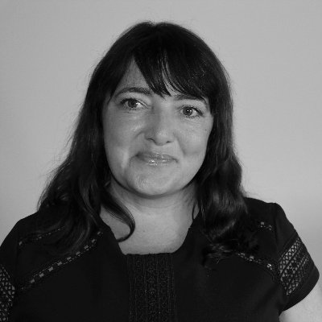
Suzanne Stone (She/Her) has worked in the education sector for over 15 years. Suzanne is currently working in the role of Learning Technologist at Dublin City University. Suzanne's active engagement in research relating to the application of educational technologies in teaching and learning informs her practice as a learning technologist. Professional interests include: Universal Design for Learning; Open Educational Practice and Open Educational Resources; student engagement in online synchronous (live) online teaching and learning; assessment and feedback; digital skills and competencies for staff; video for teaching and learning and social media in education. Suzanne is currently designing a study on Digital Well-being of staff in Higher Education as part of the Doctorate in Education programme at DCU.

@cliodhnacal

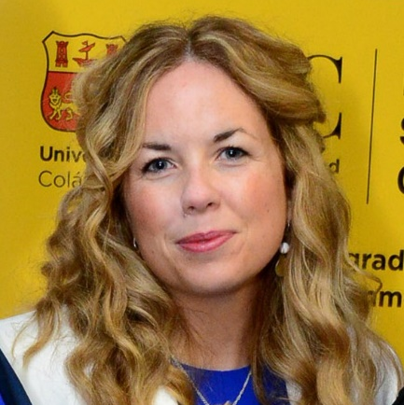
Clíodhna O'Callaghan (She/Her) is the Project Lead for the IUA Enhancing Digital Teaching and Learning (EDTL) project in UCC. Clíodhna is a higher education professional and absolutely student and person centred. Clíodhna's background is in higher education management and in lecturing in law and education (live and online). Clíodhna is a qualified Attorney-at-Law in the State of New York, USA. Clíodhna's research interests lie in the areas of higher education policy and supports, in the context of widening participation/social justice/informal criminal justice and in digital education and training. Clíodhna recently launched a digital education training programme for UCC staff called Teach Digi as part of the IUA EDTL project within the Centre for Digital Education.

Dr Jesse Stommel

Ungrading and radical assessment (16:00 – 17:00)

@jessifer

Dr Jesse Stommel (He/Him) will join us again on Day Two for the final keynote of the symposium. Can we imagine assessment mechanisms that encourage discovery, ones not designed for assessing learning but designed for learning through assessment? Much of our work in education resists being formulated as neat and tidy outcomes, and yet most assessment takes the complexity of human interaction within a learning environment and makes it “machine readable.”

When learning is the goal, space should be left for wonder and experimentation. This talk will look at the history and present of grades, examine the bias inherent in many of our standardized systems, and explore methods and approaches for designing assignments and assessments that push back against traditional notions of grading.

This session will be chaired by Dr Iain Mac Labhrainn (He/Him), Director of the NUI Galway Centre for Excellence in Learning and Teaching (CELT). Dr Mac Labhrainn is a former Lecturer/ Reader in Physics at the Universities of Durham, Edinburgh and the West of Scotland (Paisley). He teaches on professional postgraduate programmes in Academic Practice. His teaching and research interests include physics, computing, creativity in higher education, higher education policy and practice, and the strategic deployment of learning technologies.
@iainmacl

