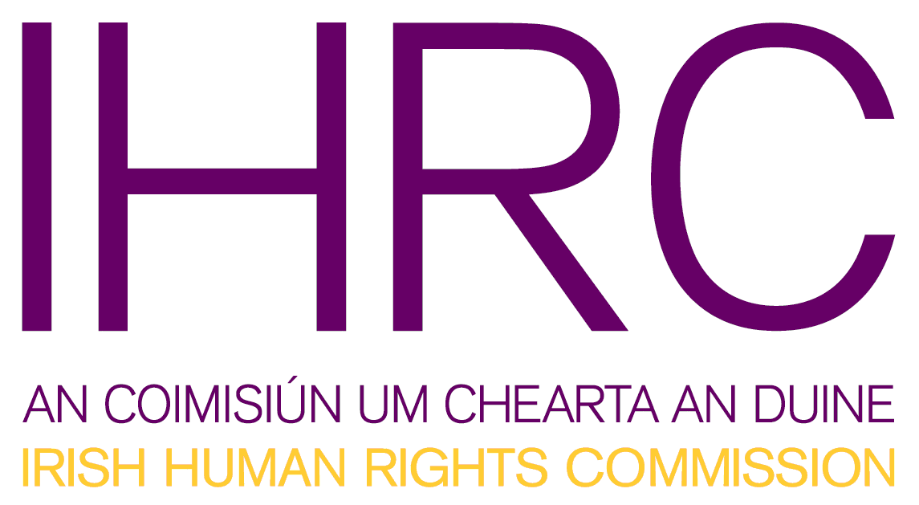
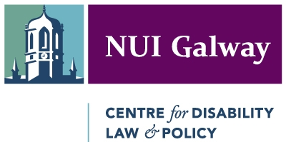
Meeting Report
of
Joint Seminar on the Development of a National Framework for Monitoring the UN Convention on the Rights of Persons with Disabilities in Ireland.

Background.
The Irish Human Rights Commission (IHRC) and the Centre for Disability Law and Policy at the National University Ireland, Galway, held a joint seminar on 27 April 2012. It was hosted by the Irish Human Rights Commission in Dublin.
The aim of the seminar was to create a reflective space to explore the possible ways to develop a national ‘framework’ in Ireland for monitoring the UN Convention on the Rights of Persons with Disabilities (CRPD) after Ireland ratifies this international human rights treaty.
The issue is timely as Ireland will be obliged to formally ‘designate’ a framework containing one or more independent elements to ‘promote, protect and monitor’ the convention once it has been ratified. Ratification by Ireland is expected later in 2012. It is important that the independent element/s meet the Paris Principles with respect to National Human Rights Institutions.
The seminar was also timely given the impending merger of the Irish Human Rights Commission with the Equality Authority. Ireland is fortunate in having a wealth of other subject-specific bodies like the National Disability Authority which has an extremely valuable role to play.
The event was co-chaired by Dr. Maurice Manning, President of the Irish Human Rights Commission and Professor Gerard Quinn, Director of the Centre for Disability Law & Policy at NUI Galway. Many Government agencies, service delivery organizations and their representative groups as well as civil society groups were in attendance.

Presentations.
Two external experts were invited to make presentations during the seminar: Duncan Wilson, Head of Strategy and Legal at the Scottish Human Rights Commission and Dr. Gauthier de Beco, then Head of the CRPD Unit at the Belgian Centre for Equal Opportunities and Opposition to Racism.
Duncan Wilson described the structure and the position of the Scottish Human Rights Commission (SHRC). The SHRC is the officially ‘designated’ Article 33.2 independent mechanism in Scotland. Scotland is similar to Ireland in many respects. It has opted to ‘designate’ a single independent mechanism (the Scottish Human Rights Commission) performing all roles under Article 33.2 instead of creating a new ‘framework’ as such.
The SHRC is a fully independent body, which among other activities organizes promotion events, intervenes as third party in human rights cases, has the power to conduct enquiries, develops indicators, or scrutinizes UK State Reports and prepares shadow report to the UN CRPD Committee. Mr Wilson explained the reasoning of the UK authorities in designating the Commission and outlined its current and future activities. He also explained in detail how the Commission actively involves and includes many others including particularly Scottish civil society groups.
Dr. Gauthier de Beco outlined the main findings of a comparative Study he completed for the UN Office of the High Commissioner for Human Rights in 2011 on how European States are establishing mechanisms under Article 33.2 (Europe Region). He gave an overview on evolving European models and explained current European trends in designating the relevant monitoring mechanism. According to his research, countries that already have a National Human Rights Institution (NHRI) or Equality Body generally tend to ‘designate’ those bodies as the independent elements of the framework (e.g. UK, Germany). If a country does not have an NHRI it generally tends to designate an Ombudsman (e.g. Spain) or some similar public body. Other purpose-made bodies can also be established or designated to perform the independent monitoring activities (e.g., Austria where a wholly new body was set-up for this purpose). He explained the process by which such bodies acquire the much coveted A-Status under the accreditation procedures of the International Coordination Committee of NHRIs. He also emphasized that it is important that the appointed framework may need more resources to perform these tasks adequately. For example, the Belgian and Danish ‘framework’ received a new grant from Government after their ‘designation’ to enable them perform their tasks under Article 33.
Roundtable Discussions.
After the presentations, a Roundtable discussion was chaired by Martin Naughton who directs Aiseanna Taciochta and is co-chair of the European Network on Independent Living. As the language of the Convention is open-ended, there is a strong need to think about and discuss the choices the ahead the Government when it is going to designate the CRPD Monitoring framework in Ireland.
The discussion was wide-ranging and centered around the following issues/questions:
- All felt that all relevant public bodies involved in disability in Ireland must somehow be involved in the ‘framework’ under Article 33. Ireland should harness all available resources. The wealth of knowledge (e.g., data) in our public institutions must be brought to bear. The Government should explore ways in which all should work together harmoniously in the relevant Article 33.2 ‘framework.’
- It was particularly emphasized by the speakers, based on their domestic experience (especially in Scotland) and their international experience, that since the framework under Article 33.2 CRPD must contain one or more ‘independent elements’ which, in turn, must comply with the Paris Principles then it is logical to designate as the ‘independent element’ any pre-existing national human rights institution with A-Status under international law (or a body such as the soon-to-be merged Human Rights And Equality Commission).
- All felt that the active involvement of persons with disabilities and their organizations in the work of the designated body - no matter what shape it takes – is crucial. This may require certain structural changes. For example, the mandate of the German Institute for Human Rights was changed in order to involve persons with disabilities through formalized consultations.
All in all, the seminar provided a useful opportunity – and indeed a first opportunity - to reflect on the choices Ireland must face once the convention is ratified. Getting the national monitoring mechanism right was felt crucial by all.

Further Resources:
UN Convention on the Rights of Persons with Disabilities and Optional Protocol http://www.un.org/disabilities/documents/convention/convoptprot-e.pdf
Study on the Implementation of Article 33 of the UN Convention on the Rights of Persons with Disabilities in Europe http://europe.ohchr.org/Documents/Publications/Art_33_CRPD_study.pdf
The UN Convention on the Rights of Persons with Disabilities: An Integral and Integrated Approach to the Implementation of Human Rights http://www.handicap.fgov.be/docs/workforum-2010/un-convention-rights.pdf
Fourth Disability High Level Group Report on the Implementation of the UN Convention on the Rights of Persons with Disabilities (May 2011) http://ec.europa.eu/justice/discrimination/files/dhlg_4th_report_en.pdf
Monitoring the Convention on the Rights of Persons with Disabilities – Guidance for Human Rights Monitors (OHCHR Professional Training Series No.17) http://www.ohchr.org/Documents/Publications/Disabilities_training_17EN.pdf

The Study is available online: http://europe.ohchr.org/Documents/Publications/Art_33_CRPD_study.pdf

