Submission to the Irish Department of Justice and Equality on
its Discussion Paper on Sexual Offences against Vulnerable Persons

September 2014

Introduction

The Centre for Disability Law and Policy (CDLP) at the National University of Ireland, Galway welcomes the opportunity to make this submission to the Irish Department of Justice and Equality on the Department’s Discussion paper on Sexual Offences against Vulnerable Persons, published on the Department’s website in July 2014. The CDLP was formally established in 2008. The Centre’s work is dedicated to producing research that informs national and international disability law reform, guided by the principles of the UN Convention on the Rights of Persons with Disabilities (CRPD). The Centre’s Director, Professor Gerard Quinn, led the delegation of Rehabilitation International during the negotiations of the CRPD in New York. Since its establishment, the CDLP has organised and participated in a number of key events regarding disability law reform.

The CDLP’s Deputy Director, Dr. Eilionóir Flynn, and Research Fellow, Anna Arstein-Kerslake, assisted Senator Katherine Zappone with the drafting and launch of the Criminal Law (Sexual Offences) (Amendment) Bill 2014 (Private Members Bill). The Bill has three main aims: 1) to make it an offence for a person to abuse a position of dependence and trust for sexual purposes; 2) to provide a statutory test for determining the existence of consent in respect of sexual acts: and 3) to amend the Criminal Law (Sexual Offences) Act 1993 by repealing section 5, which presents significant discriminatory barriers to sexual relations for people with intellectual disabilities. The broader goal of the Bill is to ensure that people with intellectual disabilities in Ireland are free to consent to sex on an equal basis with others and to ensure protection against sexual abuse from a position of power for people with and without disabilities.

The following submission will highlight the positive aspects of the Department’s Discussion Paper and will also underscore the areas in which the CDLP believes there is room for improvement in the discussion paper and its proposal for the replacement of section 5 of the Criminal Law (Sexual Offences) Act 1993. The CDLP also welcomes further dialogue with the Department on these issues. At the outset of this submission, it is important to note the somewhat unique nature of the CDLP making a submission on criminal sexual offences law. The work of the Centre focuses on protecting the rights of persons with disabilities. This is usually accomplished through research and advocacy on legislation whose purpose is the protection of those rights. However, the law is an unwieldy and unpredictable instrument whose influence often far outstretches the original intention of its drafters. Section 5 of the Criminal Law (Sexual Offences) Act 1993 is one such law, as its intention was originally to protect people with disabilities from abuse. This law does not, nor was it ever intended – nor is sexual offences law generally intended – to provide explicit protection for sexual autonomy of persons with disabilities. It is instead intended merely to punish people who abuse individuals with certain disabilities.

However, the reality is that Section 5 has had a vast and detrimental affect on the lives of people with disabilities. It has created a pervasive perception among many service providers, family members, people with disabilities themselves, and others, that people with intellectual disabilities are not permitted to engage in sexual relationships outside marriage. It has also failed to provide any quantifiable level of protection – evidenced by its relative disuse and the lack of reported cases or judgments on its application. The aim of this submission is to caution the Department strongly against creating any new law that risks having a similar affect. This submission is also supported by a number of organisations working in the areas of disability, mental health, and ageing, including many of the members of the civil society legal capacity coalition co-ordinated by the CDLP. A full list of these organisations appears on the last page of this submission. The CDLP also encourages the Department to pay special attention to the direct voices of people with disabilities who will make submissions on this discussion paper – including the Inclusive Research Network and Connect People Network.

People with intellectual disabilities in Ireland have experienced a long history of discrimination – strongly evidenced by the number of women with disabilities placed against their will into Magdalene Laundries and other institutional facilities. Section 5 of the Criminal Law (Sexual Offences) Act 1993 is a remnant from this history of discrimination. The CDLP encourages the Department of Justice to create disability neutral legislation that reflects the modern movement in Ireland to fully protect the rights of people with disabilities to the equal protection and benefit of the law.

The CDLP commends the Department for its efforts to respect the rights of people with intellectual disabilities to enter into loving sexual relationships, to repeal section 5 of the Criminal Law (Sexual Offences) Act 1993, and to ensure compliance with the CRPD. In particular, the CDLP applauds the Department’s decision not to apply the functional test of mental capacity to the context of consent to sex in the criminal law. As highlighted by the UN Committee on the Rights of Persons with Disabilities, ‘perceived or actual deficits in mental capacity must not be used as justification for denying legal capacity’ – and this extends to the exercise of legal capacity in all aspects of life, including consent to sex.

However, the CDLP is concerned about several aspects of the Discussion Paper’s proposal, including its use of the stigmatising category of ‘vulnerable persons’ and its attempt to create special laws that treat people with disabilities differently than others. Generally, the Discussion Paper does not adequately take into consideration the core concepts of the UNCRPD or Senator Zappone’s 2014 Private Members Bill. While both are mentioned in the Paper, it does not meaningfully address the issues of discrimination and equal recognition before the law, which are of primary importance in both the UNCRPD and the Bill.

While it is not within the scope of the criminal law to prohibit discrimination or promote autonomy per se – the nature of the criminal justice system and its principles of due process must guard against discriminatory treatment of any participant in the process. The existence of different standards of proof and different requirements of consent in criminal cases involving adults with disabilities from those which apply to other adults should therefore be strongly cautioned against.

Key Areas for Improvement in the Discussion Paper

Problem 1: Definition of “vulnerable person” includes a requirement of disability.

The most significant problem with the Discussion Paper is that it proposes to create specific legislation that applies only to survivors of sexual abuse who are people with disabilities, which the Discussion paper proposes to label as ‘vulnerable people.’ This is problematic because it implies that people with disabilities should be treated differently than others when it comes to consent to sex and sexual activity.

The Department was correct to focus on the CRPD in the Discussion Paper. It is true that the CRPD and its monitoring body, the Committee on the Rights of Persons with Disabilities, both highlight the importance of providing protection from abuse for people with disabilities, and in particular women with disabilities. However, neither the CRPD nor the CRPD Committee intended that protection to come in the form of legislation that treats people with disabilities differently than people without disabilities. Evidence for this can be found in the CRPD’s recently adopted General Comment No. 1 on the Right to Equal Recognition Before the Law (Article 12). The General Comment specifically highlights that women with disabilities have been discriminatorily thought of as not being able to consent to sex (Paragraph 35). It also notes that “the right to equal recognition before the law and freedom from discrimination requires that when the State denies legal capacity, it must be on the same basis for all persons. Denial of legal capacity must not be based on a personal trait such as gender, race, or disability, or have the purpose or effect of treating the person differently.” The denial of legal capacity includes the denial of legal capacity to consent to sex. Therefore, while it is very important for sexual offences law to recognize when a person does not understand sufficiently to consent to sex, it is also very important that the understanding required for consent is assessed in the same way for people with and without disabilities. This requires a disability neutral sexual offences law.

The creation of specific sexual offences law that applies to people with disabilities is both discriminatory and under-inclusive. It is discriminatory because it assumes that there is a fundamental difference in the manner in which people with disabilities consent to sex. This is inaccurate, as consent to sex is generally both personality specific (not disability specific) and a natural part of human interaction. Making sexual offences law that only applies to people with disabilities is also under-inclusive because it does not take into account sexual abuse that may occur in a similar way to people without disabilities. It risks creating a scenario where the prosecutor is forced to prove disability in the victim in order to prosecute under such a law. This is problematic because the disability of the victim should not affect the issue of whether he or she consented to the sexual activity. It should also not affect the issue of whether a person of trust or authority has abused their position for sexual purposes – this should be a prosecutable offense whether or not the survivor has a disability. The focus of an examination of the existence of consent should be the actual interaction between the parties at the relevant moment in time.

Creating a special offense for ‘vulnerable people’ creates a significant risk of discrimination, even if the language is changed from that proposed in the Discussion Paper to language that is not facially discriminatory against people with disabilities. ‘Vulnerability’ is subjective and may be incorrectly ascribed to individuals with disabilities based on prejudice or misunderstanding about disability. Significant training and guidance would need to be put into place to ensure a non-discriminatory application of a sexual offences law purported to protect ‘vulnerable people.’ That guidance would need to include information disseminated to a wide group (service providers, police, etc.) that made it clear that the law intended to protect all vulnerable adults and the existence of a disability does not, in itself, make an individual a ‘vulnerable person.’

Solution 1: Remove the diagnostic threshold in the definition of “vulnerable person.”

The problems outlined above may be partially solved by removing the diagnostic threshold of the definition of “vulnerable persons,” thereby making the legislation truly disability-neutral. The changes to the text of the proposal bill would be as follows:

“vulnerable person” means a person

who-
- is suffering from a disorder of the mind, or
- has a disability

which is of such a nature or degree as it
- may cause the person to lacks the necessary understanding to consent to sexual acts [in certain circumstances] or
- may severely restrict the capacity of the person is unable to guard himself or herself against serious exploitation by another person.

This change in the text of the proposed legislation would also need to accompany training and guidance that ensures the non-discriminatory application of the law – as the understanding of what constitutes inability to guard against exploitation must be carefully interpreted, so as not to allow prejudicial attitudes regarding the capabilities of persons with disabilities or any adult who may be perceived as vulnerable to influence this determination.

In a note below the proposed text in Appendix 1, Head X.1 of the Discussion Paper, the option is presented to also include the clause, “(c) may cause the person to be incapable of independent living.” The CDLP strongly encourages the Department of Justice to leave this text out of the legislation. Whether a person is able to live independently is wholly unrelated to his or her ability to consent to sex. Someone may need assistance with mobility around the home, but may be very capable of consenting to sex. Or someone may have an intellectual disability that requires assistance with daily tasks to the extent that the person lives in a residential facility, but the individual may still be very capable of consenting to sex. Very few people truly live independently, those with disabilities or those without disabilities. Depending on others for tasks around the home and support for daily living does not inherently make the individual vulnerable to sexual abuse.

However, it is the position of the CDLP that this problem would be better addressed by removing the specific offence of sexual act with a vulnerable person without consent altogether. The stigma attached to ‘vulnerability’ and the divergence of views as to what factors render an adult ‘vulnerable’ may make such a provision unworkable. Since the provision covers a range of existing sexual offences within its remit – and since the Department acknowledge that sexual exploitation of persons with disabilities could be prosecuted separately under these existing offences, adding a new provision which has the potential to further stigmatise persons with disabilities seems unnecessary. If the existing criminal law offences are found to be unworkable for persons with disabilities or others who may be considered vulnerable, then perhaps a more sustainable solution would be to consider whether these offences should be reformed – rather than introducing another new offence which, like the existing provision in the 1993 Act, may not achieve its stated goal of protecting people with disabilities against sexual exploitation.

Problem 2: Narrow definition of a “person in a position of trust and authority.”

In Appendix 1, Head X.1 of the Discussion Paper, a “person in a position of trust and authority” is defined as a person who is employed or contracted to provide services or treatment for a vulnerable person. This excludes many informal carers who may abuse their positions of authority and trust. Incest laws will cover some informal care, but not all (e.g. neighbours, friends, peers, etc.).

Solution 2: Reexamine Senator Katherine Zappone’s Bill.

The CDLP recommends re-examining the definition of a “person in a position of trust and authority” in light of the broader definition proposed in Senator Katherine Zappone’s Bill. The text of Senator Zappone’s Bill states:

“(3) In this section—
‘position of dependence and trust’ includes, but is not limited to, a person who—
(a) provides care,
(b) is responsible for welfare,
(c) occupies a position of authority,
(d) provides education, or
(e) provides support services including therapy or counselling, to the victim.”

The Discussion Paper notes its concern that this definition may be too wide-ranging and ambiguous. Even if the Department does not take on the full definition in Senator Zappone’s Bill, the CDLP encourages the Department to expand the definition beyond merely paid contractual employment.

Problem 3: Clarity on Requirements for Consent

The Discussion Paper proposes that the prosecution have to demonstrate that the complainant ‘did not consent or was not able to consent’ to prove that the offence of a sexual act with a vulnerable person was committed. The presence or absence of consent is clearly central to all sexual offences involving adults, including persons with disabilities. However, further clarity and guidance is required, if new language or standards of consent are introduced into the criminal law as the Department proposes. Without this clarity, there is a grave risk that paternalistic attitudes towards persons with disabilities, and perceived ‘inability’ to give meaningful consent, will re-emerge in the cases taken under this new offence.

Solution 3: Re-examine Senator Katherine Zappone’s Bill

Section 5A provides the following guidance for determining the existence of consent:

“(2) In determining the existence of consent, an agreement between the parties to engage in the specific act must be established.
(3) In determining the existence of an agreement between the parties to engage in the specific act—
- (a) an examination of the communication between the parties immediately prior to the act shall be conducted, and
- (b) each person must be shown at that time to have understood the nature of the act.
(4) An understanding of the nature of the act shall only require the person to understand the physical nature of the act and shall not require the person to understand possible physiological consequences of the act.”

The CDLP believes that this formulation strikes the appropriate balance in determining whether valid consent was provided, without imposing too high a burden on the complainant, especially with respect to the level of understanding required before a person can validly consent to sexual activity. The requirement to examine the communication ‘between the two parties’ also ensures that the burden does not fall solely to either the complainant or the defendant to demonstrate the existence or absence of consent. If the Department feels that this formulation is too broad, the CDLP nonetheless encourages the Department to provide greater clarity on the term ‘did not consent or was not able to consent’ which forms part of its definition of the new offence proposed.

Conclusion

The Department of Justice has an opportunity with this Bill to provide a long overdue remedy for the stigmatizing and damaging Section 5 of the Criminal Law (Sexual Offences) Act 1993. This opportunity must not be taken lightly because it is the opportunity to provide people with disabilities in Ireland the space and freedom to be respected as sexual decision-makers – a right which has been ignored for too long. The Centre for Disability Law and Policy is ready to put its comparative research resources on disability, sexual offences, and consent, at the Department’s disposal for this important reform, and would welcome further engagement with Minister Fitzgerald and her officials on this issue.

Appendix – List of Organisations Endorsing CDLP Submission

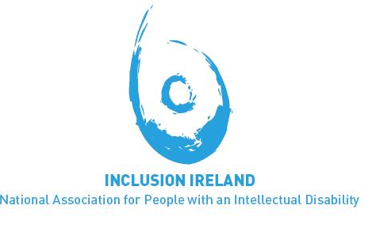

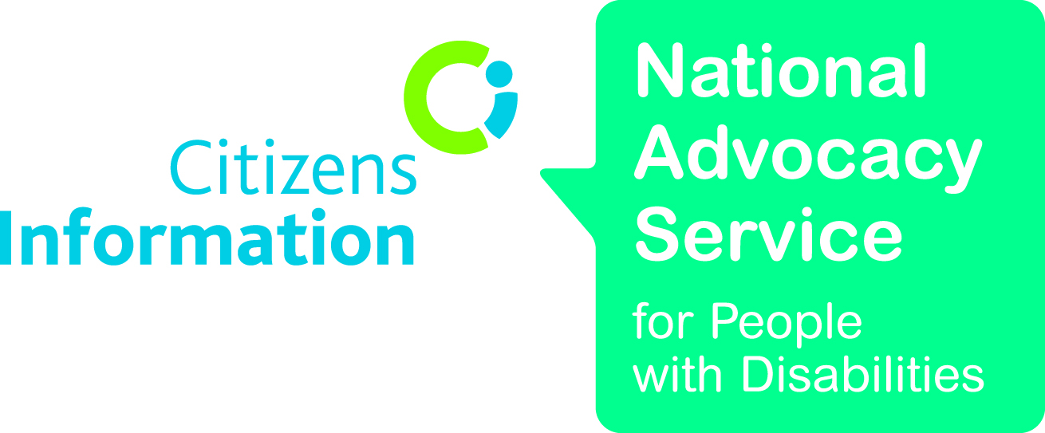

Recovery Experts by Experience (REE)

Report of the Inter-Departmental Committee to establish the facts of State involvement with the Magdalene Laundries, Irish Department of Justice and Equality, p. III, 855, 861-3, 879-80, 919-20 (2013)
Time to Move on from Congregated Settings: A Strategy for Community Inclusion, Report of the Working Group on Congregated Settings Health Service Executive, p. 10-11 (June 2011)
Committee on the Rights of Persons with Disabilities, General Comment No. 1 – Article 12: Equal Recognition Before the Law, Paragraph 15, UN Doc. No. CRPD/C/GC/1, adopted at the 11th Session (April 2014), para. 12.
For a discussion of the arguments for removing diagnostic thresholds of disability, see Sabine Michalowski, “Is the MCA’s diagnostic test to assess mental capacity compatible with the UNCRPD?,” Essex Autonomy Project Briefing Document (21 April 2014).

