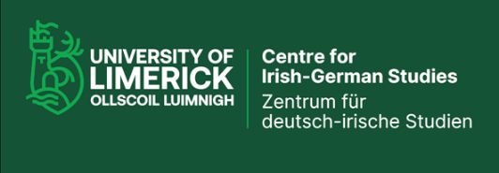 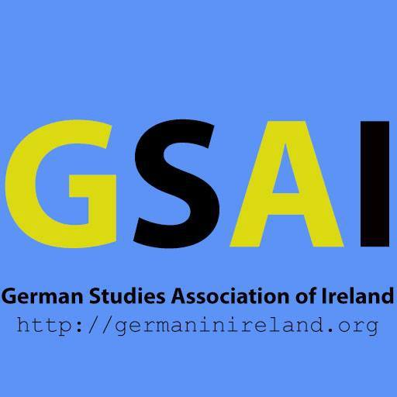

***21st International Conference of the Centre for Irish-German Studies (CIGS) & Annual German Studies Association of Ireland (GSAI) conference*** [& event of the DAAD PGS 2022-24 project]

**German Studies in Ireland Today and Tomorrow – Perspectives, Challenges and Opportunities**

**University of Limerick, 14-16 November 2024**

**Thursday, 14 November 2024** *Pre-programme*

**12.30pm B1005A, Main Building, UL**

**Derek Scally** (Irish Times, Berlin) - Germanecdotes: Tales from 25 years on the frontline in Berlin

**5.00pm Armitage Room, Plassey House**

**Noel Russell** (Belfast) – On Refugees to Northern Ireland in the 1930s & book launch ***The Saved and the Spurned*** (New Island, 2024) by Noel Russell

**Friday, 15 November 2024**

*Registration from 12pm, entrance Glucksman Library UL*

**12.30pm Launch of the Jürgen Gottschalk Collection, Glucksman Library, UL (Special Collections)**

Insights into the Irish-German Book Collection with Ms Traute Gottschalk (Würzburg), Matthias Fleckenstein (DIG Würzburg), Ciara McCaffrey (Director, Glucksman Library), Dr Sandra Joyce (Dean AHSS), Prof Gisela Holfter (Director, CIGS) and Ken Bergin (Head, UL Special Collections)

Followed by **Lunch buffet,** **Glucksman Library, UL Ground Floor (1-1.45pm)**

**1.45pm – 2pm Glucksman Library, 3rd Floor, A&L Goodbody Moot Appeal Court Room**

**Opening of the Conference** –Prof Shane Kilcommins (Acting President UL); Prof Gisela Holfter (CIGS)

**2pm – 3.15pm Session I – New developments in digital language learning**

*Chair: Dr Anita Barmettler (UL)*

Associate Prof Veronica O’Regan (UL) & Prof Christiane Brand (TH Köln) – Exploring new learning opportunities in German Studies through Irish-German Virtual Exchange

Dr Una Carthy & Dr Jessica Lysaght (ATU) – The Smarttalk project

Natascha Guggi & Prof Gisela Holfter (UL) – *Introducing and launching* [www.resources-for-german.com](http://www.resources-for-german.com)

3.15pm *Short**break*

**3.20 – 4.20pm** **Session II – German Studies in Ireland and the UK – Eine Standortbestimmung (Roundtable)**

*Chair: Dr Linda Shortt (Maynooth)*

Alex Bleistein (DAAD London) / Prof Mary Cosgrove (TCD) / Associate Prof Christiane Schönfeld (MIC)

4.20-4.45pm Coffeebreak (Ground floor Glucksman Library)

**4.45 – 5.55pm Session III –** **Keynotes: German Studies – Eine internationale Bestandsaufnahme**

*Chair: Associate Prof Marieke Krajenbrink (UL)*

Prof Jan Süselbeck (Trondheim, Norway): No Future? On Teaching German Studies in Times of Crisis

Dr Britta Bendieck (Duitsland Instituut Amsterdam & Universiteit van Amsterdam): Krise oder Wandel? Die Situation des Studienfaches Deutsch in den Niederlanden

*5.55pm Short break*

**6.00pm – Reading by Judith Hermann** *chaired by Associate Prof Michaela Schrage-Frueh* followed by launch of *Germanistik in Ireland* (and celebration of recent books by colleagues in German)

**7.30pm Conference Dinner Castletroy Park Hotel, Limerick**

**Saturday, 16 November 2024**

A&L Goodbody Moot Appeal Court Room, Glucksman Library

**9.00 – 9.45am** – **Mitgliederversammlung GSAI**

**9.45 – 10.35am Session IV – Inner, Outer and Future Worlds**

*Chair: Prof Hans-Walter Schmidt-Hannisa (University of Galway)*

Dr Thomas Wilks (University of Galway) – Thomas Glavinic’s *Die Arbeit der Nacht*: timeliness and translatability of inner and outer worlds two decades after publication

Prof Anne Fuchs (UCD) – Future Imaginaries of Permacrisis. A transdisciplinary and practice-based research programme

10.35 – 11am Coffee break (Ground floor Glucksman Library)

**11.00am – 12.15pm** **Session V****– Cultures in Contact**

*Chair: Dr Deirdre Byrnes**(University of Galway)*

Monica Brandis (UL) – Memories and facts: Approaches to researching Operation Shamrock

Dr Joseph Twist (UCD) – Kann der Traum von einem multikulturellen Deutschland […] noch weiter-geträumt werden?: Imagining Turkish-German Futurity after Solingen in *Deine Strasse* by Güzin Kar

Associate Prof Gillian Pye (UCD) – Affect, emotion & the time of happiness in Jenny Erpenbeck’s *Kairos*

12.15 – 1pm Lunch (Ground floor Glucksman Library)

**1.00 – 2.15pm** **Session VI – Visions of German Studies in Ireland in the Future and showcasing current activities by key stakeholders supporting German Studies in Ireland**

*Chair: Prof Emerita Eda Sagarra (TCD)*

H.E. Melitta Schubert (Austrian Ambassador); Wolfram von Heynitz (German Cultural Attaché); Alexander Kruckenfellner (Deputy Director Goethe Institut); Simon Dauber, President Handelskammer; Joanne Hession (GDI); Alex Bleistein, DAAD & presentations by current OeAD & DAAD Lektoren etc

**Concluding Remarks**