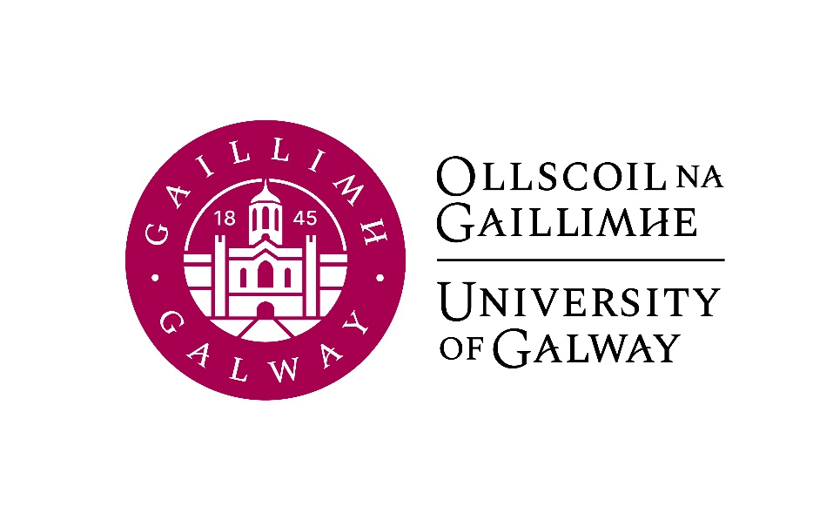

Second Year Arts
German
Course Booklet

2026-2027

Head of Discipline: Dr. Tina-Karen Pusse, Room AMB-2051
Email: tina-karen.pusse@universityofgalway.ie

Second Year Co-ordinator (Semester 1): Dr. Conor Brennan, Room AMB-2007
Email: conor.brennan@universityofgalway.ie

Discipline Administrator: Natalie Nevin, Room AMB-2006
Email: natalierebecca.nevin@universityofgalway.ie

Discipline of German website: https://www.universityofgalway.ie/german/

 | Academic Year 2026–2027
2026 (Semester 1)
Orientation 1st years | Monday 31st August to Friday 4th September
Start of teaching | Monday 7th September
End of teaching | Friday 27th November (12 weeks of teaching)
Study Week | Monday 30th November to Friday 4th December
Semester 1 Exams | Monday 7th December – Friday 18th December (10 days of exams)
Christmas Holidays | Start Saturday 19th December
2027 (Semester 2)
Start of Teaching | Monday 11th January 2027
Easter | Good Friday 26th March to Easter Monday 29th March
End of Teaching | Friday 2nd April (12 weeks of teaching)
Field Trips | Monday 5th to Friday 9th April
Study Week | Friday 12th to Friday 16th April
Semester 2 Exams | Monday 19th April – Thursday 6th May
Autumn Repeat Exams | Tuesday 3rd August to Friday 13th August (9 days of exams)
Holidays | Easter: Good Friday 26th March to Easter Monday 29th March
 | Bank Holidays: Monday 26th October 2026/Monday 2nd February 2027/ Wednesday 17th March 2027/ Monday 3rd May 2027/ Monday 7th June 2027 / Monday 2nd August 2027

SEMESTER 1
All modules have the value of 5 ECTS.

Module | Component(s)
GR236 German Language I
GR238 German Studies I  Students must choose Close Reading and Tranlsation plus one of the optional components. | Close Reading and Translation 50%  AND  Ruth Klüger: A Childhood under Nazi Control 50%  OR  Beyond DACH: German as a Minority, Heritage and Colonial Language 50%
GR239 History of German  Literature and Culture I | Literature and Climate Change: From the Little Ice Age to the Anthropocene
SEMESTER 2
All modules have the value of 5 ECTS.

Module | Component(s)
GR237 German Language II
GR240 German Studies II | Landeskunde and Intercultural Communication
GR235 History of German Literature and Culture II | Romanticism
Important information about in-house assessments:
A medical certificate or the approval of an extenuating circumstance is required for a student to be able to sit the in-class test at a later date. More information regarding the Extenuating Circumstances Policy can be found here: https://www.universityofgalway.ie/medicine-health/currentstudents/studentforms/

SEMESTER 1
GR236 | German Language I (4 hours per week)

Lecturers: Antonia Musolff, Anne Kathrin Bock
Course description:
This course will further develop the language skills acquired in first year and refine understanding of German vocabulary, communication and sentence structures. Students will improve their ability to speak, write, read and listen about up-to-date topics. The students will gain communication tools and phrases for everyday situations as well as academic and professional situations.
Students who want to reach level B1+ of the CEFR (Common European Framework of Reference for Languages) should achieve a grade of 60% or higher in this module.

Teaching and learning methods: Individual, partner and group work, presentation

Learning outcomes: Progress in German language proficiency (oral, aural, written and reading) to level B1+.

Assessment:
Written examination: 50%
Continuous assessment: 20%
Oral examination: 30%

Core texts:
Vielfalt. Deutsch als Fremdsprache. Kurs- und Arbeitsbuch. B1+, ISBN 10: 3190010366
Dreyer/Schmitt, A Practice Grammar of German: Die neue Gelbe. Ausgabe Englisch Taschenbuch. 2024
These texts are available to purchase in the campus bookshop.

Additional course material will be available on Canvas.

GR238 | German Studies I (2 hours per week)  Close Reading and Translation (obligatory) 50%  AND  Ruth Klüger: A Childhood under Nazi Control 50%  OR  Beyond DACH: German as a Minority, Heritage  and Colonial Language 50%

GR238 Close Reading and Translation (1 hour per week)
Lecturer: Conor Brennan

Course description:
This course will hone students’ skills of close textual analysis in German and advanced translation from German into English, while also introducing them to a wide range of German-language authors and texts. “Close reading” is the art of slowing down and recognising not just what a passage says, but how it achieves its effects. By analysing and translating key passages from canonical German-language novels, plays, stories, poems and songs, students can expect to further improve their comprehension and analytical skills while broadening their understanding of German literature and culture.

Assessment: In-class tests (80%), continuous assessment (20%)

GR238 OPTION 1: Ruth Klüger: A Childhood under Nazi Control (1 hour per week)
Lecturer: Jeannine Jud-Kelly
Course description:
This module will focus on Ruth Klüger’s memoir Weiter leben: Eine Jugend. In this work, Klüger, born in 1931, explores her experiences of life in Vienna as a Jewish child under Nazi control, followed by life in the Ghetto Theresienstadt and the concentration camps Auschwitz-Birkenau and Christianstadt. Through an in-depth analysis of this memoir, we are provided with a unique insight into the experiences brought to paper by a woman who experienced and survived some of the most horrific events in history first-hand. Her literature is a mosaic of the most beautiful anecdotes, illustrating that hope flickers even in the darkest of places, mixed with harrowing tales of life inside Auschwitz-Birkenau. The aim of this course is to analyse and reflect on the personal perspectives provided by Klüger of this complex historical period.

Assessment:
Active participation and continuous assessment: 30%
In-class test: 70%

Core text:
Ruth Klüger, Weiter leben: Eine Jugend
This text will be available to purchase in the campus bookshop.

GR238 OPTION 2: Beyond DACH: German as a Minority, Heritage and Colonial Language
Lecturer: Verena Platzgummer
Course description:
In this class, students will gain a more complex understanding of the German-speaking world by learning about a number of different contexts beyond D-A-CH (Germany, Austria, Switzerland) in which German is spoken. We will cover contexts where :
- German is a recognised minority language – such as South Tyrol (Italy), Belgium or Romania;
- it is a heritage language being upheld (or not) by German-speaking immigrants and their families in places like Australia, Norway and Ireland;
- it was a colonial language and plays some role in the postcolonial order – such as in Namibia or Papua New Guinea.
Students will learn about the existence of different standards and non-standard varieties of German and develop an awareness of the fact that what counts as “German”, who counts as a “German speaker”, and which places count as German-speaking is not as straightforward as one might think.

Teaching and learning methods: Lectures, in-class discussions, case studies
Assessment:
Assignment 1 – Presentation on a context in which German is a minority language: 25%
Assignment 2 – Reflective text on a heritage speaker’s narrative: 25%
In-house exam: 50%

Learning materials will be available on Canvas.

GR239 History of German Literature and Culture I (2 hours per week)
Literature and Climate Change: From the Little Ice Age to the Anthropocene
Lecturer: Tina-Karen Pusse

Course description:
This course examines literary and cultural responses to climate events – starting with the Little Ice Age (ca. 1500–1850) in Europe and leading up to contemporary literature on global warming and ecological grief. Using German-language texts, students will analyze how literature negotiates climatic upheavals, migration, pandemics, famine, environmental anxiety, and the human relationship to nature. Interdisciplinary approaches include historical, ecological, and postcolonial perspectives.

Readings
Texts will be available on Canvas:
-Hans Jakob Christoffel von Grimmelshausen: Der abenteuerliche Simplicissimus (except)
-Volksmärchen: Hänsel und Gretel, Der Frieder und das Katherlieschen
-Conrad Ferdinand Meyer: Die Füße im Feuer
-Theodor Fontane: Der Schimmelreiter (excerpt)
-Wilhelm Raabe: Pfisters Mühle (excerpt)
-Georg Heym: die Stadt
-Judith Schalansky: Verzeichnis einiger Verluste (excerpt)
-Yasmin Schreiber: Endling (excerpt)

Assessment: Written exam – 50%, Continuous Assessment – 50%

SEMESTER 2
GR237 | German Language II (4 hours per week)

Lecturers: Carlotta Schilke, Anne Kathrin Bock
Course description:
Continuing from GR236, this course builds up your fluency and accuracy. It will help you become more comfortable in the practical use of German, while deepening your understanding of German vocabulary and grammar. All four language skills – writing, reading, comprehending and speaking – will be practised, at a B2.1 level. Vocabulary and grammar will be systematically trained in a theoretical and communicative matter. Contemporary topics and authentic reading material, videos and music are central to the course. Students who want to reach level B2.1 of the CEFR (Common European Framework of Reference for Languages) should achieve 60% or higher in the module.

Teaching and learning methods:
The course involves language exercises and text production, including aural, oral and written language structure work, writing in a range of text types, conversation and oral presentations, listening comprehension and translation from English into German.

Learning outcomes:
Independence in German language learning (spoken and written) to level B2.1; development of a large, reliable core vocabulary and grammar.

Assessment:
Written examination: 50%

Continuous assessment: 20%
Oral examination: 30%

Core texts:
Vielfalt. Deutsch als Fremdsprache. Kurs- und Arbeitsbuch. B2.1. ISBN: 978-3192010378
Dreyer/Schmitt, A Practice Grammar of German: Die neue Gelbe. Ausgabe Englisch Taschenbuch. 2024

These texts will be available to purchase in the campus bookshop.

Additional course material will be available on Canvas.

GR240 German Studies II
Landeskunde and Intercultural Communication 2 hours per week

GR240 Landeskunde (2 hours per week)

This class is compulsory for students doing Erasmus in a German-speaking country.

Lecturer: Steffen Müller
Course description:
This course will focus on cultural topics which will be of benefit to you for your Erasmus year abroad. The word “Landeskunde” translates loosely as “regional studies” or “culture and society” and, as such, can encompass a broad range of topics from history, geography, education and politics to dialects, festivals, music, art, media and sport. As well as learning facts about German-speaking countries, students will also tackle the problem of generalizations and stereotypes that can arise in this context. The aim of this course is for you to familiarise yourself with elements of German culture related to the life of a student so that the transition to living in Germany is easier.

Language of instruction: Predominantly German
Teaching and learning methods: Individual and partner/group work

Assessment:
Continuous assessment: 30%
In-house-test: 70%
Please note that the language of assessment is German.

In-house-test: 60%
Poster presentation: 40%

Core texts:
All texts will be made available on Canvas.

GR235 History of German Literature and Culture II (2 hours per week)
Romanticism

Lecturer: Conor Brennan

Course description
German Romanticism was one of the most transformative movements in European cultural history, spanning from around 1795 to 1830. Emerging in response to Enlightenment rationalism and the social upheaval of the French Revolution, it emphasized imagination, individuality, and the overwhelming power and mystery of nature. At the same time, Romanticism played a central role in the invention of the German nation, helping to shape a new sense of German identity by drawing on shared traditions of folklore and myth.
This course will introduce students to key examples of literature, painting and philosophy from the Romantic era. We will read and analyse poems, fairy tales and novellas by authors such as Novalis, the Brothers Grimm, Karoline von Günderrode, E.T.A. Hoffmann and Heinrich Heine. Students will also learn to understand paintings by Caspar David Friedrich and Philipp Otto Runge.

Assessment: Written exam (70%), continuous assessment (30%)

Core texts:
Poems and songs by Novalis, Günderrode, Wilhelm Müller, and Heinrich Heine
The Brothers Grimm, ‘Hans mein Igel’
E.T.A. Hoffmann, Rat Krespel

All texts will be available on Canvas.

