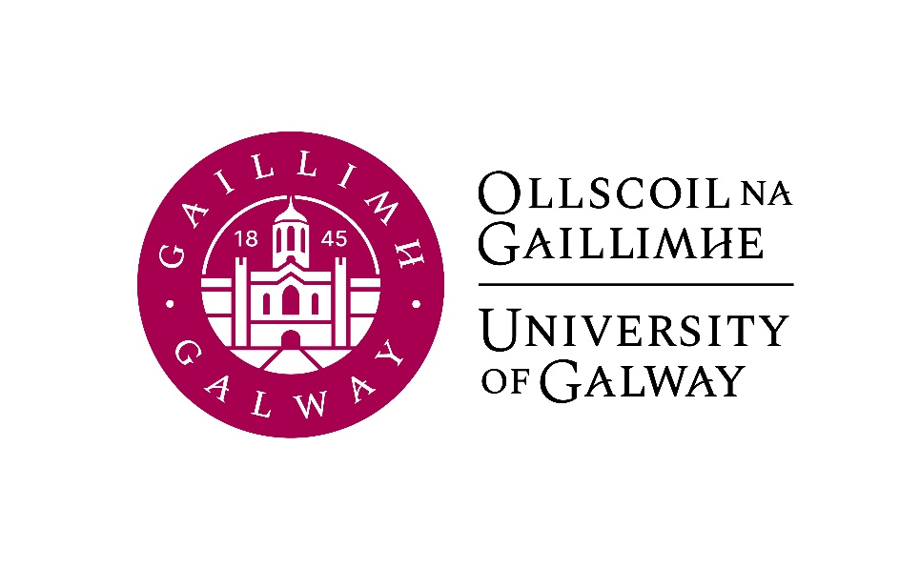

Final Year Arts
German
Course Booklet

2026-2027

Head of Discipline : Dr. Tina-Karen Pusse, Room AMB-2051
Email: tina-karen.pusse@universityofgalway.ie

Final Year Co-ordinators

Semester 1: Dr. Verena Platzgummer, Room AMB-2002
Email: verena.platzgummer@universityofgalway.ie

Semester 2: Dr. Deirdre Byrnes, Room AMB-2003
Email: deirdre.byrnes@universityofgalway.ie

Discipline Administrator: Natalie Nevin, Room AMB-2006
Email: natalierebecca.nevin@universityofgalway.ie

Discipline of German website: https://www.universityofgalway.ie/german/

 | Academic Year 2026–2027
2026 (Semester 1)
Orientation 1st years | Monday 31st August to Friday 4th September
Start of teaching | Monday 7th September
End of teaching | Friday 27th November (12 weeks of teaching)
Study Week | Monday 30th November to Friday 4th December
Semester 1 Exams | Monday 7th December – Friday 18th December (10 days of exams)
Christmas Holidays | Start Saturday 19th December
2027 (Semester 2)
Start of Teaching | Monday 11th January 2027
Easter | Good Friday 26th March to Easter Monday 29th March
End of Teaching | Friday 2nd April (12 weeks of teaching)
Field Trips | Monday 5th to Friday 9th April
Study Week | Friday 12th to Friday 16th April
Semester 2 Exams | Monday 19th April – Thursday 6th May
Autumn Repeat Exams | Tuesday 3rd August to Friday 13th August (9 days of exams)
Holidays | Easter: Good Friday 26th March to Easter Monday 29th March
 | Bank Holidays: Monday 26th October 2026/Monday 2nd February 2027/ Wednesday 17th March 2027/ Monday 3rd May 2027/ Monday 7th June 2027 / Monday 2nd August 2027

SEMESTER 1
All modules have the value of 5 ECTS.

Module | Component(s)
GR341 German Language I
GR337 German Studies I  Students must choose Sociolinguistics of German plus one of the optional components. | Close Reading and Translation (Core) 50%  AND  Women in the GDR 50%  OR  Contemporary German Crime Fiction on TV and in Literature 50%
GR338 German Studies II | Sociolinguistics of German
SEMESTER 2
All modules have the value of 5 ECTS.

Module | Component(s)
GR342 German Language II
GR339 German Studies III | German Theatre Production  OR  Christa Wolf: Kindheitsmuster
GR340 German Studies IV | German Literature and Ecology

Important information about in-house assessments:
A medical certificate or the approval of an extenuating circumstance is required for a student to be able to sit the in-class test at a later date. More information regarding the Extenuating Circumstances Policy can be found here: https://www.universityofgalway.ie/medicine-health/currentstudents/studentforms/

SEMESTER 1

GR341 | German Language I (4 hours per week)

Lecturers: Verena Platzgummer, Carlotta Schilke
Course description:

This course will further develop the language skills acquired in second year and refine your understanding of German vocabulary, communication and sentence structures. The aim is to advance your ability to speak and write correctly, fluently and accurately in typical communication situations, while also enhancing your reading and listening skills. Language learning activities include group discussions, individual Stellungnahmen, grammar exercises, reading and listening comprehension, as well as accurate vocabulary and memory work and writing to the norms of different text types.

Assessment:
Written examination: 50%
Oral examination: 30%
Continuous assessment: 20%

Note: The language modules GR341 and GR342 are the key components of this degree. Successful graduates of our programme must have achieved a specific level of language competency and MUST have passed at a minimum of 40% in the 1st or 2nd sitting.

Core text: Vielfalt. Deutsch als Fremdsprache: Kurs- und Arbeitsbuch C1.1 (available to purchase in the campus bookshop)

Please note that you are expected to attend FOUR taught sessions per week for GR341: all three sessions with Verena Platzgummer and one of the Sprechen hours with Carlotta Schilke.

GR338 German Studies II (2 hours per week)
Sociolinguistics of German

GR338 Sociolinguistics of German (2 hours per week)
Lecturer: Verena Platzgummer
Course description:

In this course, you will be introduced to key concepts and approaches in sociolinguistics, with a particular focus on the German-speaking world. We will explore how language varies across regions, social groups, and communicative contexts, and how these forms of variation are perceived and evaluated. In the first part of the course, we focus on varieties of German, including the different national and regional standards of German, dialects and sociolects. We then move on to interactional perspectives and examine how language is shaped by media use, migration, and institutional settings such as the language classroom. In the final weeks, we adopt a critical sociolinguistic lens to investigate ideologies of “good” and “bad” German and reflect on how language use is linked to biography and social positioning. Through interactive tasks and a group presentation, you will analyse language variation and ideology using real-life examples from media texts and social media, from your own experiences, and from current sociolinguistic research in German-speaking contexts.

Teaching and learning methods: Lectures, in-class discussions, case studies
Assessment:
Assignment 1 –Social Media Content: 25%
Assignment 2 –Reflective text on a language biographical narrative: 25%
In-house exam: 50%

Learning materials will be available on Canvas.

GR337 | German Studies I (2 hours per week)  Close Reading and Translation(obligatory) 50%  AND  Women in the GDR 50%  OR  Contemporary German Crime Fiction on TV and in Literature 50%

GR337 Close Reading and Translation (1 hour per week)

Lecturer: Conor Brennan

Course description:

This course will hone students’ skills of close textual analysis in German and advanced translation from German into English, while also introducing them to a wide range of German-language authors and texts. “Close reading” is the art of slowing down and recognising not just what a passage says, but how it achieves its effects. By analysing and translating key passages from canonical German-language novels, plays, stories, poems and songs, students can expect to further improve their comprehension and analytical skills while broadening their understanding of German literature and culture.

Assessment: In-class tests (80%), continuous assessment (20%)

GR337 OPTION 1: Women in the GDR (1 hour per week)

Lecturer: Jeannine Jud-Kelly

Course description:

This module will explore the lives of women in the German Democratic Republic (GDR) between 1949 and 1990. What was it like for women to live through 40 years of Soviet occupation? In this state the secret police increasingly infiltrated and controlled everyday life, and attempted escape was punished with imprisonment or death. How did women in this communist state juggle work, motherhood and emancipation? Did they benefit from a system in which everyone was considered equal, and women were an integral part of the work force? To explore these questions, we will look at Maxi Wander’s Guten Morgen, du Schöne and Sara Kirsch’s Die Pantherfrau: Fünf Frauen in der DDR, both examples of “Protokoll-Literatur”, capturing conversations these authors carried out with women of different ages and sensibilities. Both of these works illuminate the thoughts of women in the GDR on family, work, relationships, politics and sexuality. We are provided with a unique insight into their lives during this fascinating historical period.

Assessment: In-class test (70%), continuous assessment (30%)

Core texts: Maxi Wander: Guten Morgen, du Schöne (available for purchase in the university bookshop) and Sara Kirsch: Die Pantherfrau: Fünf Frauen in der DDR (chapters available on Canvas).

GR337 OPTION 2: Contemporary German Crime Fiction on TV and in Literature (1 hour per week)
Lecturer: Jeannine Baetz
Course description:
This course will provide students with an overview of contemporary Germany crime fiction by analysing the way the genre engages with socio-political and cultural discourses. This course is divided into three units, each of which delves into specific dimensions of this genre trend. In the first unit, students examine the representation of domestic political discourses in German-language crime fiction; the second unit focuses on ecocriticism and environmental crime fiction, and the third unit explores genre hybridity in contemporary crime fiction.
In consideration of the key role played by TV series in German-language crime fiction since the 1970s, this course predominantly focusses on German television crime dramas. Students will be asked to discuss excerpts of selected case studies (available through Canvas) to gain a deeper understanding of the genre’s representation of (and influence on) socio-political discourses.

Assessment:
- Active participation: 20 %
- In-class presentation of essay topics and outlines: 30%
- Essay on one case study (to be submitted by the end of week 12): 50%

Case Studies
- Tatort: Das fleißige Lieschen
- Tatort: Im gelobten Land
- Zoë Beck, Memoria and Paradise City (excerpts)
- Letzte Spur Berlin – Tag X
- Die Saat (Episode 1)
- Höllgrund

SEMESTER 2
GR342 | German Language II (4 hours per week)

Lecturers: Verena Platzgummer, Anne Kathrin Bock

Course description:
Continuing from GR341, this course builds up fluency and accuracy in the German language. The classes will involve language exercises and text production, including aural, oral and written work.

Assessment:
Written examination: 50%
Oral examination: 30%
Continuous assessment: 20%

Note: The language modules GR341 and GR342 are the key components of this degree. Successful graduates of our programme must have achieved a specific level of language competency and MUST have passed at a minimum of 40% in the 1st or 2nd sitting.

Core text: Vielfalt. Deutsch als Fremdsprache: Kurs- und Arbeitsbuch C1.2
This text will be available to purchase in the campus bookshop.
Please note that you are expected to attend FOUR taught sessions per week for GR341: all three sessions with Verena Platzgummer and one of the Sprechen hours with Anne Kathrin Bock.

Important information about end-of-year oral exams for GR342:
Although the written examinations conclude on Thursday, 6th of May, the oral examinations for GR342 do not take place until the external examiner is on campus. These are in-person examinations and usually take place later in May. Please do not make arrangements to travel overseas until the oral examinations are over. Exact dates for the oral examinations will be provided in early February 2027.

GR339 German Studies III
German Theatre Production
OR
Christa Wolf: Kindheitsmuster

GR339 German Theatre Production (2 hours per week)
Lecturer: Antonia Musolff , Carlotta Schilke
Maximum number of students: 16
Course description:
German at University of Galway has a long tradition of bringing a German play to the stage. The aim of this course is to prepare a drama which will be performed in the Bank of Ireland Theatre on three evenings in March 2026. Students will contribute to the performances in various ways – as actors, stagehands, lighting technicians, prompters, make-up artists, programme editors, costume designers, surtitle technicians, etc. Participating in the performance of a play is an excellent way to improve rhetoric and language skills; it is also a valuable exercise in time management and organization. In addition, students will acquire a deeper understanding of a work of literature.

Teaching and learning methods:
The project requires regular and active student participation.
Please note that due to the practical nature of this course, a repeat option cannot be offered. Attendance and active participation are essential.

Assessment:
Contribution to the performance: 70%
Written reflection: 30%.

Core text: to be confirmed

GR339 Christa Wolf: Kindheitsmuster (2 hours per week)
Lecturer: Jeannine Jud-Kelly
Course description:

This module will focus on Christa Wolf's semi-autobiographical novel Kindheitsmuster. Born in 1929 in Landsberg an der Warthe (current-day Poland), Christa Wolf lived through three historical eras: the Nazi era, the GDR era and reunified Germany. In Kindheitsmuster, published in 1976, Wolf reflects on her experiences as an Aryan German child in Nazi Germany and on her childhood and youth during the Second World War and post-war years. Kindheitsmuster explores concepts of childhood indoctrination, how much the Germans really knew about the atrocities that were happening, and the trauma of war. The novel reflects Wolf’s problematic relationship with authority and her conflicted personal identity; it also provides insight into the difficulties of coping with memories of a traumatising past. The course will focus on a close reading of this novel, which will be supported by an analysis of the socio-historical context.

Assessment:
Presentation: 40%
Essay: 40%
In-class-test: 20%

Core text: Christa Wolf, Kindheitsmuster
This text will be available to purchase in the campus bookshop.

GR340 German Cultural Studies IV (2 hours per week)
German Literature and Ecology
Lecturer: Conor Brennan
Course description
This course focuses on German-language texts that engage with animals, plants and other aspects of the more-than-human world. The question of how literature and art can pay attention to other species and think beyond the boundaries of the human has preoccupied writers through the centuries, from Romantic fairytales to the stories of Kafka or the films of Christian Petzold. Now, in the face of rapidly unfolding climate and biodiversity crises, it is more urgent than ever. The course will introduce students both to relevant theoretical approaches and to key literary works by Kafka, Rilke, Ingeborg Bachmann, W.G. Sebald, Yoko Tawada and Christian Petzold. Alongside these short texts and excerpts, which will be uploaded to Canvas, the course will include a detailed reading of Marlen Haushofer’s eco-feminist classic Die Wand (1963).

Assessment:
Continuous Assessment: 50%
Essay: 50%

Core text: Marlen Haushofer, Die Wand
This text will be available to purchase in the campus bookshop.

