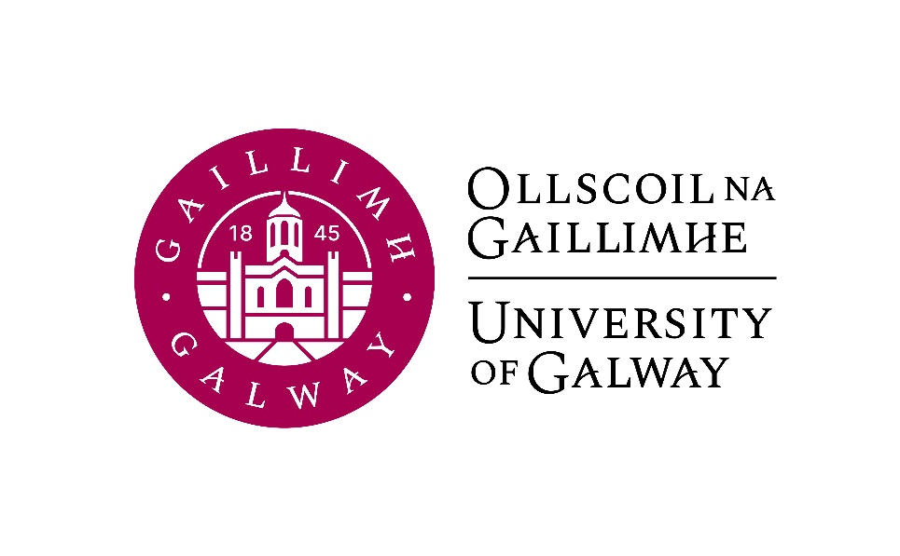

Second Year Arts
German
Course Booklet

2024-2025

Second Year Co-ordinator (Semester 1): Professor Hans-Walter Schmidt-Hannisa, Room AMB-2007
Email: h.schmidthannisa@universityofgalway.ie
Head of Discipline: Dr. Deirdre Byrnes, Room AMB-2003
Email: deirdre.byrnes@universityofgalway.ie
Discipline Administrator: Natalie Nevin, Room AMB-2006
Email: natalierebecca.nevin@universityofgalway.ie

Discipline of German website: https://www.universityofgalway.ie/german/

 | Academic Year 2024 -2025
2024 (Semester 1)
Start of teaching | Monday 9th September
End of teaching all years | Friday 29th November
Study Week | Monday 2nd December - Friday 6th December
Semester 1 Exams | Monday 9th December – Friday 20th December
Christmas Holidays | Start Saturday 21st December
2025 (Semester 2)
Start of Teaching | Monday 13th January
End of Teaching | Friday 4th April
Field Trips | Monday 7th April to Thursday 10th April
Study Week | Friday 11th April to Thursday 17th April
Easter | Good Friday 18th April to Easter Monday 21st April
Semester 2 Exams | Tuesday 22nd April – Friday 9th May
Autumn Repeat Exams | Tuesday, 5th August to Friday 15th August
Holidays | St. Brigid’s Day: Monday 5th February 2024
 | Easter: Good Friday 18th April to Easter Monday 21st April
 | Bank Holidays: Monday 28th October 2024 /Monday 3rd February 2025/ Monday, 17th March 2025/ Monday 5th May 2025/ Monday 2nd June 2025 / Monday 4th August 2025

SEMESTER 1
All modules have the value of 5 ECTS.

Module | Component(s)
GR236 German Language I
GR238 German Studies I  Students must choose Law in Literature plus one of the optional components. | Law in Literature 50%  AND  Romanticism 50%  OR  Ruth Klüger: A Childhood under Nazi Control 50%
GR239 History of German  Literature and Culture I | Literature and Culture of the Wiener Moderne 100%
SEMESTER 2
All modules have the value of 5 ECTS.

Module | Component(s)
GR237 German Language II
GR240 German Studies II  Students must choose Landeskunde plus one of the optional components. | Landeskunde 50%  AND  Making invisibilities visible: GDR and German reunification retold 50%  OR  The linguistic development of Swiss German 50%
GR235 History of German Literature and Culture II | Distraction in German Literature 100%

Important information about in-house assessments:
A medical certificate or the approval of an extenuating circumstance is required for a student to be able to sit the in-class test at a later date. More information regarding the Extenuating Circumstance Scheme can be found here: https://www.universityofgalway.ie/colleges-and-schools/arts-social-sciences-and-celtic-studies/student-information/studentformsandlinks/

SEMESTER 1
GR236 | German Language I (4 hours per week)

Lecturers: Antonia Musolff, Lisa Tismenezky
Course description:
This course will further develop the language skills acquired in first year and refine understanding of German vocabulary, communication and sentence structures. It will advance your ability to speak and write correctly, fluently and accurately in typical communication situations.
Core aims for Semester 1 are to ensure that all participants are engaging in high-level language learning activities, appropriate to a BA course. As well as accurate vocabulary and memory work, these activities involve translation into English, writing to the norms of different text types (CV, applications, etc.) and speaking at varying levels of formality. Students who want to reach level B1.2 of the CEFR (Common European Framework of Reference for Languages) should achieve a grade of 60% or higher in this module.

Teaching and learning methods: Individual, partner and group work, team presentation

Learning outcomes: Progress in German language proficiency (spoken and written) to level B1.2; improved language acquisition skills.

Assessment:
Written examination: 40%
Continuous assessment: 60%

Core texts:
Menschen B1.2 Kursbuch (available to purchase in the campus bookshop)
Menschen B1.2 Arbeitsbuch (available to purchase in the campus bookshop)
Dreyer/Schmitt. A Practice Grammar of German: Die neue Gelbe. Ausgabe Englisch Taschenbuch. 2024 (available to purchase in the campus bookshop)

Additional course material (translation assignments, video links, handouts, etc.) will be available on Canvas.

GR238 | German Studies I (2 hours per week)  Law in Literature (obligatory) 50%  AND  Romanticism 50%  OR  Ruth Klüger: A Childhood under Nazi Control 50%

GR238 Law in Literature (1 hour per week)
Lecturer: Deirdre Byrnes
Course description:
This seminar develops close reading skills as we consider the portrayal of the Law and of the legal system in selected works of literature. In the first unit, we will analyse Paul Celan’s poem “Todesfuge” – a text which depicts the horrors of the concentration camps and illustrates in devastating fashion what happens when people are deprived of their basic rights.
The second unit of the course focuses on Ferdinand von Schirach’s play Terror, which was published in 2015 and quickly became a global theatre phenomenon. In this courtroom drama, the spectators assume the role of jurors and must arrive at a verdict, which is delivered at the end of each live performance. Von Schirach’s thought-provoking play challenges audience and readers alike to grapple with complex ethical questions and to consider issues of guilt and responsibility.
In the third part of the course, we will explore two parables by Franz Kafka: “Der Schlag ans Hoftor” and “Vor dem Gesetz”. These texts raise important questions about access to the Law and about the labyrinthine apparatus often surrounding it.

Assessment:
Continuous assessment: 30%
In-house essay in week 12 (November 29th): 70%

Core texts:
Reader (available on Canvas) containing texts by Paul Celan and Franz Kafka
Ferdinand von Schirach’s play Terror is available to purchase in the campus bookshop.
A study guide is available on Canvas.

GR238 OPTION 1: Romanticism (1 hour per week)
Lecturer: Hans-Walter Schmidt-Hannisa

Course description:
Romanticism, the time between 1795 and 1830, was one of the most productive periods in Germany’s cultural history. In the aftermath of the French Revolution and overshadowed by the Napoleonic Wars, Romanticism began as an eruption of original and often provoking philosophical and literary ideas. Its aim was nothing less than the re-enchantment of the world that had been radically transformed by the rationalism of the Enlightenment during the 18th century. However, Romanticism is not simply a corrective of Enlightenment, but in many respects also its continuation.
The course will introduce students to samples of literature, painting, music and philosophy of the epoch. We will read and analyse aphorisms, poems, fairy tales and novellas by authors such as Novalis, the Brothers Grimm, Clemens Brentano, E.T.A. Hoffmann and Joseph von Eichendorff. We will also learn to understand paintings by Caspar David Friedrich and Friedrich Schinkel and listen to music by Franz Schubert.
Assessment: In-class-test at the end of the term
Core texts:
E.T.A. Hoffmann: Rat Krespel
Fairy tales by Brothers Grimm
Poems by Novalis, Brentano, and Eichendorff
All texts will be available on Canvas.

GR238 OPTION 2: Ruth Klüger: A Childhood under Nazi Control (1 hour per week)
Lecturer: Jeannine Jud
Course description:
This module will focus on an examination of Ruth Klüger’s memoir Weiter leben: Eine Jugend. In this work, Klüger, born in 1931, explores her experiences of life in Vienna as a Jewish child under Nazi control, followed by life in the Ghetto Theresienstadt and the concentration camps Auschwitz-Birkenau and Christianstadt. Through an in-depth analysis of this memoir, we are provided with a unique insight into the experiences brought to paper by a woman who survived some of the most horrific events in history first-hand. Her literature is a mosaic of the most beautiful anecdotes, illustrating that hope flickers even in the darkest of places, mixed with harrowing tales of life inside Auschwitz-Birkenau. The aim of this course is to analyse and reflect on the personal perspectives provided by Klüger of this complex historical period.

Assessment:
Active participation and continuous assessment: 30%
In-class test: 70%

Core text:
Ruth Klüger, Weiter leben: Eine Jugend (available to purchase in the campus bookshop)

GR239 History of German Literature and Culture I (2 hours per week)
Literature and Culture of the Wiener Moderne
Lecturer: Hans-Walter Schmidt-Hannisa

Course description:
The module introduces students to the literature and culture of Vienna in the period 1890-1930. It provides a portrait of the Habsburgian Capital, including aspects such as the economic and political situation, urban sociology and architecture. The major thematic focus of the module will be the representation of women in contemporary literature, art and theory (psychoanalysis). It introduces major representatives of contemporary art (Gustav Klimt, Egon Schiele), and music (Gustav Mahler, Arnold Schönberg). The module analyses major texts of various genres (novella, poetry, drama) by various authors (Arthur Schnitzler, Hugo von Hofmannsthal, Peter Altenberg). These texts will be discussed in the context of relevant contemporary theories such as psychoanalysis and the criticism of language.

Assessment: Written exam

Core texts:
Arthur Schnitzler, Fräulein Else
Hugo von Hofmannsthal, Poems
All texts will be available on Canvas.

SEMESTER 2
GR237 | German Language II (4 hours per week)

Lecturers: Antonia Musolff, Lisa Tismenezky
Course description:
Continuing from GR236, this course builds up your fluency and accuracy. It will help you become more comfortable in the practical use of German, while deepening your understanding of German vocabulary. All four language skills – writing, reading, comprehending and speaking – will be practised, at a B2.1 level. Vocabulary and grammar will be systematically trained in a theoretical and communicative matter. Contemporary topics and authentic reading material, videos and music are central to the course. Students who want to reach level B2.1 of the CEFR (Common European Framework of Reference for Languages) should achieve 60% or higher in the module.

Prerequisites: Erasmus students arriving in Semester 2 who are interested in doing this module should consult the lecturer.

Teaching and learning methods:
The course involves language exercises and text production, including aural, oral and written language structure work, writing in a range of text types, conversation and oral presentations, listening comprehension and translation from English into German.

Learning outcomes:
Independence in German language learning (spoken and written) to level B2.1; development of a large reliable core vocabulary with particular focus on the requirements of study at a German university; reading and translating literary texts; translation from and to German

Assessment:
Written examination: 40%
Oral examination: 30%
Continuous assessment: 30%

Core texts:
Sicher B2.1 Kurs-und Arbeitsbuch (available to purchase in the campus bookshop)
Dreyer/Schmitt, A Practice Grammar of German: Die neue Gelbe: Ausgabe Englisch Taschenbuch. 2024 (available to purchase in the campus bookshop)

Additional course material (translation assignments, video links, handouts, etc.) will be available on Canvas.

GR240 German Studies II
Landeskunde (obligatory) 50%

AND
Making invisibilities visible: GDR and German reunification retold 50%
OR
The linguistic development of Swiss German 50% c

GR240 Landeskunde (1 hour per week)
This class is compulsory for students doing Erasmus in a German-speaking country.
Lecturer: Antonia Musolff
Course description:
This course will focus on cultural topics which will be of benefit to you for your Erasmus year abroad. The word “Landeskunde” translates loosely as “regional studies” or “culture and society” and, as such, can encompass a broad range of topics from history, geography, education and politics to dialects, festivals, music, art, media and sport. As well as learning facts about German-speaking countries, students will also tackle the problem of generalizations and stereotypes that can arise in this context. The aim of this course is for you to familiarise yourself with elements of German culture related to the life of a student so that the transition to living in Germany is easier.

Language of instruction: Predominantly German
Teaching and learning methods: individual and partner/group work

Assessment:
Continuous assessment: 30%
In-house-test: 70%
Please note that the language of assessment is German.

GR 240 OPTION 1: Making invisibilities visible: GDR and German reunification retold (1 hour per week)
Lecturer: Antonia Musolff
Course description:
In this course we will take a close look at Germany before and after reunification. From 1949 until 1989 Germany was divided: the German Democratic Republic (GDR) in the East and the Federal German Republic (FGR) in the West. Since German reunification in 1990 GDR literature, as well as life in the GDR, have been an important part of German remembrance culture. However, former GDR citizens frequently do not feel seen in the dominating remembrance politics because it tends to reduce life in the GDR to victims of or perpetrators within a socialist, totalitarian system.
The aim of this course is therefore to paint a more diverse picture of life in the GDR and shed light on aspects that have not been at the centre of discussion. In the first half of the course, we will learn about life in the GDR through literary and scientific texts. In the second half, the focus will be on everyday life in the GDR, Queer movements in the GDR, immigration into the GDR, reunification from a Black German or migrant viewpoint, discrimination experienced by people who grew up or lives in the former East Germany and the relationship between Ireland and the GDR.
Teaching and learning methods: In-class discussions, partner and group work
Assessment:
In-house-test: 50%
Poster presentation: 50%

Core texts:
All texts will be made available on Canvas.

Gisela Holfter, Deirdre Byrnes and Jean E. Conacher (Eds.), Perceptions and Perspectives: Exploring Connections between Ireland and the GDR (2019)
Lydia Lierke and Massimo Perenelli (Eds), Erinnern stören: Der Mauerfall aus migrantischer und jüdischer Perspektive (2020)
Ursula Sillge, Queere Bewegungen in der DDR (2007)

GR240 OPTION 2: The linguistic development of Swiss German (1 hour per week)
Lecturer: Jeannine Jud
Course description:
Since the introduction of social media, Swiss German has been undergoing somewhat of a linguistic revolution. A conglomeration of Alemannic dialects spoken by just over 60% of the population in Switzerland, Swiss German was historically spoken and not written. This has changed significantly in the last decade and Swiss German is now often being typed as it is phonetically pronounced. This course will focus on the linguistic development of Swiss German since the 18th century, how historical discourses have influenced the language debates and how Swiss German dialects are perceived and received from a socio-linguistic perspective. It will analyse the discussions surrounding the “Mundartwellen” in Switzerland, the language policies implemented in schools and Kindergartens, the shifts in the language spoken in radio and television and the popularity of Swiss German bands.

Assessment: Continuous assessment: 30%
In-house exam: 70%
Core Text:
Emanuel Ruoss, Juliane Schröter (Eds.), Schweizer Deutsch: Sprache und Identität von 1800 bis heute (2020)
All texts will be made available on Canvas.

GR235 Distraction in Sickness and in Health in German Literature (2 hours per week)

Lecturer: Tom Wilks
Course description
This seminar develops close reading skills in German as well as critical thinking about modes of distraction and their effects on well-being as presented in selected literature by leading authors in German. We will consider the relationship between experiences of distraction that are signified separately in German, but which coincide for the protagonists in our set texts.
The first unit will introduce distraction concepts in German as they have been theorised in
philosophical, psychological and sociological discourses since the Enlightenment.
In the second unit, we will focus on a novel by Thomas Glavinic, Die Arbeit der Nacht (2006), in which distraction is taken to extremes by a protagonist who finds himself isolated and often reliant on his recollections of personal and social history.
In the third unit, we will compare and contrast presentations of distraction in short prose fiction, including by Emine Sevgi Özdamar, the Turkish-German recipient of one of Germany’s major literary awards in 2022.
Taken together, our set reading demonstrates the importance of understanding the remarkable range of experiences and effects of distraction in contributing either to ill health or to well-being.

Assessment:
Continuous Assessment: 30%, including in-class assessment
Written Examination: 70%

Core texts:
Extracts from theories and short prose fiction will be available on Canvas.
Thomas Glavinic’s novel Die Arbeit der Nacht is available as a DTV paperback (2008 or any later date; ISBN: 978-3-423-13694-5) and has been ordered for the campus bookshop.
A study guide will be provided on Canvas.

