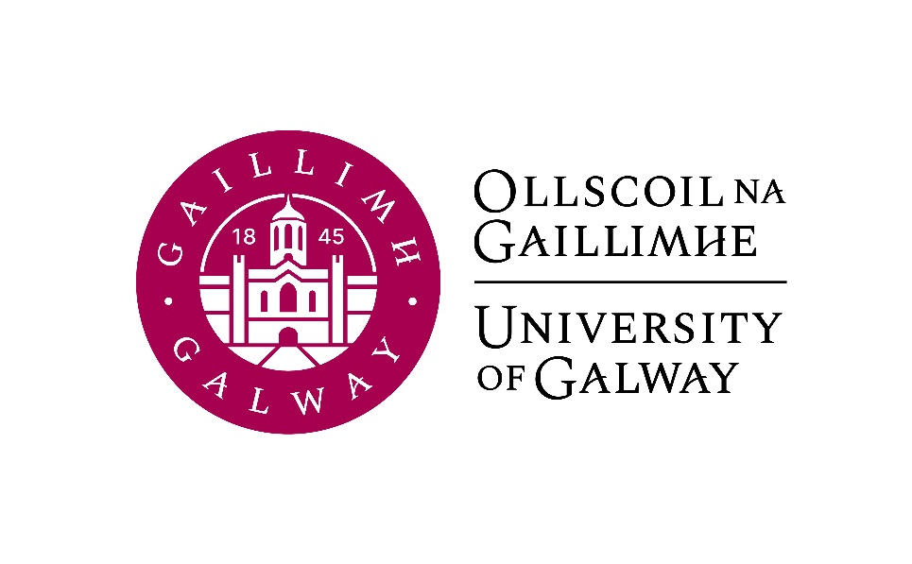

Second Year Arts
German
Course Booklet

2025-2026

Second Year Co-ordinator (Semester 1): Antonia Musolff, Room AMB-2045
Email: antonia.musolff@universityofgalway.ie

Head of Discipline: Dr. Deirdre Byrnes, Room AMB-2003
Email: deirdre.byrnes@universityofgalway.ie

Discipline Administrator: Natalie Nevin, Room AMB-2006
Email: natalierebecca.nevin@universityofgalway.ie

Discipline of German website: https://www.universityofgalway.ie/german/

 | Academic Year 2025–2026
2024 (Semester 1)
Start of teaching | Monday 8th September
End of teaching all years | Friday 28th November
Study Week | Monday 1st December – Friday 5th December
Semester 1 Exams | Monday 8th December – Friday 19th December
Christmas Holidays | Start Saturday 20th December
2026 (Semester 2)
Start of Teaching | Monday 12th January
End of Teaching | Thursday 2nd April
Easter | Good Friday 3rd April to Easter Monday 6th April
Field Trips | Tuesday 7th April – Friday 10th April
Study Week | Monday 13th April – Friday 17th April
Semester 2 Exams | Tuesday 21st April – Friday 8th May
Autumn Repeat Exams | Tuesday 4th August to Friday 14th August
Holidays | Easter: Good Friday 3rd April to Easter Monday 6th April
 | Bank Holidays: Monday 27th October 2025/Monday 2nd February 2026/Tuesday, 17th March 2026/ Monday 4th May 2026/ Monday 1st June 2026 / Monday 3rd August 2026

SEMESTER 1
All modules have the value of 5 ECTS.

Module | Component(s)
GR236 German Language I
GR238 German Studies I  Students must choose Law in Literature plus one of the optional components. | Law in Literature 50%  AND  Intertextuality and Intermediality in German-Language Media 50%  OR  Beyond DACH: German as a Minority, Heritage and Colonial Language 50%
GR239 History of German  Literature and Culture I | Literature and Climate Change: From the Little Ice Age to the Anthropocene
SEMESTER 2
All modules have the value of 5 ECTS.

Module | Component(s)
GR237 German Language II
GR240 German Studies II  Students must choose Landeskunde plus one of the optional components. | Landeskunde 50%  AND  Making Invisibilities Visible: GDR and German Reunification Retold 50%  OR  Ruth Klüger: A Childhood under Nazi Control 50%
GR235 History of German Literature and Culture II | Romanticism
Important information about in-house assessments:
A medical certificate or the approval of an extenuating circumstance is required for a student to be able to sit the in-class test at a later date. More information regarding the Extenuating Circumstances Policy can be found here: https://www.universityofgalway.ie/colleges-and-schools/arts-social-sciences-and-celtic-studies/student-information/studentformsandlinks/

SEMESTER 1
GR236 | German Language I (4 hours per week)

Lecturers: Antonia Musolff, Nura Alwani
Course description:
This course will further develop the language skills acquired in first year and refine understanding of German vocabulary, communication and sentence structures. Students will improve their ability to speak, write, read and listen about up-to-date topics. The students will gain communication tools and phrases for every day situations as well as academic and professional situations.
Students who want to reach level B1+ of the CEFR (Common European Framework of Reference for Languages) should achieve a grade of 60% or higher in this module.

Teaching and learning methods: Individual, partner and group work, presentation

Learning outcomes: Progress in German language proficiency (oral, aural, written and reading) to level B1+.

Assessment:
Written examination: 40%
Continuous assessment: 60%

Core texts:
Vielfalt. Deutsch als Fremdsprache. Kurs- und Arbeitsbuch. B1+, ISBN 10: 3190010366
Dreyer/Schmitt, A Practice Grammar of German: Die neue Gelbe. Ausgabe Englisch Taschenbuch. 2024
These texts are available to purchase in the campus bookshop.

Additional course material will be available on Canvas.

GR238 | German Studies I (2 hours per week)  Law in Literature (obligatory) 50%  AND  Intertextuality and Intermediality in German-Language Media 50%  OR  Beyond DACH: German as a Minority, Heritage and Colonial Language 50%

GR238 Law in Literature (1 hour per week)
Lecturer: Deirdre Byrnes
Course description:
This seminar develops close reading skills as we consider the portrayal of the Law and of the legal system in selected works of literature. In the first unit, we will analyse Paul Celan’s poem “Todesfuge” – a text which depicts the horrors of the concentration camps and illustrates in devastating fashion what happens when people are deprived of their basic rights.
The second unit of the course focuses on Ferdinand von Schirach’s play Terror, which was published in 2015 and quickly became a global theatre phenomenon. In this courtroom drama, the spectators assume the role of jurors and must arrive at a verdict, which is delivered at the end of each live performance. Von Schirach’s thought-provoking play challenges audience and readers alike to grapple with complex ethical questions and to consider issues of guilt and responsibility.
In the third part of the course, we will explore two parables by Franz Kafka: “Der Schlag ans Hoftor” and “Vor dem Gesetz”. These texts raise important questions about access to the Law and about the labyrinthine apparatus often surrounding it.

Assessment:
Continuous assessment: 40%
End-of-term in-house essay: 60%

Core texts:
Reader (available on Canvas) containing texts by Paul Celan and Franz Kafka
Ferdinand von Schirach’s play Terror will be available to purchase in the campus bookshop.

A study guide is available on Canvas.

GR238 OPTION 1: Intertextuality and Intermediality in German-Language Media (1 hour per week)
Lecturer: Jeannine Baetz
Course description:
This seminar is designed to introduce students to the basics of intertextuality and intermediality theory.
The first unit of this course introduces students to the concept of intertextuality: following an overview of several key approaches to the concept (Kristeva, Bloom, Barthes, Genette, Pfister), students will then apply Genette’s framework of the five types of transtextual relationships to selected case studies. The second unit of this course introduces the students to the fundamentals of intermediality theory according to Irina Rajewsky, focussing on three of the most common types of intermedial relationships.
The aim of this course is to familiarise students with the forms and functions of intertextual and intermedial references and to encourage them to observe and critically engage with connections between texts and media by analysing and discussing selected case studies. For their final assessment, students will be asked to prepare a presentation on the forms and functions of intertextual or intermedial references in a case study of their choosing.

Assessment:
Active participation: 20%
In-class quiz on intertextuality theories in week 6: 40%
Presentation of a case study in week 11/12: 40%
Case studies:
- Baumgartner, Jasmin (dir.). „Unmensch“. Filmakademie Wien, 2016
- Borchert, Wolfgang. Draußen vor der Tür. (excerpts)
- Müller, Hertha. Vater telefoniert mit den Fliegen. (excerpts)
- Rilke, Rainer Maria. “Der Panther” (1902-03); “Archaïscher Torso Apollos” (1908)
- Pletzinger, Thomas. Bestattung eines Hundes. (excerpts)

Learning materials will be available on Canvas.

GR238 OPTION 2: Beyond DACH: German as a Minority, Heritage and Colonial Language
Lecturer: Verena Platzgummer
Course description:
In this class, students will gain a more complex understanding of the German-speaking world by learning about a number of different contexts beyond D-A-CH (Germany, Austria, Switzerland) in which German is spoken. We will cover contexts where :
- German is a recognised minority language – such as South Tyrol (Italy), Belgium or Romania;
- it is a heritage language being upheld (or not) by German-speaking immigrants and their families in places like Australia, Norway and Ireland;
- it was a colonial language and plays some role in the postcolonial order – such as in Namibia or Papua New Guinea.
Students will learn about the existence of different standards and non-standard varieties of German and develop an awareness of the fact that what counts as “German”, who counts as a “German speaker”, and which places count as German-speaking is not as straightforward as one might think.

Teaching and learning methods: Lectures, in-class discussions, case studies
Assessment:
Assignment 1 – Presentation on a context in which German is a minority language: 25%
Assignment 2 – Reflective text on a heritage speaker’s narrative: 25%
In-house exam: 50%

Learning materials will be available on Canvas.

GR239 History of German Literature and Culture I (2 hours per week)
Literature and Climate Change: From the Little Ice Age to the Anthropocene
Lecturer: Tina-Karen Pusse

Course description:
This course examines literary and cultural responses to climate events – starting with the Little Ice Age (ca. 1500–1850) in Europe and leading up to contemporary literature on global warming and ecological grief. Using German-language texts, students will analyze how literature negotiates climatic upheavals, migration, pandemics, famine, environmental anxiety, and the human relationship to nature. Interdisciplinary approaches include historical, ecological, and postcolonial perspectives.

Readings
Texts will be available on Canvas:
-Hans Jakob Christoffel von Grimmelshausen: Der abenteuerliche Simplicissimus (except)
-Volksmärchen: Hänsel und Gretel, Der Frieder und das Katherlieschen
-Conrad Ferdinand Meyer: Die Füße im Feuer
-Theodor Fontane: Der Schimmelreiter (excerpt)
-Wilhelm Raabe: Pfisters Mühle (excerpt)
-Georg Heym: die Stadt
-Judith Schalansky: Verzeichnis einiger Verluste (excerpt)
-Yasmin Schreiber: Endling (excerpt)

Assessment: Written exam

SEMESTER 2
GR237 | German Language II (4 hours per week)

Lecturers: Antonia Musolff, Nura Alwani
Course description:
Continuing from GR236, this course builds up your fluency and accuracy. It will help you become more comfortable in the practical use of German, while deepening your understanding of German vocabulary and grammar. All four language skills – writing, reading, comprehending and speaking – will be practised, at a B2.1 level. Vocabulary and grammar will be systematically trained in a theoretical and communicative matter. Contemporary topics and authentic reading material, videos and music are central to the course. Students who want to reach level B2.1 of the CEFR (Common European Framework of Reference for Languages) should achieve 60% or higher in the module.

Teaching and learning methods:
The course involves language exercises and text production, including aural, oral and written language structure work, writing in a range of text types, conversation and oral presentations, listening comprehension and translation from English into German.

Learning outcomes:
Independence in German language learning (spoken and written) to level B2.1; development of a large reliable core vocabulary and grammar.

Assessment:
Written examination: 40%
Oral examination: 30%
Continuous assessment: 30%

Core texts:
Vielfalt. Deutsch als Fremdsprache. Kurs- und Arbeitsbuch. B2.1. ISBN: 978-3192010378
Dreyer/Schmitt, A Practice Grammar of German: Die neue Gelbe. Ausgabe Englisch Taschenbuch. 2024

These texts will be available to purchase in the campus bookshop.

Additional course material will be available on Canvas.

GR240 German Studies II
Landeskunde (obligatory) 50%

AND
Making Invisibilities Visible: GDR and German Reunification Retold 50%
OR
Ruth Klüger: A Childhood under Nazi Control 50% c

GR240 Landeskunde (1 hour per week)
This class is compulsory for students doing Erasmus in a German-speaking country.
Lecturer: Antonia Musolff
Course description:
This course will focus on cultural topics which will be of benefit to you for your Erasmus year abroad. The word “Landeskunde” translates loosely as “regional studies” or “culture and society” and, as such, can encompass a broad range of topics from history, geography, education and politics to dialects, festivals, music, art, media and sport. As well as learning facts about German-speaking countries, students will also tackle the problem of generalizations and stereotypes that can arise in this context. The aim of this course is for you to familiarise yourself with elements of German culture related to the life of a student so that the transition to living in Germany is easier.

Language of instruction: Predominantly German
Teaching and learning methods: Individual and partner/group work

Assessment:
Continuous assessment: 30%
In-house-test: 70%
Please note that the language of assessment is German.

GR 240 OPTION 1: Making Invisibilities Visible: GDR and German Reunification Retold (1 hour per week)
Lecturer: Antonia Musolff
Course description:
In this course we will take a close look at Germany before and after reunification. From 1949 until 1989 Germany was divided: the German Democratic Republic (GDR) in the East and the Federal German Republic (FGR) in the West. Since German reunification in 1990 GDR literature, as well as life in the GDR, have been an important part of German remembrance culture. However, former GDR citizens frequently do not feel seen in the dominating remembrance politics because it tends to reduce life in the GDR to victims of or perpetrators within a socialist, totalitarian system.
The aim of this course is therefore to paint a more diverse picture of life in the GDR and shed light on aspects that have not been at the centre of discussion. Students will be introduced to the concept of memory and remembrance culture and discuss the (de-) construction of it. In the first half of the course, students will learn about the history and about life in the GDR through literary and scientific texts. In the second half, the focus will be on Queer movements in the GDR, immigration into the GDR, reunification from a Black German or migrant viewpoint, discrimination experienced by people who grew up or lives in the former East Germany and the relationship between Ireland and the GDR.

Teaching and learning methods: In-class discussions, partner and group work
Assessment:
In-house-test: 60%
Poster presentation: 40%

Core texts:
All texts will be made available on Canvas.

GR238 OPTION 2: Ruth Klüger: A Childhood under Nazi Control (1 hour per week)
Lecturer: Jeannine Jud
Course description:
This module will focus on Ruth Klüger’s memoir Weiter leben: Eine Jugend. In this work, Klüger, born in 1931, explores her experiences of life in Vienna as a Jewish child under Nazi control, followed by life in the Ghetto Theresienstadt and the concentration camps Auschwitz-Birkenau and Christianstadt. Through an in-depth analysis of this memoir, we are provided with a unique insight into the experiences brought to paper by a woman who experienced and survived some of the most horrific events in history first-hand. Her literature is a mosaic of the most beautiful anecdotes, illustrating that hope flickers even in the darkest of places, mixed with harrowing tales of life inside Auschwitz-Birkenau. The aim of this course is to analyse and reflect on the personal perspectives provided by Klüger of this complex historical period.

Assessment:
Active participation and continuous assessment: 30%
In-class test: 70%

Core text:
Ruth Klüger, Weiter leben: Eine Jugend
This text will be available to purchase in the campus bookshop.

GR235 History of German Literature and Culture II (2 hours per week)
Romanticism

Lecturer: Conor Brennan

Course description
German Romanticism was one of the most transformative movements in European cultural history, spanning from around 1795 to 1830. Emerging in response to Enlightenment rationalism and the social upheaval of the French Revolution, it emphasized imagination, individuality, and the overwhelming power and mystery of nature. At the same time, Romanticism played a key role in the invention of the German nation, helping to shape a new sense of German identity by drawing on shared traditions of folklore and myth.
This course will introduce students to samples of literature, painting and philosophy of the epoch. We will read and analyse poems, fairy tales and novellas by authors such as Ludwig Tieck, the Brothers Grimm, Novalis, Karoline von Günderrode, E.T.A. Hoffmann and Heinrich Heine. We will also learn to understand paintings by Caspar David Friedrich and Friedrich Schinkel.

Assessment: Written exam

Core texts:
E.T.A. Hoffmann: Rat Krespel
Fairy tales by Brothers Grimm
Poems by Novalis, Günderrode, Brentano, and Heine

All texts will be available on Canvas.

