Participant Information Sheet

Title of Research: Living Independently & Free from Targeted Abuse (LIFT): Understanding the Experiences of Disabled People

Background to the Study

This research is being conducted by Charles O’Mahony and Fiona McNulty at the University of Galway. The research aims to explore the experiences of disabled people who have been targeted for exploitation or abuse (sometimes referred to as ‘mate crime’) and to assess policing, legal responses, and community safety measures in Ireland. The research will also gather insights from key stakeholders, including disability service providers, Disabled Persons Organisations, community policing representatives, and policymakers.

The research is funded by the Policing and Community Safety Authority and funded by Research Ireland.

Invitation to Participate

You are invited to take part in this study because your experiences and insights are highly valuable in understanding how abuse affects disabled people and how systems respond to it. Before you decide, it is important to understand the purpose of the study and what participation involves.

Purpose of the Study

This research seeks to address key questions, including:
- What are the experiences of disabled people who have faced targeted abuse or exploitation?
- How effective are policing, legal, and community responses to this form of abuse?
- What changes are needed to ensure better protection and justice for disabled people?

Do You Have to Participate?
No, participation is entirely voluntary. If you decide to take part, this information sheet explains what is involved.

Right to Withdraw & Withdrawal Process
You may withdraw from the study at any time.

What Will Happen if You Agree to Take Part?

You will complete this survey online or the easy read version.

Benefits of Participation
By taking part in this research, you will have the opportunity to share your experiences and contribute to a better understanding of how to improve legal and policing responses for disabled people.

Your insights will help shape recommendations for policymakers, police services, and disability advocacy groups.

Potential Risks & Support Available
Some topics may be sensitive or distressing to discuss. If you feel uncomfortable at any time, you may pause, stop, or withdraw from the survey.

Confidentiality
All information you provide will be kept confidential. Data will be stored securely on an encrypted University of Galway system, accessible only to the research team. You will not be identified in the research or the report for this project.

Easy Read Survey
We have developed an easy read version of the survey. This can be filled out and emailed or posted to Dr Charles O’Mahony (see contact information below). If you would like support to complete the survey or require any accommodations, or support please contact the research team Charles and Fiona (see contact details below).

Ethical Approval & Oversight
This research has been reviewed and approved by the University of Galway Research Ethics Committee.

What This Research Can and Cannot Do
Your participation will help increase awareness of targeted abuse against disabled people and improve understanding of how to respond to it. However, this study cannot directly change laws or policies, though findings will be shared with decision-makers and Disabled Peoples Organisations to inform future reforms.

Feedback & Access to Study Findings
A summary of the research findings will be shared with participants once the study is complete. If you would like to receive updates about this project, please email Dr Charles O’Mahony.

Dr Charles O’Mahony
Associate Professor in Law
School of Law, University of Galway, Galway, H91 TK33
📧 charles.omahony@universityofgalway.ie
📞 +353 (0)91 494391

Fiona McNulty
Researcher
School of Law, University of Galway, Galway, H91 TK33
📧 fiona.mcnulty@universityofgalway.ie

Thank you for considering participation in this research.

Signed

Charles O’Mahony & Fiona McNulty
Participant Information Sheet (Accessible Version)

Participant Information Sheet

Title of Research | Living Independently & Free from Targeted Abuse (LIFT): Understanding the Experiences of Disabled People
Who is Doing This Research?    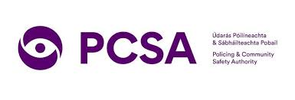 | This research is being carried out by Dr Charles O’Mahony and Fiona McNulty at the University of Galway. The research is supported by the Policing and Community Safety Authority and funded by Research Ireland.  Research Ireland funds research projects that aim to improve knowledge and understanding in different areas law, science and medicine.  The Policing and Community Safety Authority is an independent organisation that oversees policing in Ireland.
Why is This Research Being Done?   | We want to learn about the experiences of disabled people who have faced targeted abuse or exploitation (sometimes called mate crime).  We also want to understand how police, disability services, and communities respond to these issues and what can be done to improve safety and justice for disabled people.
Who Can Take Part?   | We are inviting disabled people, self-advocates, and people working in disability support services, advocacy, or policing to share their experiences and knowledge.
Do I Have to Take Part?   | ❌ No. Taking part is your choice. You can say no now or change your mind later.
Can I Leave the Study Later?  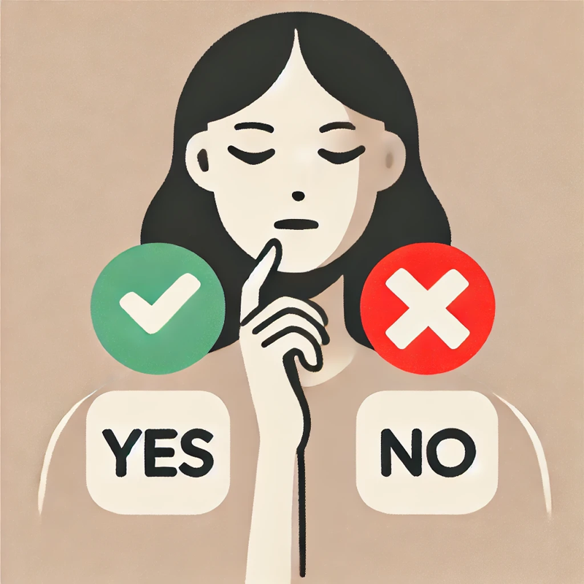 | ✅ Yes. You can leave the survey at any time without submitting.
What Will Happen If I Take Part?   | Through completion of the survey.
Will I Get Paid?   | No. There is no payment for taking part in this study.
What Are the Benefits of Taking Part?   | Your feedback may help influence policy discussions and improve understanding of targeted abuse against disabled people.
Could This Be Difficult for Me?  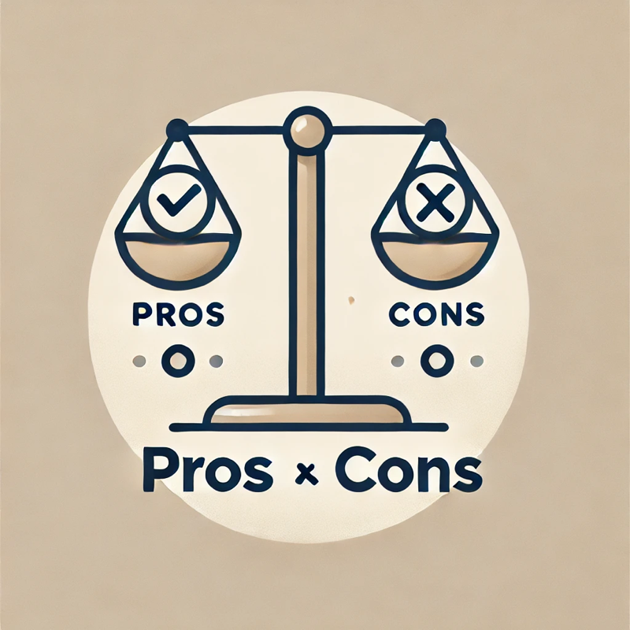 | Talking about your experiences may be emotional.  If you feel uncomfortable, you can pause, stop, or leave at any time.
Will My Information Be Kept Private?   | Yes. Everything you share will be kept confidential.  Your name will not be used.
 | Easy Read Survey  We have developed an easy read version of the survey. This can be filled out and emailed or posted to Dr Charles O’Mahony (see contact information below).  If you would like support to complete the survey or require any accommodations, or support please contact the research team Charles and Fiona (see contact details below).
Will My Words Be Used in the Research?  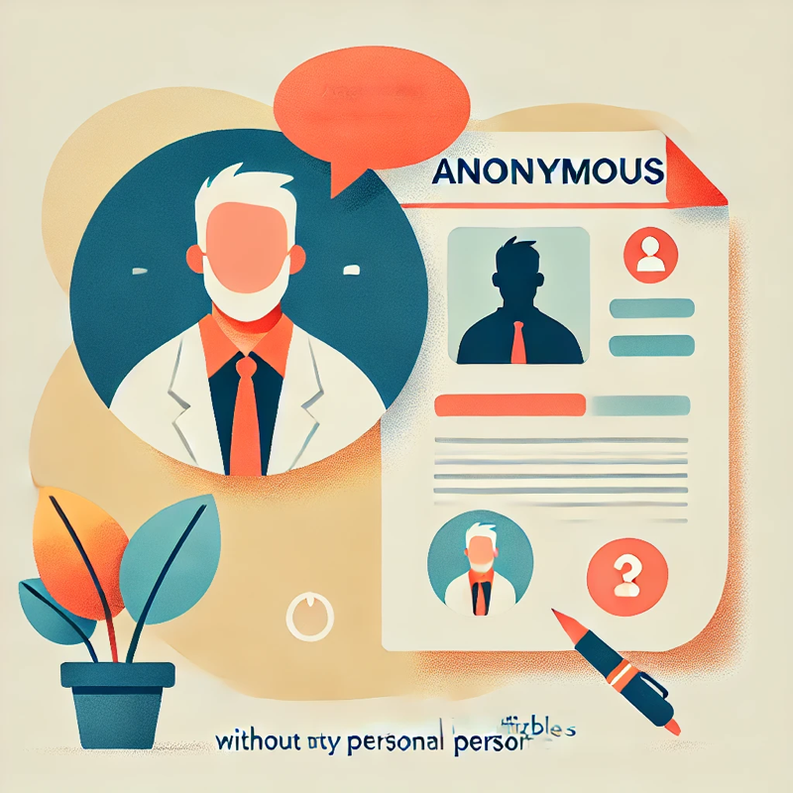 | Yes, but anonymously. We may use some quotes from the survey. But no one will be identified.
What Will Happen With the Research?   | This research will help raise awareness of targeted abuse against disabled people.  It may be used to suggest policy changes, but we cannot promise that it will lead to direct improvements.
Who Approved This Research?   | This research has been approved by the University of Galway Research Ethics Committee (TBC).
Who Can I Contact for More Information?  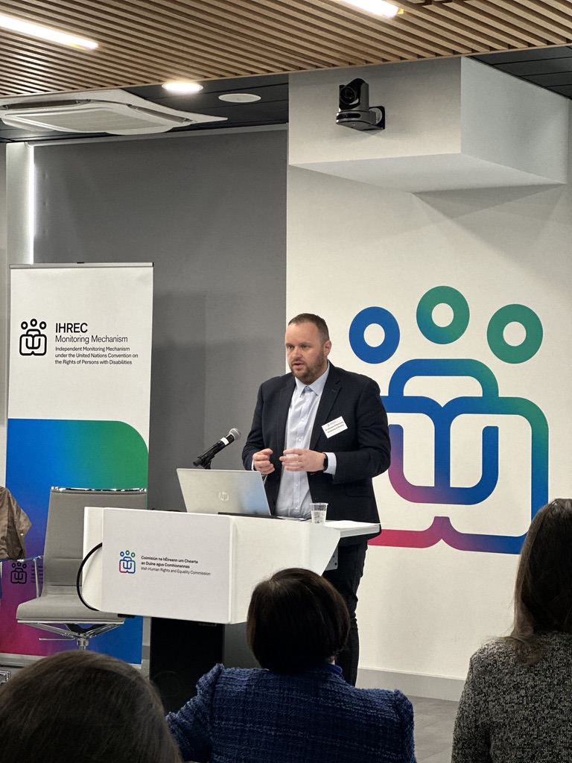 | Dr Charles O’Mahony  Associate Professor in Law  School of Law, University of Galway, Galway, H91 TK33  📧 charles.omahony@universityofgalway.ie  📞 +353 (0)91 494391  Fiona McNulty  Researcher  School of Law, University of Galway, Galway, H91 TK33  📧 fiona.mcnulty@universityofgalway.ie

