CH120 - Chemistry: Molecular Science (A.Y. 2023/2024)
General Information
- Credits: 15
- Course instances: 0MB3, 1BGG1, 1BO1, 1MR1
- Coordinator: Dr Constantina Papatriantafyllopoulou
Academic staff involved: Dr C.Papatriantafyllopoulou, Dr A. Erxleben, Dr S. von Euw, Prof. O. Thomas, Dr B. Mai
- Module delivery
- Lectures: 66 (30 in Sem. I, 36 in Sem. II)
- Tutorials: 16 (7 in Sem. I, 9 in Sem. II)
- Practicals: 8 (8 in Sem. I (1BGG1 and 1MR1 only), 8 in Sem. II (0MB3 and 1BO1 only))

The indicative timetable is reported below:

SEMESTER I

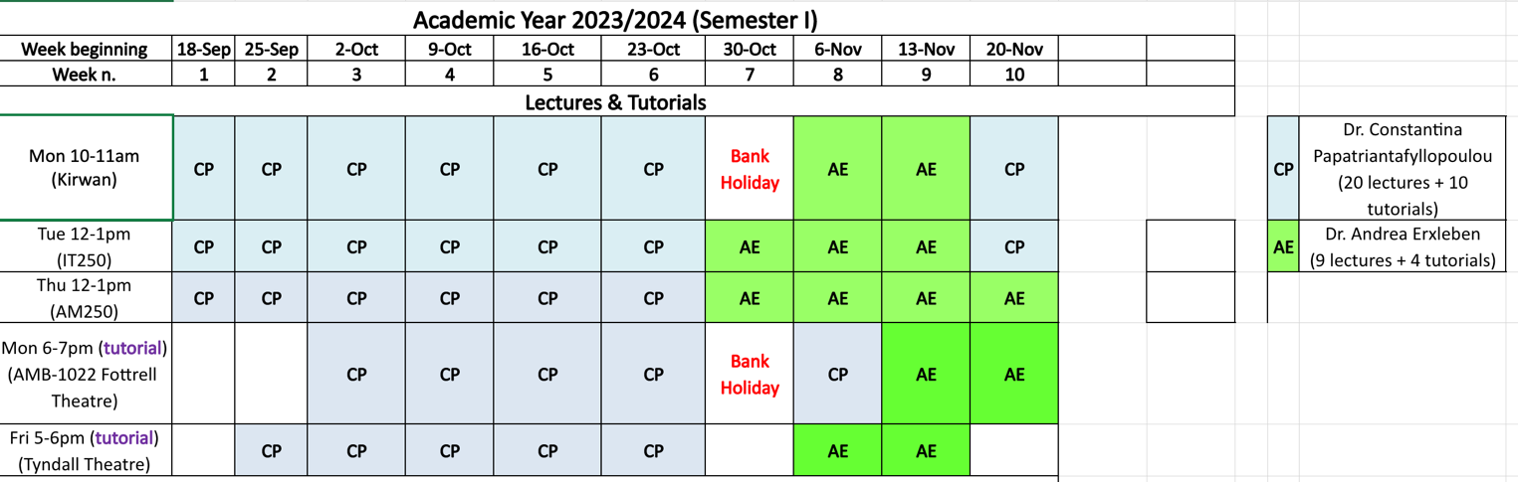
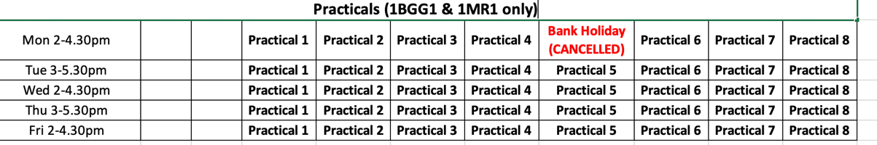

SEMESTER II
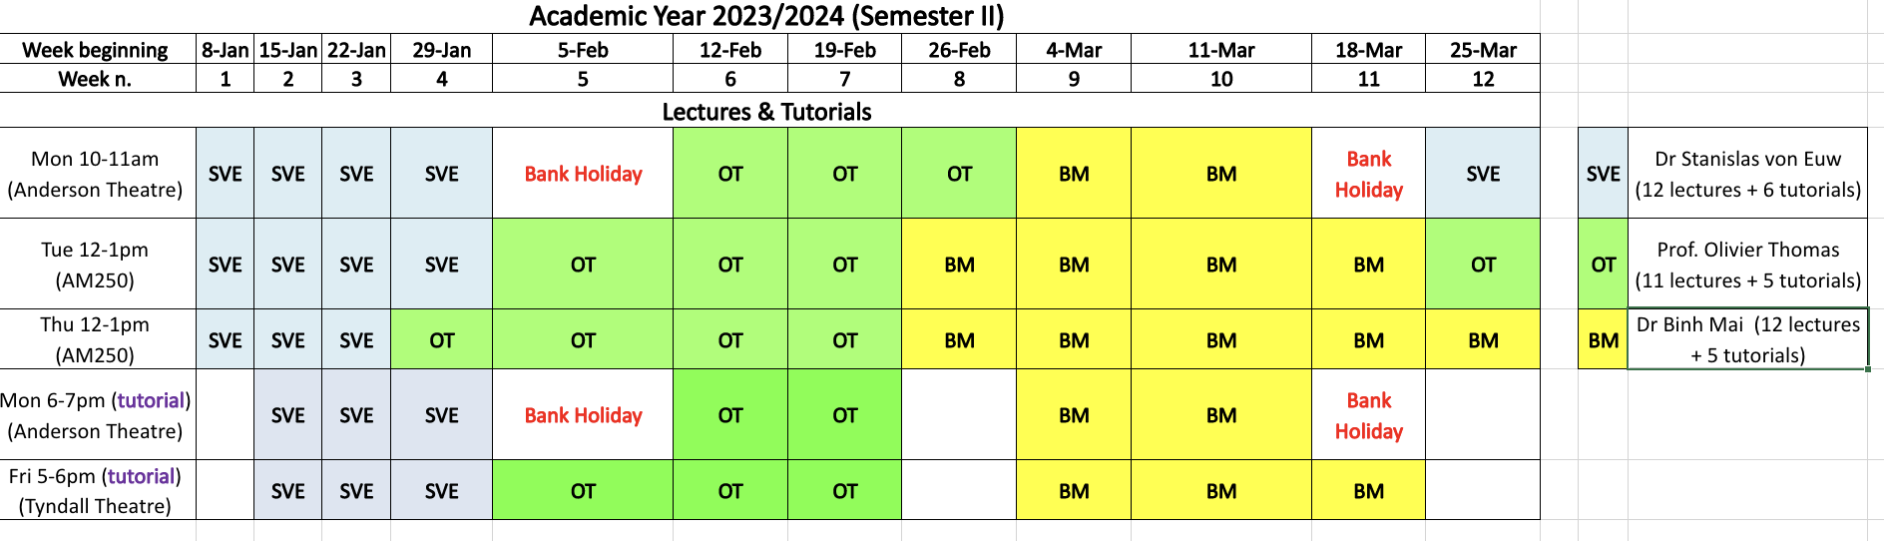
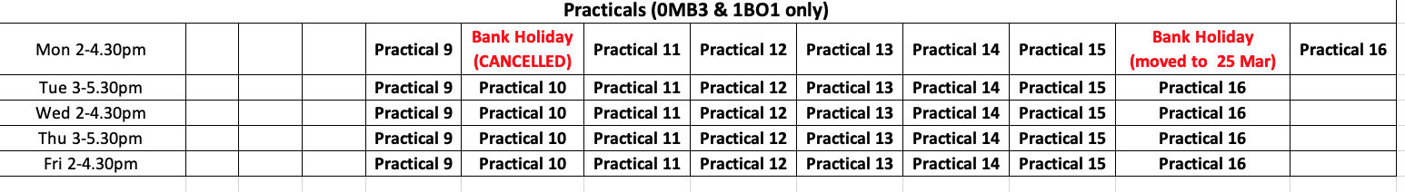
Unless otherwise stated, all lectures and tutorials will be delivered on campus according to the timetable provided. In order to improve the learning process and facilitate the effective interaction between students and lecturers, the same tutorial is delivered twice per week, meaning that students will have the option to attend the weekly tutorials either on Mondays or Fridays.
As far as the practical component of the course is concerned, there are 20 hours of laboratory work split into 8 practical sessions of 2.5 hours each. Students will be notified by the College the day of practicals and allocated a bench number. Pre-practical talks, highlighting the practical and theoretical aspects of the laboratory experience to be carried out, as well as the associated health and safety information, will be held in the laboratory prior to the actual start of the practical.
All practicals will be carried out on campus. Students are expected to perform their laboratory work on the assigned day (no day swapping allowed).
Laboratory prerequisites:
- Students must bring their own white laboratory coat and safety glasses/goggles (available at the SU shop). Laboratory coats and safety glasses cannot be hired or borrowed: should a student arrive at a practical without their own laboratory coat and/or safety glasses/goggles, they will not be allowed to carry out the practical and, as such, will be given an unauthorized absence.
- Students must attend the pre-practical talks: should a student not attend the pre-practical talk, they will not be allowed to carry out the practical and, as such, will be given an unauthorized absence.
- The electronic version of the laboratory manual will be available on Canvas. Students must bring their own printout of the laboratory manual (no hardcopy provided, mobile phones/tablets/laptops strictly prohibited): should a student arrive at a practical without their own printout of the laboratory manual, they will not be allowed to carry out the practical and, as such, will be given an unauthorized absence.
Course Outline & Learning Outcomes

- Atoms and the Periodic Table
Basic atomic theory, electron configuration and periodic properties
- Chemical Bonding
From atoms to molecules, chemical formulas and molecular shape
- Quantitative Chemistry
Mole, percent composition and concentration
- Thermodynamics
Enthalpy and entropy, spontaneous change and chemical equilibrium
- Reactions in Aqueous Solutions
Acids and bases, redox reactions, solubility and titrations
- States of Matter
Intermolecular forces, gases, liquids and solids
- Kinetics
Activation energy, reaction rates and mechanisms
- The Molecules of Life
Carbon-based compounds and their reactivity
On successful completion of this Module, the learner will be able to:
- show an understanding of fundamental atomic structure and rationalize the properties of the elements and their compounds based on electron configuration and periodic trends;
- draw representations of the bonding and geometry of simple molecules and ions;
- predict chemical formulas of compounds using valence considerations and the knowledge of simple and complex cations and anions;
- solve quantitative chemistry problems and demonstrate reasoning clearly and completely as applied to mass- and mole-type calculations, acid-base, redox and precipitation reactions in aqueous solutions;
- solve quantitative problems involving chemical equilibrium and chemical kinetics, to include thermochemistry, entropy, Gibbs free energy, the direction of spontaneous change, and the effect of temperature on the rate of reactions;
- use models of structure at the atomic/molecular level, including intermolecular forces, to explain the physical properties of matter;
- predict and explain the expected chemical and physical behavior of simple organic compounds based on their functional groups and geometry, to include conformation and stereochemistry;
- show an understanding of the threshold concepts of nucleophiles, electrophiles, electronegativity, and delocalization/resonance;
- draw mechanisms of selected fundamental organic reactions, to include substitution, elimination and addition reactions, and predict their outcome;
- develop skills in problem solving, critical thinking and analytical reasoning as applied to scientific problems;
- appreciate the central role and societal relevance of chemistry and use this as a basis for ethical behavior in issues facing chemists including an understanding of safe handling of chemicals and environmental impact, as well as key issues facing our society in energy, health and medicine.
On successful completion of the associated practical work in the laboratory, the learner will be able to:
- analyze salts for the presence of common cations and anions, and simple organic substances for the presence of common functional groups;
- use titrimetry and physico-chemical techniques for quantitative analysis and to determine physico-chemical properties;
- use appropriate laboratory techniques and equipment to synthesize, separate and purify chemical compounds;
- implement safe work practices in a chemistry laboratory, to include awareness of common hazards and appropriate safety precautions;
- carry out scientific experiments, accurately record and analyze the results of such experiments, and report to a scientifically acceptable standard on laboratory work.

Textbook and Reference Material
- P. Flowers, K. Theopold, R. Langley, E.J. Neth, W.R. Robinson, Chemistry: Atoms First 2e, OpenStaxTM, 2019 (web version last updated in June 2023 downloadable for free at https://openstax.org/details/books/chemistry-atoms-first-2e).
- First Year Chemistry Laboratory Manual (downloadable from Canvas).
- Lecture notes, slides and literature papers (provided in due course on Canvas).

Module Assessment & Marking
The Module will be assessed over the two Semesters as follows:
- Continuous Assessment (CA, overall worth 40% of the final grade):
  - Mandatory attendance to laboratory sessions and submission of a written report on the laboratory work each week (worth 30%)
  - 18 weekly online homework (9 in Semester I / 9 in Semester II) on topics dealt with during lectures/tutorials (worth 10%)
- Two formal two-hour duration written examinations at the end of each Semester on the theory course (overall worth 60% of the final grade):
  - Paper-1 ⇒ multiple choice question (MCQ) examination at the end of Semester I (worth 30%)
  - Paper-2 ⇒ multiple choice question (MCQ) examination at the end of Semester II (worth 30%)

Continuous Assessment
- Laboratory attendance ⇒ mandatory to all pre-practical talks and subsequent laboratory sessions. One authorized absence may be given only for:
  - medical reasons (upon provision of an official medical certificate);
  - bereavement in the event of the death of an immediate family member;
  - participation to scheduled sports events involving members of any of the University of Galway sports teams (upon provision of an official absence request sent in advance by the University of Galway Sports Office).
Requests for authorized absences will be evaluated on a case-by-case basis.
- Laboratory reports ⇒ reports of the laboratory work submitted each week through Canvas Templates of the laboratory reports are included in the laboratory manual. Downloadable templates of the laboratory reports (as Word documents) will be available in due course on Canvas. Attending the laboratory only is not enough to get credits: practicals must be completed satisfactorily and complete laboratory reports must be submitted weekly through Canvas by the relevant deadline. Each report will be marked out of 10. A “zero” will be assigned for late or no submission.

- Online homework ⇒ weekly assignments to be worked out online over the two semesters. A total of 18 online homework will be assigned on a weekly basis over the two semesters and will need to be completed and submitted through Canvas by the relevant deadline (to be communicated in due course). Each homework will be marked out of 10 and will comprise of short-answer questions, numerical problems and multiple-choice questions.
Written Examination
Past exam papers are available on Canvas and in the Exam Papers Archive (https://regexam.nuigalway.ie/regexam/paper_index_search_main_menu.asp) of the James Hardiman Library. Note that, according to the policy in place at the School of Biological and Chemical Sciences, past repeat (i.e. 2nd sitting) exam papers are not made available, nor are past MCQ-type examinations (i.e. Paper-1).
- Paper-1 ⇒ MCQ examination at the end of Semester I
The written examination of two-hour duration will be marked out of 45 and the overall grade to be returned as % mark. It will consist of 45 MCQs (marking scheme: +1 for each correct answer, 0 for each unattempt question, 0 for each incorrect answer) and students are required to answer all MCQs.
- Paper-2 ⇒ multiple choice question (MCQ) examination at the end of Semester II. Same layout as Paper-1.

Marking
Marks of laboratory reports and online homework will be made available on Canvas in due course.
Results of Paper-1 examination will be returned on Blackboard as provisional grades (not as percentage) as follows:
  - grade A: 70-100%
  - grade B: 60-69%
  - grade C: 50-59%
  - grade D: 40-49%
  - grade E+: 35-39%
  - grade E-: 30-34%
  - grade F: 0-29%
Students will be communicated the aggregate mark for the Module once the overall examination process is complete (that is, at the end of Semester II after the final written examination has been marked).
A student will have passed if the mark in the CA component is at least 35% (that is, 14 out of 40) and the aggregate mark for the Module is at least 40%.
A student will be deemed incomplete if the mark in the CA component is less than 35%. Should this be the case they will not be able to progress regardless of the performance in the written examination for the Module in the 1st sitting. Consequently, the student will not be allowed to re-sit either, and will have to re-register for the Module the following year and re-engage in all parts of the Module again.
A student will have failed the 1st sitting where the mark in the CA component is at least 35% but the aggregate mark for the Module is less than 40%. Should this be the case, the student will have to repeat the written examination in the 2nd sitting with a view to improving the overall Module mark, retaining the CA mark from the 1st sitting. Should the student underperform also in the 2nd sitting (that is, by obtaining an aggregate mark for the Module lower than 40%), they will have failed the 2nd sitting and will have to re-register for the Module the following year and re-engage in all parts of the Module again.

