NUI Galway Invoice Scanning

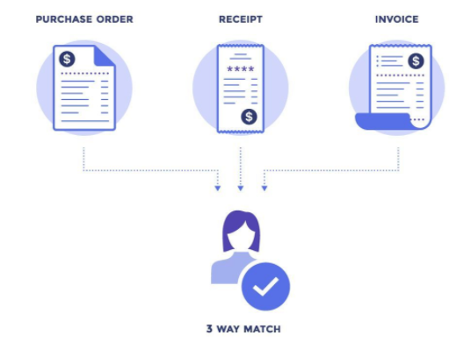
In order to facilitate prompt processing and payment of suppliers, it is vitally important to adhere strictly to the following steps:

- Suppliers must email invoices directly to Accounts Payable, at accountspayable@nuigalway.ie.
- Attach one invoice only in PDF format i.e. emails can have multiple pdf attachments (invoices) provided it is only one invoice per pdf.
- The PDF must be an attachment, not embedded within the body of the email.

- Please ensure that the Goods Received Note is completed on Agresso which is your acknowledgement of satisfactory delivery and agreement to pay the supplier. If the GRN is not completed, the invoice will not be processed for payment.
All invoices are scanned into Agresso and will be checked against the Purchase Order and Goods Received Note. If the 3 match, the invoice will be processed and paid.

- If the invoice is for a greater amount than the original Purchase Order, complete the task as indicated in FAQ 1 below.

- If you forget to complete the Goods Received Note, complete the task as indicated in FAQ 2 below.

- If an invoice is in dispute, contact the supplier directly and only when resolved, should the invoice and credit note (if applicable) be GRNed/approved.

- If you receive a task alert email as below: Non-PO invoice coding
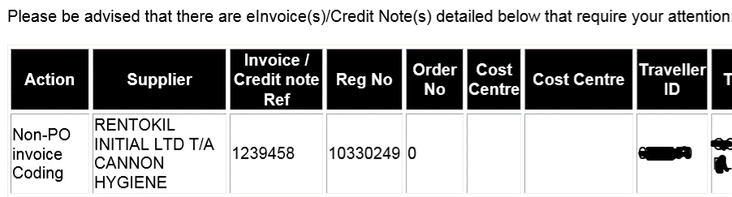
This is where an invoice has been received, where the Purchase Order has not been indicated on the invoice. You must log into Agresso, open the task, within your task list and select “Query with AP”, indicate in the workflow comment the Purchase Order Number and select again “Query with AP”

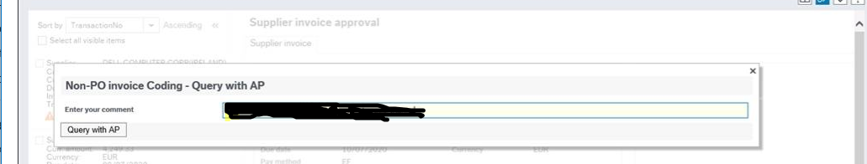

The invoice will be returned to Accounts Payable to be matched to the PO indicated, and provided the GRN is completed and the 3 match, the invoice will be processed and paid.

FAQ 1. What happens if there is a price difference between the order and invoice?
Please follow the instructions in the workflow task which is sent to the requisitioner initially. If in agreement with the additional cost, click on Approve. The task will then be sent to the Budget Holder. If not in agreement, click Park and contact the supplier to request a credit note. When you receive the credit note un-park the invoice and approve if all is in order.
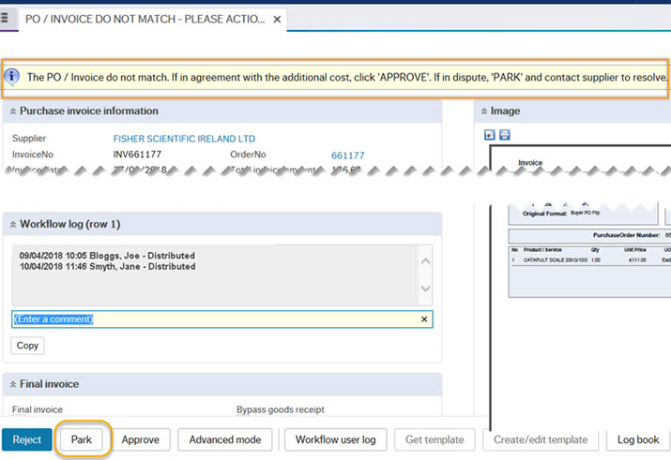

FAQ 2. What‌ happens if I forget to do a GRN?
A missing Goods Receipt Note email is sent to the Requisitioner if the invoice is received and the ‌GRN has not been completed.
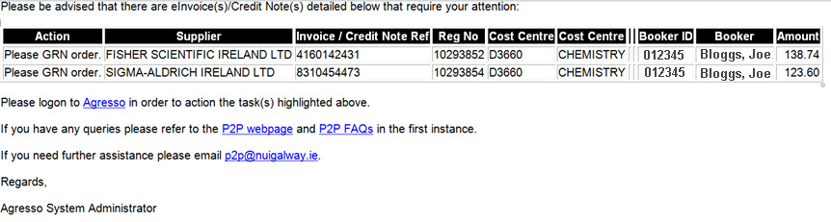
They must then log in to the Financial System (Agresso) and complete the GRN task as follows.
Please click RECEIVE GOODS to confirm the GRN in full, or click Goods receipt for partial receipt.
REJECT will return the invoice to Accounts Payable.
A second task will then appear to accept the invoice, by clicking on the “Accept” button.
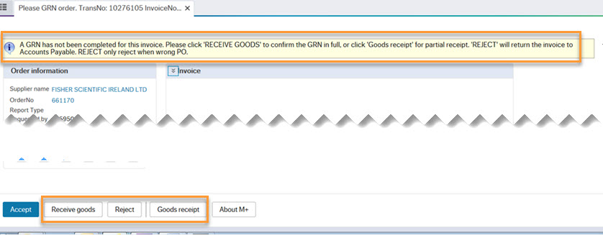

Why did I receive an email from the Financial System (Agresso) - "P2P - EINVOICES/CREDIT NOTE APPROVAL ALERT" asking me to “Please GRN Order” even though I did a GRN?
The following email task alert will arise if a Goods Received Note is completed after the invoice has been received into Financial System from the supplier.
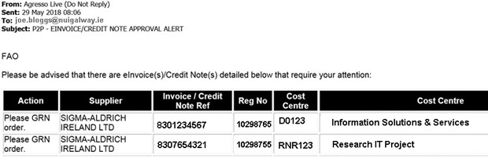
You must log into the Financial System and confirm that the invoice should be accepted if all is in order, by clicking on the Accept button, see below. The Reject button will return the invoice to Accounts Payable.

