Bachelor of Science in Geography and Geosystems
FIRST YEAR
Academic Year 2026 / 2027
Year Coordinator: Dr Audrey Morley
Email: audrey.morley@universityofgalway.ie

The Discipline of Geography welcomes you to the BSc Geography and Geosystems Programme!
Over the course of the next four years, you will be trained in human-environment relationships with a focus on the spatial dynamics of the natural world and management of our natural resources. The BSc (Geography and Geosystems) addresses the challenge of mapping and understanding spatial and temporal variability of natural systems and measuring the impacts of climate change and human activities on their health and resilience at various scales. The overall motivation of the programme is the conviction that informed decision-making must be based upon scientific data as we try to project how these natural systems will respond to short- and long-term forcing.
Please note that times and venues are subject to changes. Please track information on Canvas to stay on top of times and venues for each module
Semester 1 2026/2027
Semester 1 | Monday | Tuesday | Wednesday | Thursday | Friday
09:00 | CP102 L  Lamour LT | BO101 L (G2)  Anderson LT
10:00 |  | MA161 L  Kirwan LT | MA161 L  Kirwan LT | MA161 L  Kirwan LT
11:00 |  | BO101 L (G2)  IT250 |  | BO101 L (G2)  Anderson LT
12:00 |  |  | TI150 TI1103  O’Flaherty LT |  | CP102 L  CSB-G005
13:00 | MA161 L  O’Flaherty LT |  |  | MA161 P*  IT125G
14:00
CP102P
TBD
15:00 | TI150 TI1103  OhEocha LT |  |  | CP102P  TBD
16:00 | MA161 P* | MA161 P* |  | CP102P  TBD
 | ADB-1020 | ADB-1020 |  | BO101 P  TBD
17:00 | CP102 L | TI150 TI1103  Anderson LT |  | BO101 P  TBD
 | CSB-G005 | TI150 TI1103  Anderson LT |  | BO101 P  TBD
18:00 | MA161 P* |  |  | BO101 P  TBD
 | AC215

Semester 2 2025/2026
Semester 2 | Monday | Tuesday | Wednesday | Thursday | Friday
09:00 | BO101 L (G2)
 | O’Flaherty LT |  |  |  | CP102 P*
10:00 |  | MA161 L  Kirwan LT | MA161 L  Kirwan LT | MA161 L  Kirwan LT
11:00 |  |  |  |  | TI150 TI1103  Kirwan LT
12:00 | CP102 L |  | CP102 L  D’Arcy Thom. LT
 | AUC-G002 |  | CP102 L  D’Arcy Thom. LT
13:00 | MA161 L  Kirwan LT | BO101 L (G2) |  | BO101 L (G2
 | MA161 L  Kirwan LT | Kirwan LT |  | Kirwan LT
14:00 |  |  | MA161 P*  AC204 | CP102 P* | CP102 P*
15:00 | TI151 TI1103  OhEocha LT |  |  | CP102 P* | CP102 P*
16:00 |  | MA161 P*
 |  | ADB-1020 |  | BO101 P  TBD
17:00 |  | TI151 TI1103  O’Flaherty LT |  | BO101 P  TBD
18:00 |  |  |  | BO101 P  TBD
* Students attend one MA161 Practical per week
*CP102 Practicals: Students will be assigned one of the 3 Practical slots
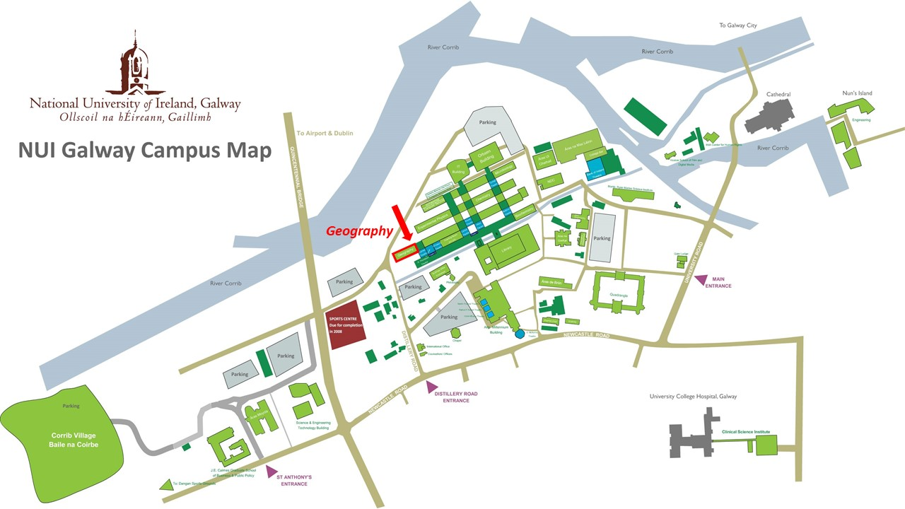
Figure 1 University of Galway Campus Map

Key contacts in Geography
Head of Geography
Dr Patrick Collins
patrick.collins@universityofgalway.ie

Geography Administrator
Christina Costello
Christina.costello@universityofgalway.ie

Senior Technician/Cartographer
William Hamilton
William.hamilton@universityofgalway.ie

1 BA Geography Programme Coordinator
Dr Eugene Farrell
Eugene.farrell@universityofgalway.ie

1 BSc Geography and Geosystems Coordinator
Dr Audrey Morley
Audrey.morley@universityofgalway.ie

Module Outlines:
BO101 Biology
Coordinators: Dr Maria Barrett, maria.barrett@universityofgalway.ie
Dr Peter McKeown, peter.mckeown@universityofgalway.ie
Dr Liam Morrison, liam.morrison@universityofgalway.ie
Dr Susan Gallagher, susan.gallagher@universityofgalway.ie
Biology is an integrative and interdisciplinary field that aims to investigate the dynamic and complex nature of living systems in terms of their molecular components and the interactions between organisms and their biotic and abiotic environment. This module will introduce students to fundamental concepts of biology. The course is intended to provide the necessary biological background to allow learners in general and specialised Science courses, Foundation Medicine and Biomedical Engineering to progress into more specialised topics in later years. First, the nature of biomolecules and the basis for cellular form and function are discussed. Then students are introduced to the structure, function, diversity and impact of plants, animals, and microorganisms.
BO101 comprises three lectures and one lab practical per week.
CP102 Chemistry & Physics
Coordinator: Dr Mihai Lomora mihai.lomora@universityofgalway.ie
Prof Paul Murphy paul.v.murphy@universityofgalway.ie
Dr Andrea Erxleben andrea.erxleben@universityofgalway.ie

This module lays a broad foundation in chemistry and physics for students who need an introductory level knowledge of the physical sciences for the denominated courses in Marine Science and Health and Safety Systems. Some of the students may have level 4/5 knowledge of either or both subjects but no prior knowledge is assumed in the course design. The level of mathematics required for the physics component is simple algebra and trigonometry.
In Semesters I (12 weeks overall) the module is delivered in 36 lectures (normally 3 one-hour lectures per week) and 11 tutorials (normally 1 one-hour tutorial per week). All lectures will be delivered in person. There will be no recording of lectures made available on CANVAS as students are expected to engage with and attend the lectures. All tutorials will also be delivered in person on campus.
MA161 Mathematical Studies
Coordinator: Dr Goetz Pfeiffer goetz.pfeiffer@universityofgalway.ie
Dr Donal O'Regan donal.oregan@universityofgalway.ie
Mathematical Studies MA161 is an introduction to university mathematics aimed at students studying the physical and life sciences. The majority of MA161 students will have studied ordinary level mathematics at Leaving Certificate, though some will have studied the subject at higher level. Although students are unable to proceed from this module to a Mathematics BSc, the module does lead on to a range of second- and third-year Mathematical Studies modules relevant to the physical and life sciences.
Geography Modules:
Semester 1
ECT | Module | Coordinator | Day, Time | Assessment
5 | TI150 Principles of Human Geography | Prof Frances Fahy | Mondays 3pm: OhEocha Theatre  Tuesdays 5pm: Anderson Theatre  Wednesdays 12pm: O’Flaherty Theatre | CA / MCQ
10 | TI1100/ TI1101 Geography in Action (GiA) | Dr Eugene  Farrell | Details in GiA handbook | CA
Semester 2
5 | TI151 Principles of Physical Geography | Dr Gordon  Bromley | Mondays 3pm: OhEocha Theatre  Tuesdays 5pm: O’Flaherty Theatre  Fridays 11 am: Kirwan Theatre | CA / MCQ
10 | TI1100/ TI1103 Geography in Action (GiA) | Dr Eugene  Farrell | Details in GiA handbook | CA

TI 150 Principles of Human Geography
Coordinator: Prof Frances Fahy frances.fahy@universityofgalway.ie

This course seeks to introduce key problems, concepts and contexts within human geography. Its focus is a contemporary one: it strives to illuminate the world of today by exploring and analysing the origin of central issues that make the headlines (or not) in the media and beyond. The course places lectures alongside the information given in the textbook; for examination purposes, both are essential. Major Themes covered in TI 150 (subject to change depending on staff availability) Rural Geographies, Cultural Geographies, Environment and Society, Social Geographies, Economic Geographies, Political Geographies, Development Geographies, Urban Geographies.
TI 151 Principles of Physical Geography
Coordinator: Dr Gordon Bromley gordon.bromley@universityofgalway.ie
This course is designed to provide insight and understanding to the fundamental concepts and principles of physical geography as an academic discipline. In doing this, the course explores how the physical environment functions; how different environmental systems interact and how the physical environment impacts on human activities. The course explores the various components that make up these environmental systems, such as the biosphere, atmosphere, hydrosphere and geosphere. In addition, the course also provides some understanding of how these fundamentals apply to Ireland and in so doing gives an insight into the richness of the physical geography of Ireland. Major Themes covered in TI 151: The Biosphere: Biogeography – species distribution and ecosystems; The Atmosphere: Weather and Climate, Glaciers and Glaciation; The Hydrosphere: Rivers The Geosphere: Coasts.
TI 1103 Geography in Action (GiA)
Coordinator: Dr Eugene Farrell Eugene.farrell@universityofgalway.ie
This module introduces first-year geography students to a range of skill-based exercises designed to enhance their learning experience and develop their research competences. Supported by on-line lectures and class-based tutorials, students undertake a series of exercises on referencing, academic writing, mapping, data analysis and fieldwork that will reinforce the skills geographers use every day. Further information on each exercise and submission dates is available in the TI1100/TI1101 handbook on CANVAS.

