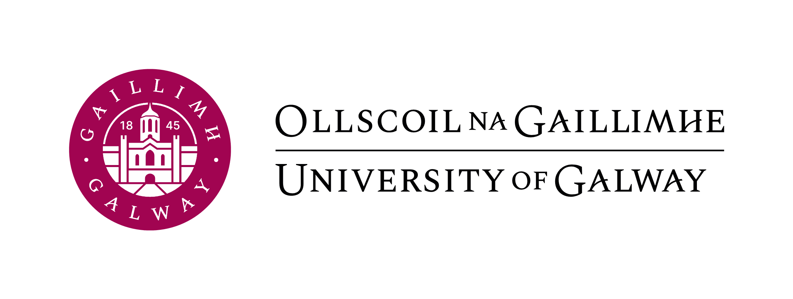
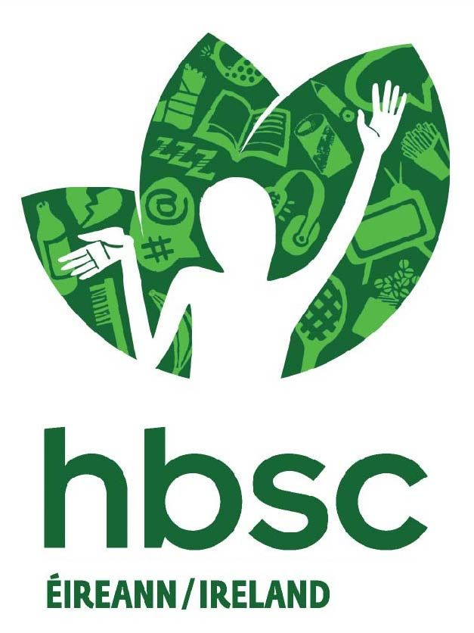

HBSC Ireland Short Report Request Form
Name:
Organisation:
Contact details:
Phone:
Email:
Date of request:
Main research question:

What areas/variables are you interested in? (Please describe using the national report as a guide to areas/variables)

What will the analysis be used for (brief overview) e.g. reprint in report, for use in internal meetings in my Department, thesis/research project etc.

The most recent survey round will be used for analyses unless otherwise requested

Terms of using information received from HBSC Ireland;
Any reprints or use of the HBSC data must reference/acknowledge the HBSC study as
appropriate, please see the link
https://www.universityofgalway.ie/hbsc/acknowledgements/

Please Tick to indicate you understand these terms

The HBSC study in Ireland (www.universityofgalway.ie/hbsc) is conducted by staff of the Health Promotion Research Centre, University of Galway (www.universityofgalway.ie/hpr) and is part of the World Health Organization Collaborative Study – Health Behaviour in School-aged Children (www.hbsc.org)

