
Report an Incident:
Accident | Near Miss | Hazard
Help keep our campus safe by reporting any incidents you witness. Scan the QR code below to access the incident reporting form.
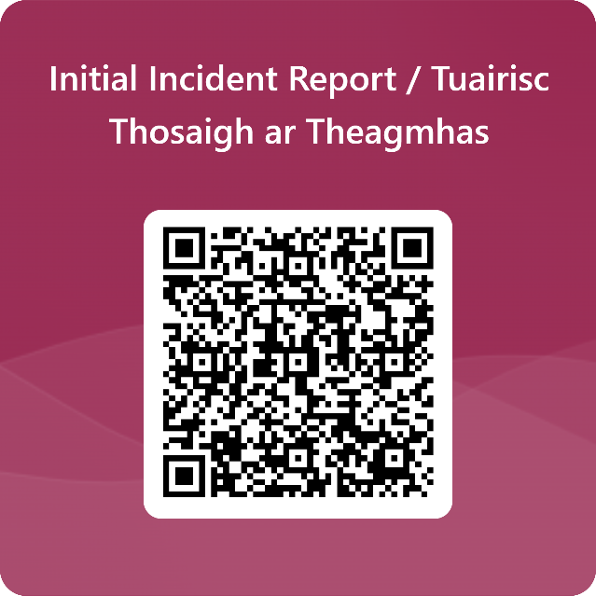
IN AN EMERGENCY:
- Call 112 / 999 for emergency services.
- For security issues, contact University Security at (091) 493333.

Thank you for contributing to a safer campus for everyone!
SEE IT - REPORT IT - SORTED

