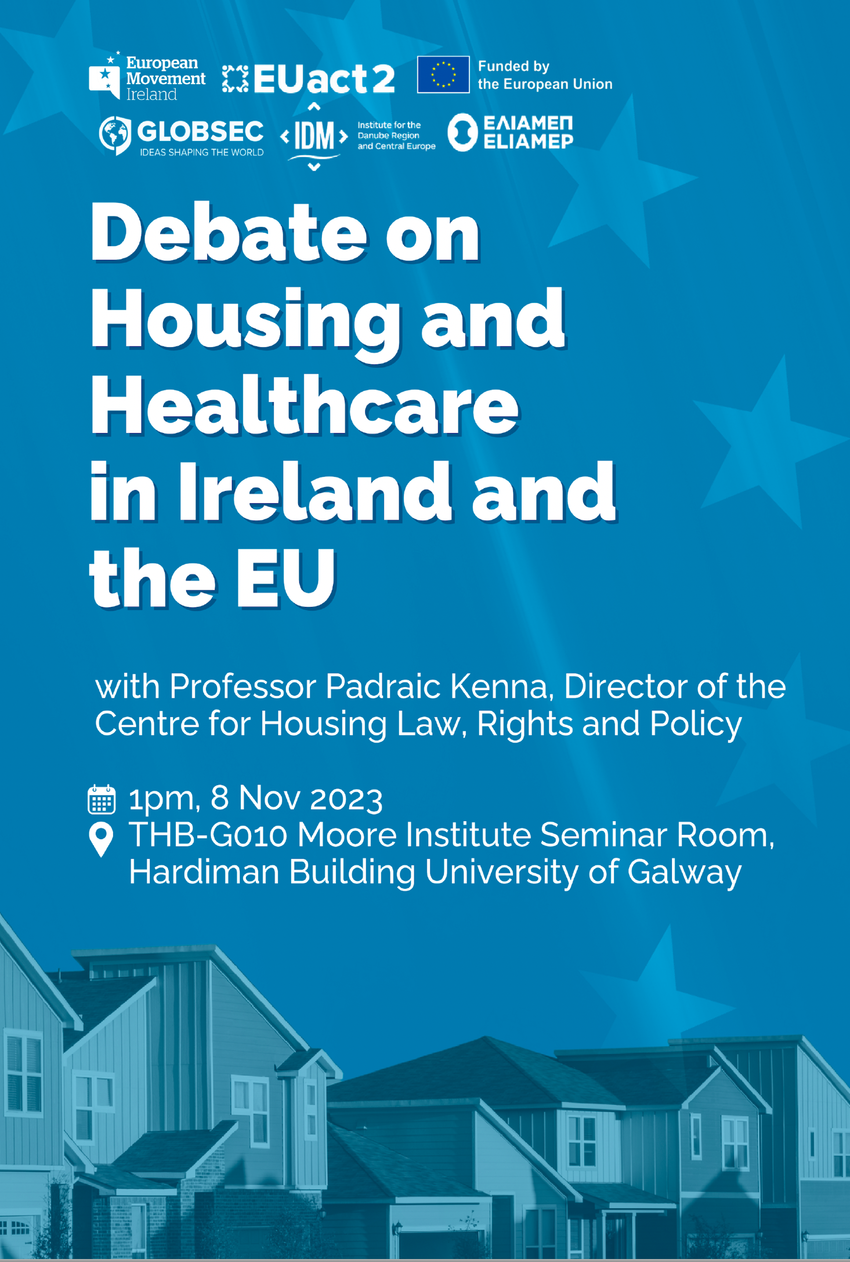

EUACT 2 Debate - Housing and Healthcare in Ireland and the EU
13:00-15:00 | Wednesday, 08 November 2023 | THB-G010 Moore Institute Seminar Room, Hardiman Building, University of Galway.
EUAct2 is a pan-European programme, aimed at building democratic engagement with people who don’t always feel heard in the EU. We’re bring together people living in Ireland, Austria, Greece and Slovakia, giving them a platform to influence policies and share their ideas on a truly international level. We want you to have a seat at the table in discussing and influencing crucial policy.
EM Ireland and our partner organisations will be carrying out focus groups, online discussions, open panels and large forums, so we can hear your ideas. We’re asking you to share opinions and ideas about policy, to shape actions and initiatives at a European level. So come take part, and join our debate!
We want to know how you feel about the EU, what EU issues are important to you, and how you want to be represented in the future. This is your chance to let us know.
Date: Wednesday 08 November 2023
Time: 13.00 – 15.00 with light refreshments served
Register here: https://www.europeanmovement.ie/euact-2-debate/
