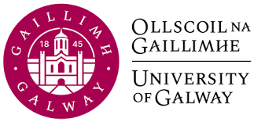

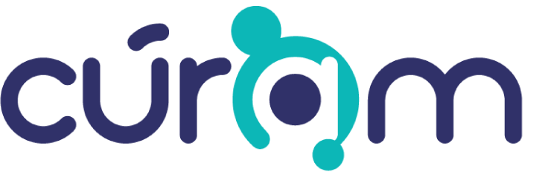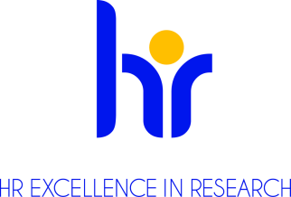
NO-Cancer-Net Project 7 – Hydrogel delivery of NO scavenging therapeutics Marie Sklodowska Curie Actions Doctoral Network PhD Training Position (1 FTE)
CÚRAM, SFI Centre for Medical Devices and Lambe Institute for Translational Research
Ref. No. University of Galway 002-24

Applications are invited from suitably qualified candidates for a full time fixed term MSCA DN Doctoral Candidate (1.0 FTE) to pursue a PhD at the SFI Centre for Research in Medical Devices (CÚRAM) and Lambe Institute for Translational Research University of Galway, Ireland.

The position is available immediately for 36 months at 1.0 FTE. This position is funded through a recent Horizon Europe MSCA DN consortium grant.

Organisation: CÚRAM, SFI Research Centre for Medical Devices is a national, SFI funded, research centre that brings together researchers from University of Galway and other leading universities from Ireland. The prime objective for CÚRAM is to radically improve health outcomes for patients by developing innovative implantable ‘smart’ medical devices to treat major unmet medical needs. Implants will be designed and manufactured to respond to the body’s environment and to deliver therapeutic agents, such as drugs, exactly where needed. Lambe Institute for Translational Research was established in 2015 with the aim to translate basic research findings to clinical applications, in particular cancer research. The Lambe Institute boasts a state-of-the-art research infrastructure including imaging, histology, flow cytometry, molecular biology, gene vector and mammalian cell culture core facilities which are coordinated by a team of fully trained technical support staff.

Website: https://www.universityofgalway.ie/our-research/people/sharonglynn/ https://www.universityofgalway.ie/curam/ and https://www.universityofgalway.ie/cancercentre/research/no-cancer-net/

NO-CANCER-NET:
Recently, Prof. Sharon Glynn and Prof. Abhay Pandit, Principal Investigators (PI) at CÚRAM and the Lambe Institute, have been awarded an EU-funded MSCA Doctoral Network Grant – NO-CANCER-NET: Advanced Engineering of Nitric Oxide Based Therapeutics for Triple Negative Breast Cancer Training Network. The position will help the PI to manage this award as project lead. The postholder will pursue a PhD under the supervision of Prof. Abhay Pandit and co-supervisor Prof. Sharon Glynn.

Successful candidates will be highly motivated and have an excellent track record in academic achievement. They will have a BSC and/or Masters qualification in a biomedical/biomaterials-related field.

Project Description:
Required applicant profile: BSC and/or MSc in Biology/Medicine/Life Science/Bioengineering/Chemistry
Desired Skills: A range of basic techniques of in the areas such as Biochemistry, Molecular and Cellular Biology (biochemical assays, Western blot, real time, cellular assays), Microscopy, Cell culturing, Cloning, FACS, basic knowledge of bioinformatics (R, pithon), Biomaterials, Chemical Synthesis
Project Objectives: The overall objective of this project is to continue development of nitric oxide scavenging agents and their incorporation in optimal hydrogel delivery systems for the treatment of TNBC. 1) To assess and understand the mechanism of cellular uptake of a variety of hemin derivatives across TNBC subtype and understand the factors that influence the success of uptake. 2) To optimize the formulation of injectable hydrogel towards a continuous release of active NO-scavenging compound. 3) To identify the effects of hydrogel degradation products on the NO-induced migration from molecular perspectives.
Secondment(s): University of Siena (3 months), and University of Seville (3 months).
Start date: June 2024.
For more information, contact: Professor Abhay Pandit; Abhay.pandit@universityofgalway.ie

Duties and Responsibilities:
- Performing research into hydrogel and drug development and delivery under the guidance of Prof. Abhay Pandit
- Attending and participating in consortium meetings and training activities
- Reporting of project milestones and deliverables in accordance with EU deadlines
- Any other duties assigned commensurate to this level of post

Qualifications/Skills required:
Essential:
- Masters in Biomedical Sciences/Engineering
- Demonstrated proficiency in wet laboratory experimental techniques
- Demonstrated proficiency in trouble shooting experiments
- Excellent knowledge in data interpretation
- Excellent communication, organisational and interpersonal skills
- Excellent report writing, presentations and IT skills
- Flexibility and ability to work in a team environment

Desirable:
- Any relevant working experience in clinical research, laboratory research or a data management-related role will also be considered.
- If English is not the first language, an English language qualification (IELTS, Cambridge C1 Advanced, Cambridge C2 Advanced, TOEFL, iBT/TOEFL iBT Home Edition, Pearson PTE and Duilingo).

Benefits:
Marie Sklodowska-Curie Doctoral Candidates are paid a competitive gross salary of 3,400 €/month, adjusted for their host country, a Mobility Allowance of 600 €/month and, for researchers who have a family, a Family Allowance of 660 €/month. All amounts are subject to deductions and taxes. Family is defined as persons linked to the researcher by (i) marriage, or (ii) a relationship with equivalent status to a marriage recognised by the national legislation of the country of the beneficiary or of nationality of the researcher, or (iii) dependent children maintained by the researcher. Should the fellow’s personal status (marriage, children) change during the action, they will also become eligible for family allowance.

MSCA DN Eligibility criteria:
To apply for this PhD position, the applicant should fulfil the following conditions:
- Have — at the date of recruitment — a Bachelors and/or Master’s degree in a discipline as indicated in the project description specific to the beneficiary to which you are applying.
- Trans-national mobility: The applicant — at the date of recruitment — should not have resided in the country where the research training takes place for more than 12 months in the 3 years immediately prior to recruitment, and not have carried out their main activity (work, studies, etc.) in that country. For refugees under the Geneva Convention (1951 Refugee Convention and the 1967 Protocol), the refugee procedure (i.e. before refugee status is conferred) will not be counted as ‘period of residence/activity in the country of the beneficiary’.
- Be able to communicate fluently in English (speaking and writing). Oral interview with the prospective advisor may be required.
Further information on research and working at University of Galway is available on Research at University of Galway

For information on moving to Ireland please see www.euraxess.ie

Further information about {school/centre} is available at CÚRAM - CÚRAM (universityofgalway.ie)

For informal enquiries about this post please contact Abhay Pandit abhay.pandit@universityofgalway.ie or Sharon Glynn at NOCancerNet@universityofgalway.ie

To Apply:
Applications are to include (1) a letter of motivation describing why you wish to apply to NO-CANCER-NET and your specific project of choice, (2) an up to date CV, and (3) the contact details of three referees should be submitted via Google Application form https://forms.gle/x2qQrv1p7Bb7PKWU6. Please be aware that your application may be shared amongst the beneficiaries.

Please put reference number University of Galway 002-24 in subject line of all e-mail applications or enquiries.

Closing date for receipt of applications is 5.00 pm (Irish Time) on February 29th 2024

We reserve the right to re-advertise or extend the closing date for this post.

All positions are recruited in line with Open, Transparent, Merit (OTM) and Competency based recruitment.

University of Galway, Galway is an equal opportunities employer

