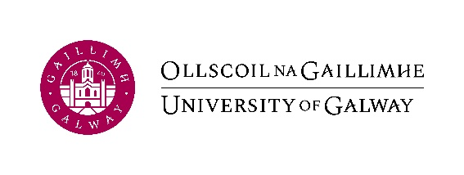
Application form for permission to work outside the University
(Research and Professional Support Staff)
Staff No: | Name: | School/Unit:
Period during: | From: | To:

Please read and adhere to the University AQ413 Conflict of Interests Policy in advance of submitting this request.
Requests must include the following details:
- A description of the “Venture” (work / commercial activity / employment).
- Detail of duties to be undertaken.
- Details of any payment from the other Venture.
- How your working time will be allocated between commitments to University of Galway and to the external venture.
- Address/Location of Company/Venture.
- Where you will be working (Venture).
- A reduction in University of Galway working hours may be required.
  - full time staff (research) are contracted to work 39 hours per week (Mon – Fri between the core hours of 9 – 5).
  - full-time staff (Professional Support) are contracted to work 35 hours per week (Mon – Fri between the core hours of 9 – 5).
- Under the Organisation of Working Time Act, you are entitled to at least 35 hours of rest over the weekend, which includes:
  - A minimum of 24 consecutive hours off within a 7-day period.
  - An 11-hour daily rest period before this 24-hour break.
This means your rest period could be:
  - 11 hours on Friday night + all of Saturday off, or
  - 11 hours on Saturday night + all of Sunday off.

As a result, you cannot work both Saturday and Sunday, as that would not meet the required rest period.
- Any other relevant information.
Type here:

Note: The University staff insurance policy does not cover staff whilst undertaking external activity (non-University of Galway activities).

Intellectual Property:
Does this venture involve the use of any University of Galway intellectual property? Yes / No.
If so – please provide:
- Title of University of Galway Intellectual Property & grant reference numbers if applicable
- Details of University of Galway Innovation office approval
Type here:

Required signatures:
 | Printed name | Signature | Title | Date
Applicant

Line Manager
Head of School/Unit.
Innovation Office (for research staff only)
HR Office

Note: The form should only be forwarded to the HR Office (irin.nichualain@universityofgalway.ie) for approval after all other approvals have been received.
Once permission is approved the University would ask that if staff members are working for themselves or other parties, they should not use the University logo, headed stationery etc. if their business is not meant to represent the University. Furthermore, when airing one’s views, we would ask any staff member of University of Galway to consider the University's position if they are airing those views in public as their association with the University automatically creates the assumption that their views represent those of the University. Further to this we would also ask people not to cite their University of Galway credentials, titles etc. if they are not representing the University.
As previously advised, should there be any change to this employment in the future from what you have advised us of to date, please advise the Office of Human Resources immediately to ensure it remains in compliance with your contract of employment at University of Galway.

