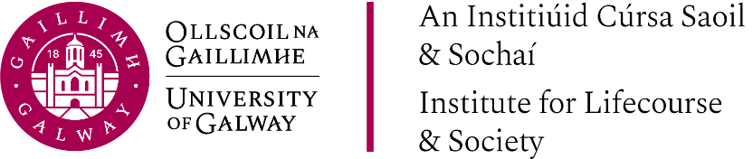

ILAS International Research
Training Series
Enhancing Knowledge Equity through use of Grounded Theory for Social Justice and Decolonisation Approaches
Mon, 31st March 2025

Presentations
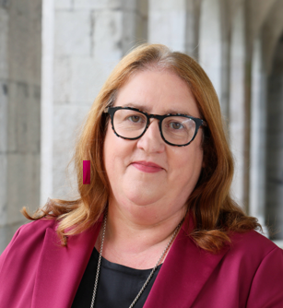 | Enhancing Knowledge Equity and Challenging Epistemic Injustice: Opportunities and Challenges  Presented By: Prof. Caroline McGregor
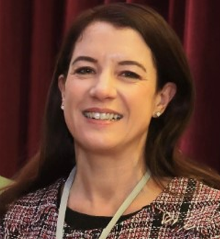 | Constructivist Grounded Theory in Qualitative Research for Social Justice: Purpose, Process, and Promise  (to be added at a later date)  Presented By: Prof. Elaine Keane
 | Where margin meets the centre: Decolonising Curriculum Initiative at the University of Galway  Presented By: Prof. Tanja Kovacic

