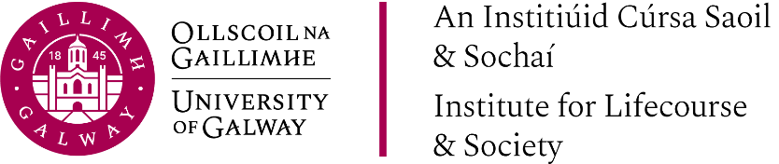

Presentation
Slides

Multidisciplinary Perspectives on Evaluative
Frameworks for Assessing the Economic and
Social Value of Public Policy Interventions

Monday, 15th September 2025

“Health Economic Evaluation for the Health Technology Assessment of Health and Social Care Interventions.”

 | Presentation By:  Professor Paddy Gillespie  Health Economic & Policy Analysis Centre (HEPAC)  Institute for Lifecourse and Society (ILAS)
“2025 Social Return on Investment (SROI) and the Evaluation of Alternative Education Provision Interventions.”

 | Presentation By:  Dr Cormac Forkan  UNESCO Child and Family Research Centre  Institute for Lifecourse and Society (ILAS)
“Critical Perspectives on Evaluating Youth Work.”

 | Presentation By:  Dr Tania de St Croix  King’s College, London

