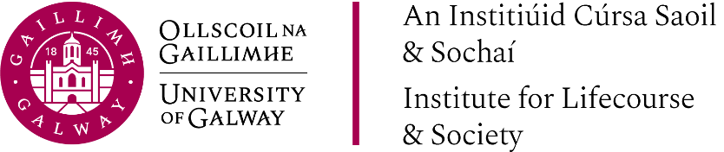

Presentation
Slides

Decolonising research, education,
knowledge production and knowledge exchange - ongoing dialogues

Thursday, 5th March 2026

“Decolonising Social Work Education Memory, Haunting and Critical Hope in the Nordics.”

  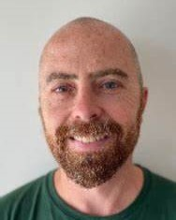 | Presented By:  Prof. Kris Clarke,  University of Helsinki.  Prof. Michael Wallengren Lynch,  Malmo University ,Sweden.

