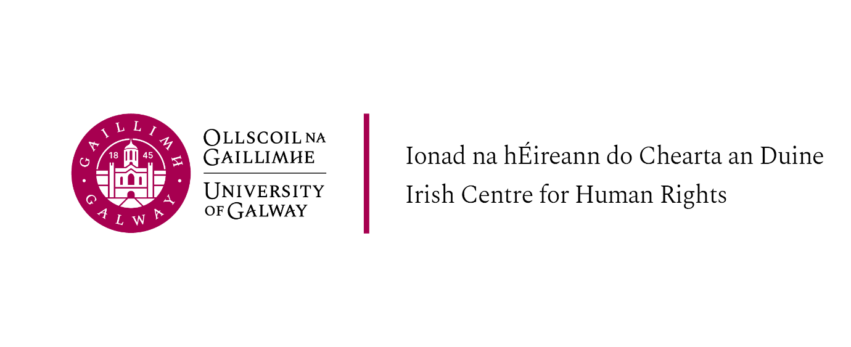
LLM Introductory Week, Schedule of Events, 7th-10th September 2026

Please note that attendance at the introductory sessions is required for all students on the LLM programmes offered at the Irish Centre for Human Rights, they are as follows:
LLM in International Human Rights Law
LLM in International Migration and Refugee Law and Policy
LLM in Peace Operations, Humanitarian Law and Conflict
LLM in International Criminal Law
LLM in Gender and Human Rights: Law and Policy
LLM in Transitional Justice, Human Rights and Conflict

Monday 7th September
Venue: Aula Maxima: Michael D. Higgins Auditorium, The Quadrangle, University of Galway

10.00 (all students)
- Welcome from Prof Martin Hogg, Head of School of Law
- Student supports overview:
- Using Canvas: Dr Sergei Medvedev
- Student Support Officer: Ms Mary Cairns
- Race Equality and Intercultural Skills: Dr Tanja Kovacic
- Academic Integrity Adviser: Ms Anna-Louise Hinds
- Career Development Centre: Ms Aisling Conroy
- English Language Support, Ms Meave Egan

14.00 Welcome and introduction to the Irish Centre for Human Rights
Professor Siobhán Mullally, Director, Irish Centre for Human Rights
ICHR academic and professional services staff and Programme Directors

15.00 Introduction to staff and to LLM modules and Q&A
All ICHR Teaching Staff

15:45 Brief outlines of modules available by Programme Directors outside of ICHR LLM

16.15 Introduction to the Human Rights Podcast and Mooting at the ICHR

Academic Integrity, Legal Research and LLM Dissertation information session (Professor Siobhán Mullally and graduates)

17:00 Welcome reception – Moffetts restaurant, Orbsen building

Tuesday 8th September

Venue: Michael D. Higgins Auditorium, The Quadrangle, University of Galway

9.30 - 10.30 Guest presentation and Q+A with Dr Sophie Capicchiano Young
Title: Death and Disappearance in the US Borderlands'

Break

11.00 - 12.00 Guest presentation, Prof Terry McGovern
Title: "Global Governance in Crisis: Gender Justice, UN80, and Feminist Organizing”

Break

12.30 -1pm Welcome address from the Mayor of Galway city, Cllr Helen Ogbu

14.00 – 15.30 Inaugural Professorial Lecture Professor Ekaterina Yahyaoui Krivenko Title: Equality in International Human Rights Law: Relations, Comparisons and Future Directions
Break

4-5pm Guest presentation: Dr Illan Wall, The Irish Legal Observers Network (Irish Council for Civil Liberties and the Irish Centre for Human Rights)
Title: The network is a group of people who have been trained to carry out legal observing of protests in Ireland.
Learn more: https://www.iccl.ie/iccl-irish-network-of-legal-observers/

Wednesday 9th September

Venue: Michael D. Higgins Auditorium, The Quadrangle, University of Galway

10.00 - 11.00 Guest Presentation, Ramez Al-Hayek
Title: ‘Palestine and International Law’

Break

11.30-12.15 Internship opportunities

14.00 - 15.00 Guest Presentation from Mr Colin Smith, Senior Counsel

Break

17.00 - 18.30 Inaugural Professorial Lecture - Professor Ciara Smyth
Title: 'Neoliberalism in the EU Pact on Migration and Asylum'.

Thursday 10th September

Venue: Seminar Room – Irish Centre for Human Rights – Programme Meetings

11:00 LLM in International Migration and Refugee Law and Policy
(Programme students only)
Professor Ciara Smyth Programme Director

12.00 LLM in International Criminal Law
(Programme students only)
Dr. Paul Bradfield, Programme Director

14.00 Library Training – online training via Teams (for all students)
Join: https://teams.microsoft.com/meet/328333665707892?p=B5tb6LicMThzkOX9tS
Meeting ID: 328 333 665 707 892
Passcode: ER2qy6SK
15:00 LLM in Gender and Human Rights: Law and Policy
(Programme students only)
Prof. Roja Fazaeli, Programme Director

16:00 LLM in Transitional Justice, Human Rights and Conflict
(Programme students only)
Dr. Anita Ferrara Programme Director

Friday 11th September
Venue: Seminar Room – Irish Centre for Human Rights – Programme Meetings

10.00 LLM in Human Rights Law
(Programme students only)
Professor Siobhan Mullally, Programme Director

Monday 14th September
Venue: Seminar Room – Irish Centre for Human Rights – Programme Meeting

12:00 LLM in Peace Operations, Humanitarian Law and Conflict
(Programme students only)
Dr. Mais Qandeel, Programme Director

