**University Skills Passport (USP) - Skills in Curriculum Setup Form**

Thank you for engaging with the USP - University Skills Passport. This form will determine the eligibility of your activity for inclusion on the USP - University Skills Passport. You are required to fill out one form for each badge that you would like to award. It will capture the basic data required to set up your activity on the USP platform and to set up the credentials that you choose to award your students on completion of your activity (Digital Badge / University Skills Passport Transcript).

Should you wish to change the setup outside of the annual review process please email [USP@universityofgalway.ie](mailto:designingfutures@universityofgalway.ie).

1. **Module code**

|  |
| --- |
|  |

1. **Title:**

#### (Note: This title will appear on the badge certificate and on the University Skills Passport Skills transcript)

|  |
| --- |
|  |

1. **Module Owner contact Details:**

|  |
| --- |
| **Name:** |
| **Email:** |
| **Phone:** |

1. **Hosting Department**

Please specify the disciplines(s) linked to this module on Akari

|  |
| --- |
|  |

1. “**Contact Us” Email address**

(Email Correspondence from students enquiring about your credential will be directed to this address)

|  |
| --- |
| **“Contact us” Email:** |

1. **Description of Activity**

Please provide a brief description of your badge. This description will be recorded on the metadata associated with the digital badge. This should explain to a student and an external partner what the badge is about and what a student has completed in order to achieve the badge. Recommended text length: Description AND criteria 150 words – Maximum length 200 words.

|  |
| --- |
|  |

1. **Criteria to earn this Digital Badge**

Please list a brief formal description of how the student earns this badge. This description will be recorded on the metadata associated with the digital badge. This should explain what a student has completed in order to achieve the badge (i.e., badge criteria: Attendance, Written reflection, presentation etc,)

|  |
| --- |
| **To earn this badge the student must**: |

1. **Target Cohort**

|  |  |
| --- | --- |
| Undergraduate | Yes |
| Postgraduate | Yes |
| All | Yes |

1. **Duration of the Activity**:

Duration that the activity typically spans (e.g., X weeks, Semester 1, Semester 2, yearlong)

|  |
| --- |
|  |

1. **Time Commitment in Hours (Min)**

What is the usual time commitment associated with this badge? If a range of hours is likely, please indicate what the minimum time commitment is?

|  |
| --- |
|  |

1. **Verification**

Describe the validation process used to verify that this activity has been satisfactorily completed by the student? (Attendance log, Formal assessment, Grade downloaded from canvas, other)

|  |
| --- |
|  |

1. **Current Activity Visual Identity**

Digital badges for Academic activity follow a standard design as provided below. Please specify the Primary text and Secondary text for the badge. The image is standard for all curricular badges. Note: This may differ from the module name given that the space is limited. Approximate primary text length : 26 characters, Approximate Secondary Text length : 34 characters.

Note : Some variability is possible given the interplay between both texts.

|  |
| --- |
|  |

1. **Skills and Dispositions**

* Please select **up to 5** skills and/or dispositions in the Designing Futures Framework that the student developed upon completion of this module.
* For each skill stated please identify at least one specific example of how the student developed this skill/disposition. The example should clearly outline what the student did in this context to develop the skill highlighted. (Reference Sample completed setup form available here)
* The example should be short and concise, 1 – 2 sentences long and phrased in the past tense.
* Please find the Skills Framework and associated examples available for your reference [here.](https://www.universityofgalway.ie/designingfutures/aboutdesigningfutures/frameworkforstudentdevelopment/frameworkforstudentdevelopment/)

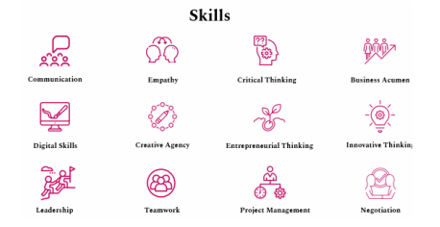

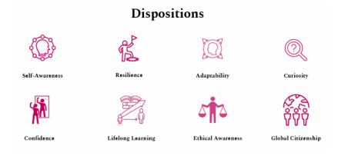

|  |  |
| --- | --- |
| **Skill / Disposition** | **Skills /Dispositions Description: give specific examples of how this skill/disposition was acquired by undertaking this module:** |
| 1. |  |
| 2, |  |
| 3. |  |
| 4. |  |
| 5. |  |

**Section 12 B**

**OPTIONAL NOT REQUIRED: Domain Specific competencies / Technical Competencies**

If you would like to highlight domain specific competencies / technical competencies that are outside of the skills framework, please list them here.

* You should list the name of the competency and a short description (Max 1 line) only if required.
* The text should be short and concise and phrased in the past tense.
* Note: If you choose to list competencies below you should only capture 4 skills in the skills section above

|  |
| --- |
| **Domain Specific Competency / Technical Competency list** |
| 1.  2.  3.  4.  5. |